Something about Ken Drake, the author of these Fitzwilliam House/College Boat Club Documents
Rowing with the Old Cantabs, as they were originally known
My rowing career began at the Cambridgeshire High School for Boys, now Hills Road Sixth Form College, here in Cambridge. In 1950 the Old Boys, officially the Old Cantabrigian Society, formed a new Boat Club initially restricted to members and ex members of the school and staff of that school. It was extremely unusual for a new club to start in the Bumps with a couple of crews and we started with four! All the crews started at the bottom of the 2nd division, there were only two divisions in those years. We started in the right order of 1st, 2nd, 3rd and 4th, the latter being made up of school boys and I was in that crew. On the first night the 1st got a quick bump, no surprise there as some of the crew were rowing in College 1st VIIIs. Behind them the 2nd VIII got an overbump and the schoolboys bumped the 3rd crew. So yes I got a bump on my very first row! The order was now 2nd, 1st, 4th, 3rd with other boats placed between 4th and 1st. It was hoped that the 2nd would get a quick bump so the 1st could go for an overbump but that did not happen so the 1st had to bump the 2nd. The 4th made one more bump on the third night, having made a disputed bump on the second which was disallowed.
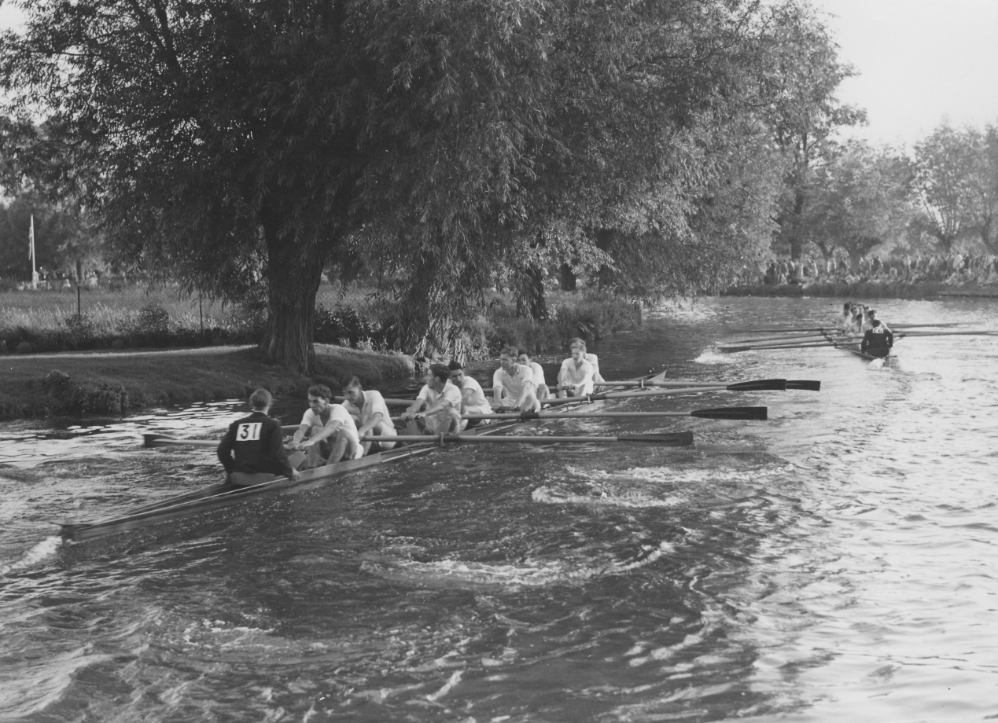
This Schoolboys' boat was unusual in that it had staggered seats so that instead of being in a line down the middle of the boat the seats were placed further away from the rigger which meant that if bow side didn't weigh the same as stroke side sitting the boat was not easy. It was a clinker built boat and the stern behind Cox and the bow in front of Bow were not covered. In addition to all that the boat had what were called fixed pins instead of the rowlocks we use today.
In 1951 I was again in the School VIII and this year we made three bumps. I then left school to do my National Service in the Royal Air Force. I had been interviewed by the Censor, W. S. Thatcher, M. C. and he offered me a place at Fitzwilliam provided I gained an O level Latin before I was due to come up. I had not been taught Latin at school so I had two years in which to achieve this. After my initial training at Melksham in Wiltshire I was posted to Martlesham Heath near Ipswich where I assumed I could enrol to study Latin. I was wrong! I reported to the Education Officer and he suggested I should put in for an Educational Posting to somewhere where I could be taught Latin. I knew this was possible at Cambridge so very shortly I was posted to Waterbeach, just north of Cambridge. This had the advantage that in addition to being able to study Latin I could continue to row for the Old Cantabs.
In 1953 I was in the Cantabs 2nd VIII and we not only won our oars but this included an overbump.
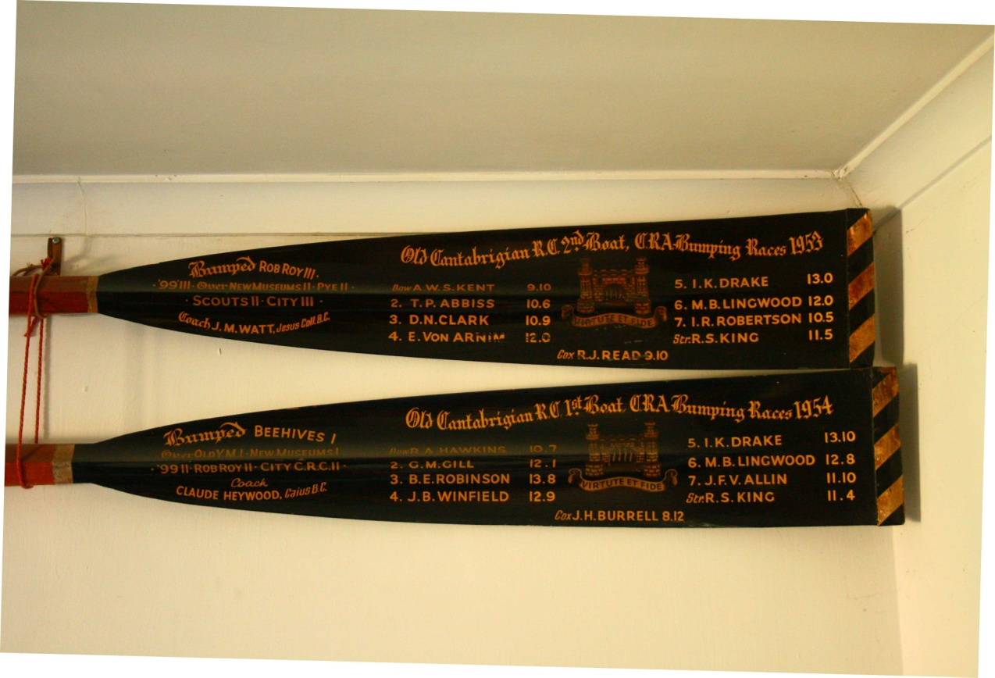
Old Cantabs 2nd VIII oar which included an overbump
The following year some of that same crew rowed as the 1st boat and again we won our oars and again it included an overbump.
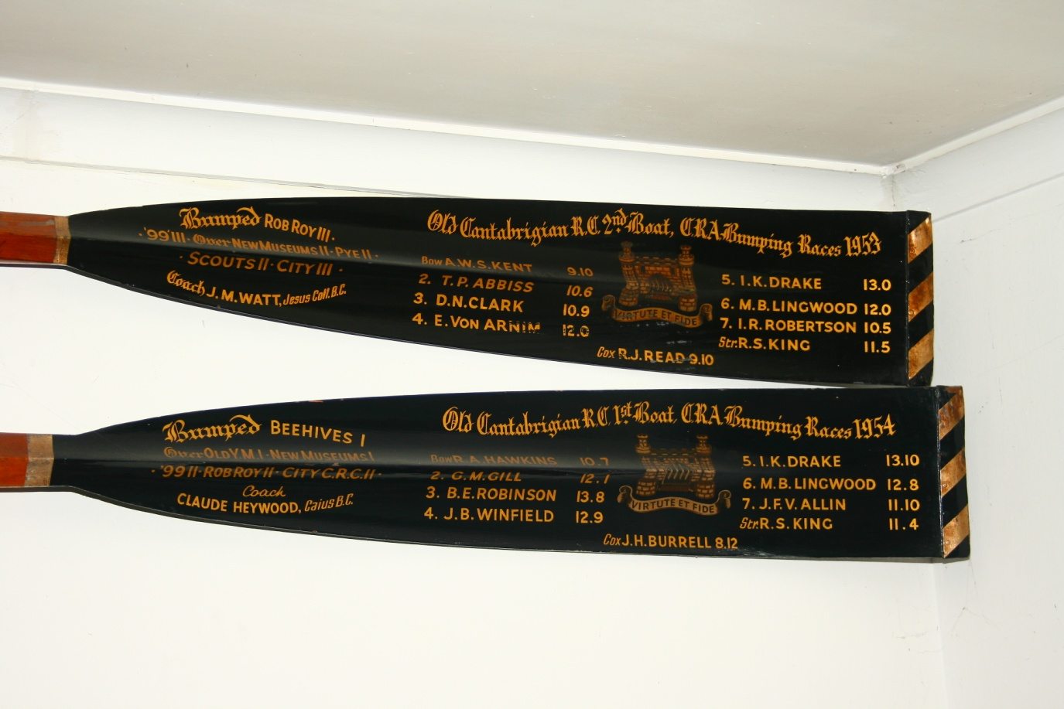
This Old Cantabs 1st Boat oar shows that G.M. Gill rowed at 2 and he later became Chief Cashier at the Bank of England so that many of us carried his signature around in our wallets.

In both cases I was rowing on bow side. The next year still in the 1st VIII we had a really hard row on the second day being chased by our 2nd VIII which was made up of schoolboys and to our disgust they caught us. However on the last night we got them back to retain our position of fourth on the river.
And so to Fitzwilliam
After my Cantabs success in 1953 bumps I came up to Billy and towards the end of my first term I got into the 1st VIII and rowed in it for all the four years I was up.
My first Lents in 1954 was a doddle. We won our oars. It all seemed so easy. Did this mean all Fitzwilliam 1st crews won their oars? Apparently not!!

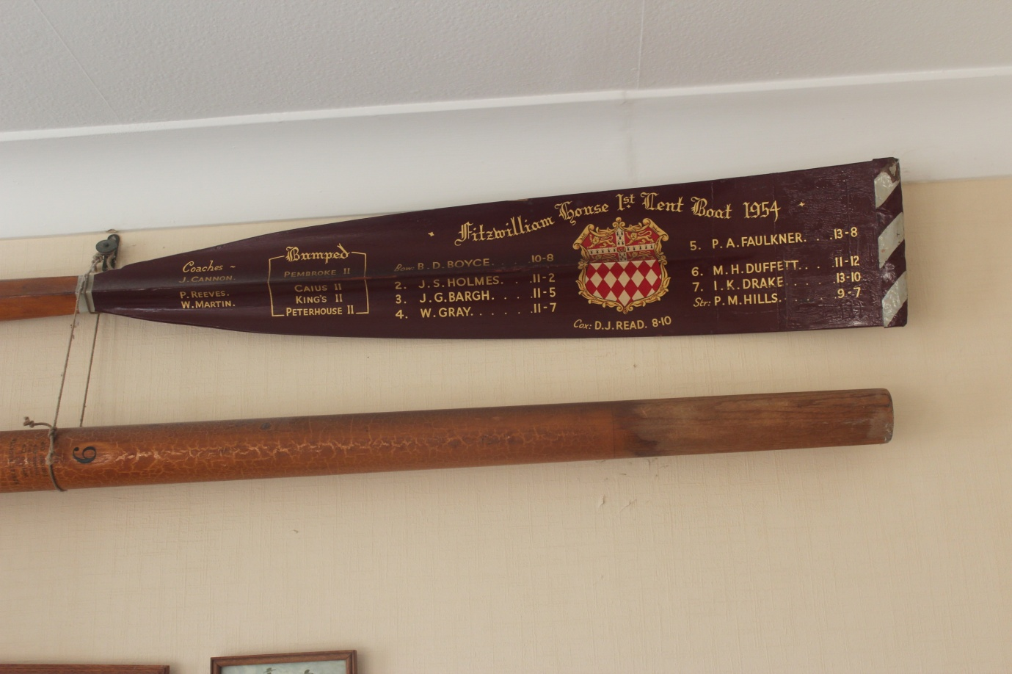My first Fitzwilliam oar won in my first Lents
I continued to row on bow side as I had done with the Cantabs. But in the Mays we didn't do so well as we were bumped three times. I was elected as Secretary for the 1954-55 year. In the 1955 Lents we rowed over three times and were bumped on the fourth.
In the 1955 Mays I rowed on stroke side. We trained very hard and on most outings when we got back to Peters Posts we turned round and went back to Baits Bite before returning to the boathouse. We rowed with the Lady Margaret style, lying back a very long way as the photo shows.
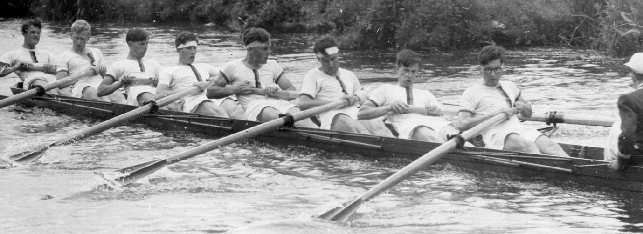
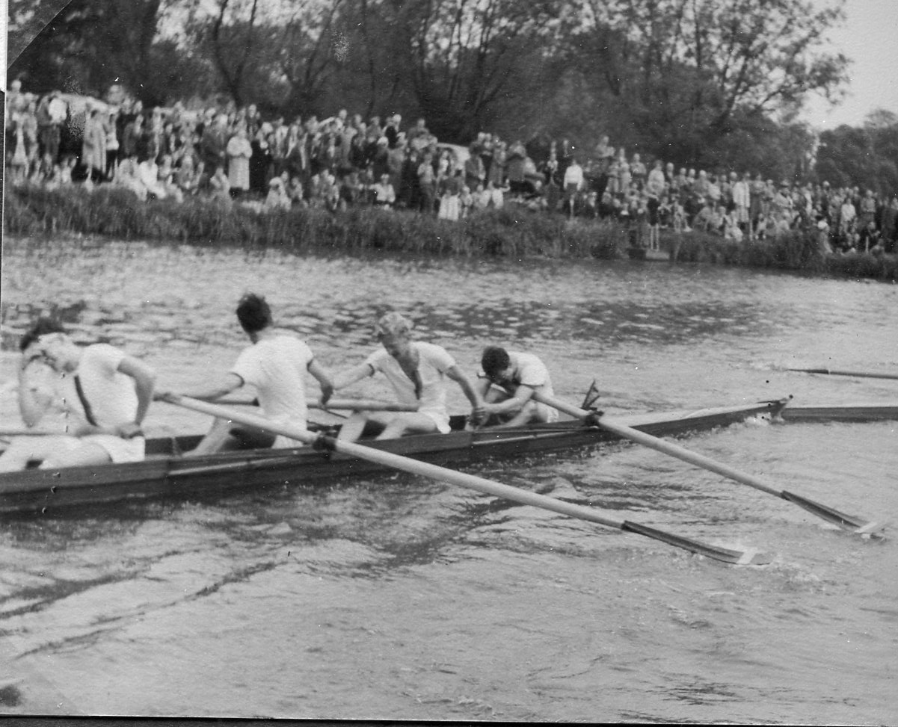
I am rowing at 6 and on the way to the start on the first day I managed to break my oar so in the actual race I rowed with a Sidney Sussex Ayling oar. Our crew was using Collar oars at that time. Our boatman, Cecil Phillips, carried a great variety of spares with him in case of breakages but I do not recall seeing him cycling with a spare oar! In those days we shared our boathouse with Sidney and they used the changing rooms at the front, nearest the river, and we used them at the back. We had an urn which heated the water if we remembered to put it on before we left on our outing! Possibly rowing with this different oar was partly responsible for us rowing over on the first day. On the second day we bumped Trinity Hall 3 moving us to second in that division. The Friday was very exciting as we first bumped the sandwhich boat 1st & 3rd Trinity 3 and then 45 minutes later we bumped Selwyn 2. We had now moved up three places so one more would mean us winning our oars. On the Saturday we steadily made progress eventually catching Christ's 2 at Ditton Corner. Their Cox was wearing a Leander scarf and we felt we were really among the top crews to have bumped him! Derek Read, our Cox, was thrilled that he managed to get our bow inside Christ's rudder at Ditton Corner. The next photograph shows the President, Mike Duffett rowing at 2 being congratulated on his success by bow (John Hankin) and 3 (Warren Gray). Also note the pennant in front of bow. When I arrived at Fitzwilliam there were no pennants on the boats and the old Billygoat flag was in tatters. That soon changed and a brand new flag was made for us to fly when we won our oars and each boat had its own pennant in grey which had embroidered on it a
Congratulations Mr President (2) also showing pennant . maroon Billygoat and a number (to indicate which boat it was e.g. 1, 2, 3, 4 and 5) and a maroon border. These were all made by Vivian, later to become my wife.

This success in gaining our oars also marked the first time since 1922 that Fitzwilliam had been in the Second Division.

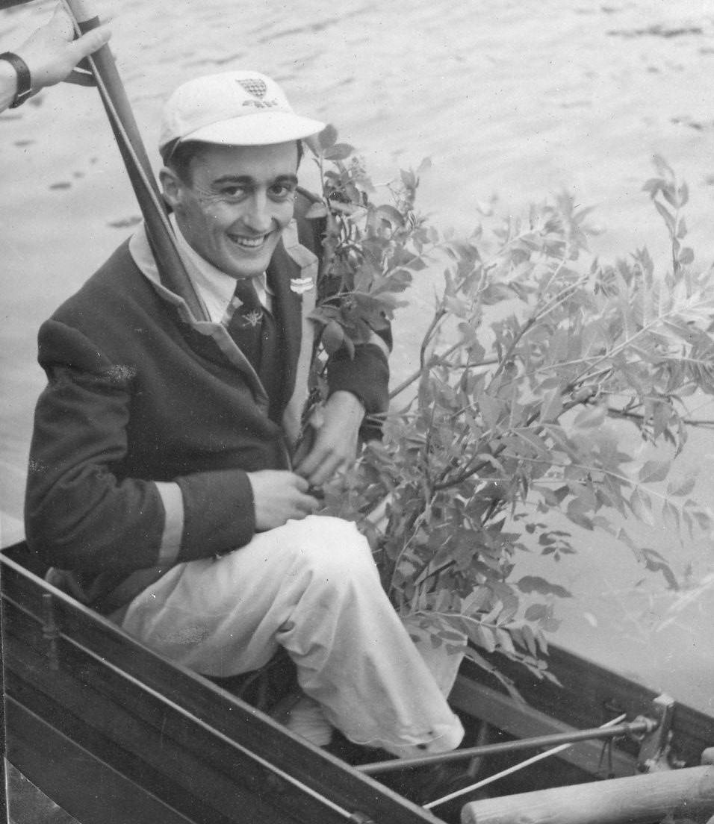
Derek Read, the Cox really entered into the spirit of the afternoon by acquiring a tree instead of the traditional piece of willow and he also had the honour of flying the large Billygoat Flag that Vivian had made. The original outline for that large Billygoat is still in our possession over 60 years later and it is reproduced on the following page.
It was this crew that we got together again 50 years later and rowed downstream to the Cables to see where we made those bumps in 1955. A full account of that appears as a separate document in this series entitled "Record Breaking 1955 Fitzwilliam 1st May VIII".

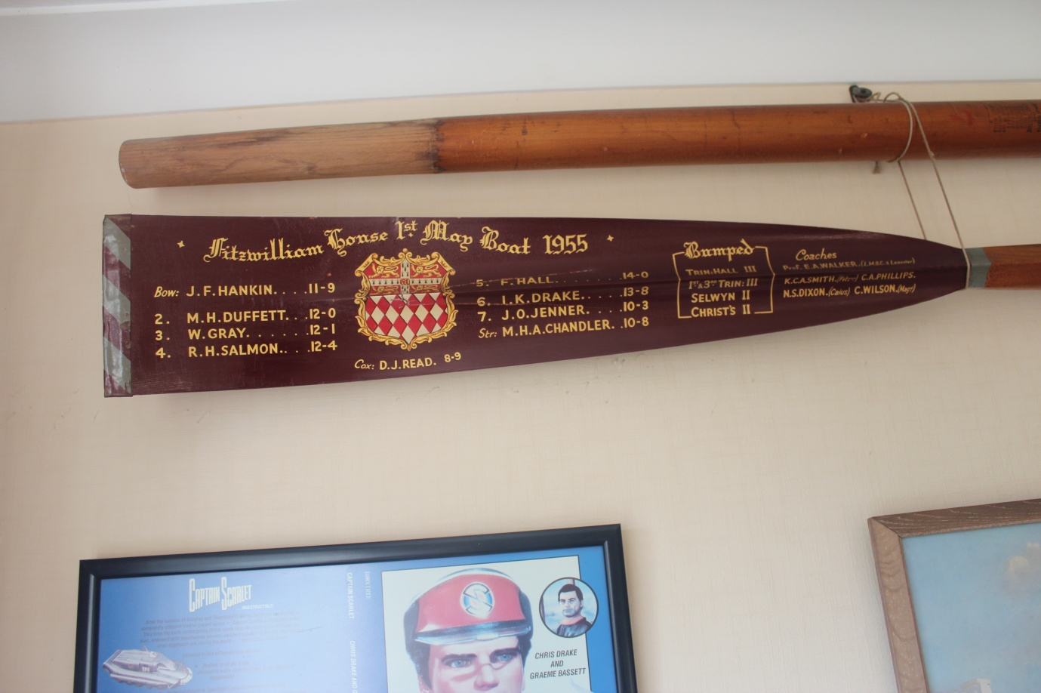

My second Fitzwilliam oar won in my second Mays and on stroke side
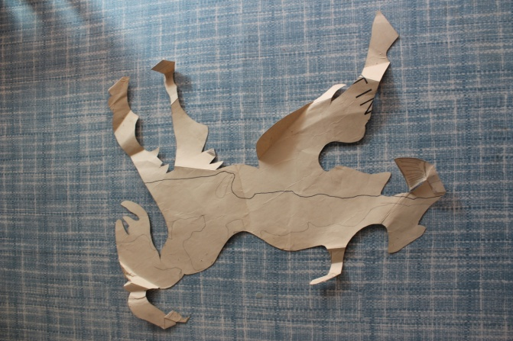
Stencil of Billygoat, greatly reduced in size, used for large flag made in 1954 by Vivian Halls later Drake.

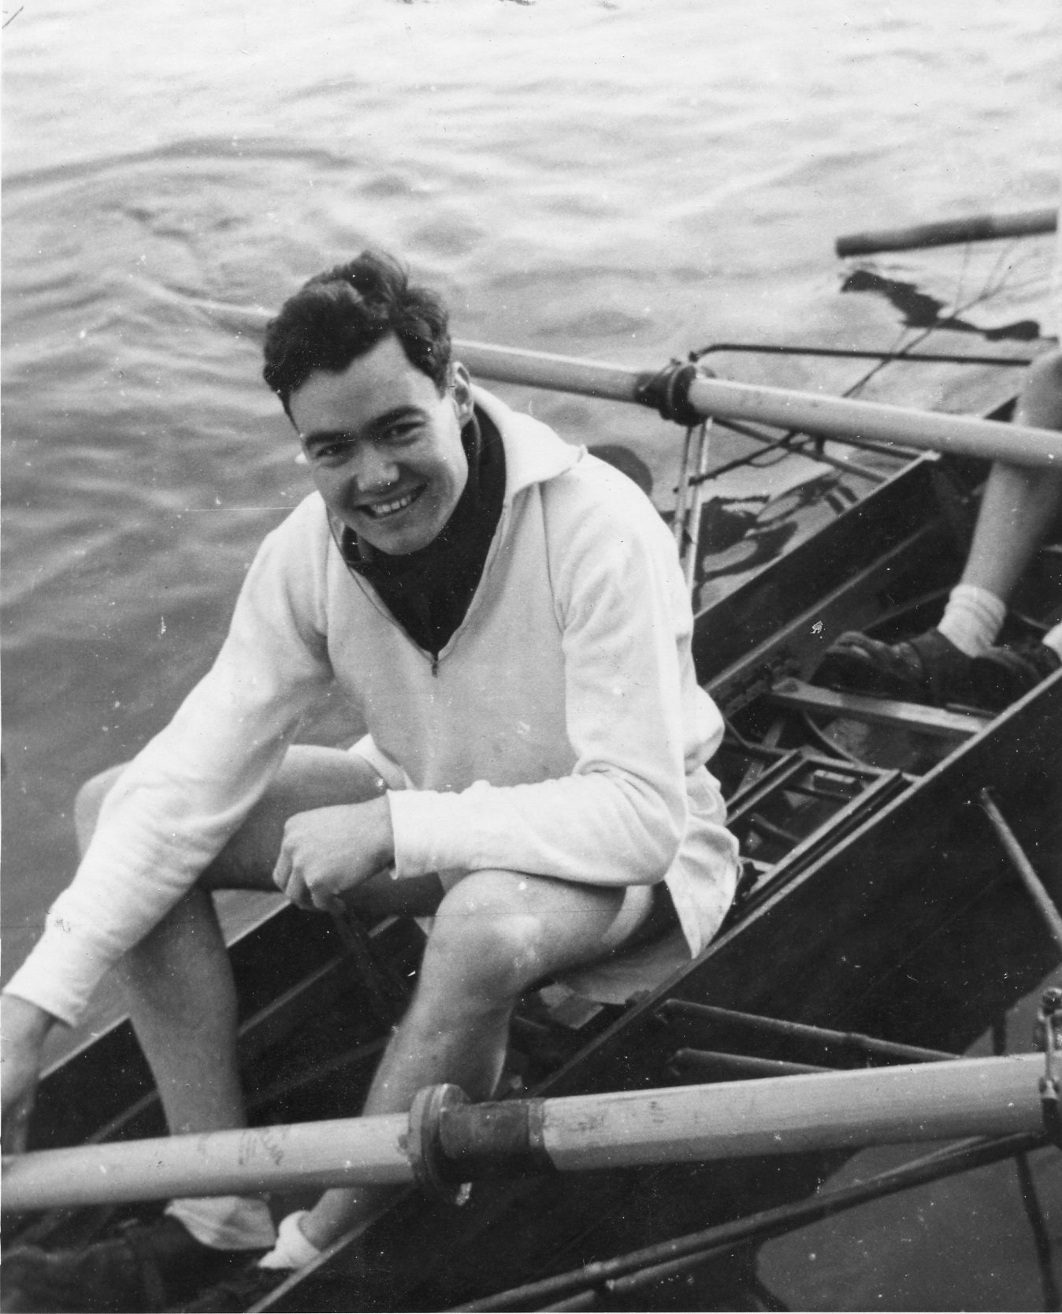
In my third year I was elected Captain of Boats, a term I introduced as up to that time the captain had been President and I thought that that position ought to be held by the Censor, now the Master, as was the case in the great majority of the Cambridge Colleges. Even in the early Billygoats literature there is reference to Captain of Boats. In fact in this year two of those who rowed with me in the Cantabs crews were elected Captains of their College Boat Clubs in Cambridge - one at St Catharine's and one at Sidney Sussex. It seemed quite incredible that three of us from that same school should hold these offices at the same time. In 1956 Lents we made bumps on the first three nights but rowed over on the 4th and in the 1956 Mays we again finished up three places. In that year 1955-56 Fitzwilliam gained the most places of all the colleges in the Mays and had it been in existence then we would have won the Pegasus Cup.
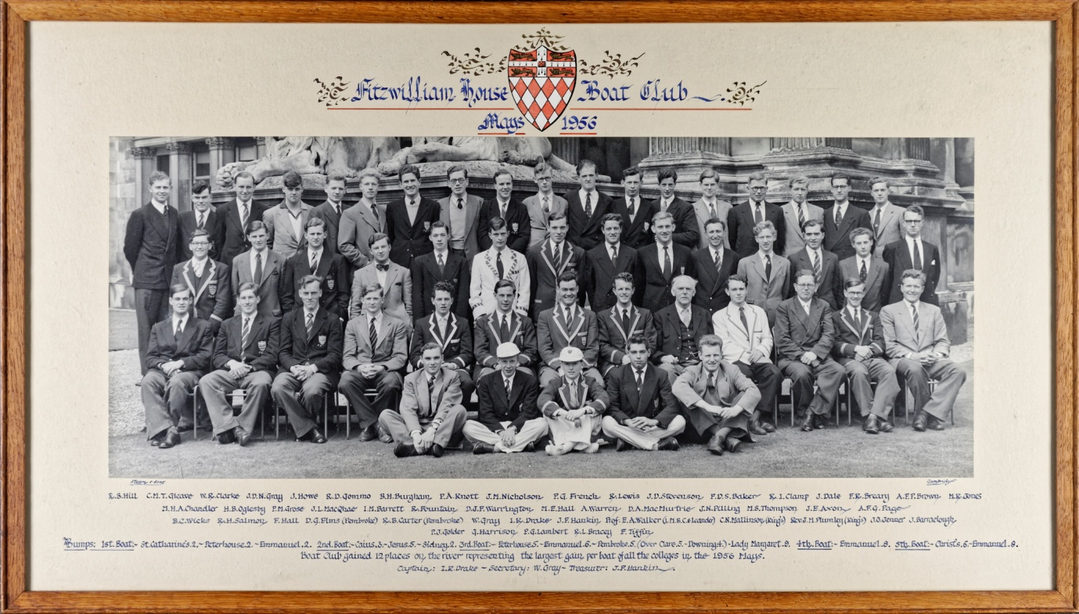

In 1957 Lents we experienced everything, we made a bump, we rowed over twice and we were bumped once thus ending where we started. In my final bumps for Billy the crew rowed over three times and bumped Pembroke 2. So the general movement of the 1st VIII was upwards 6 places in the Lents and 11 in the Mays over four years. I ended up with two oars, one on bow side and one on stroke side so they make a nice pair. I introduced a Fitzwilliam Sculling Cup event which I won in 1956.

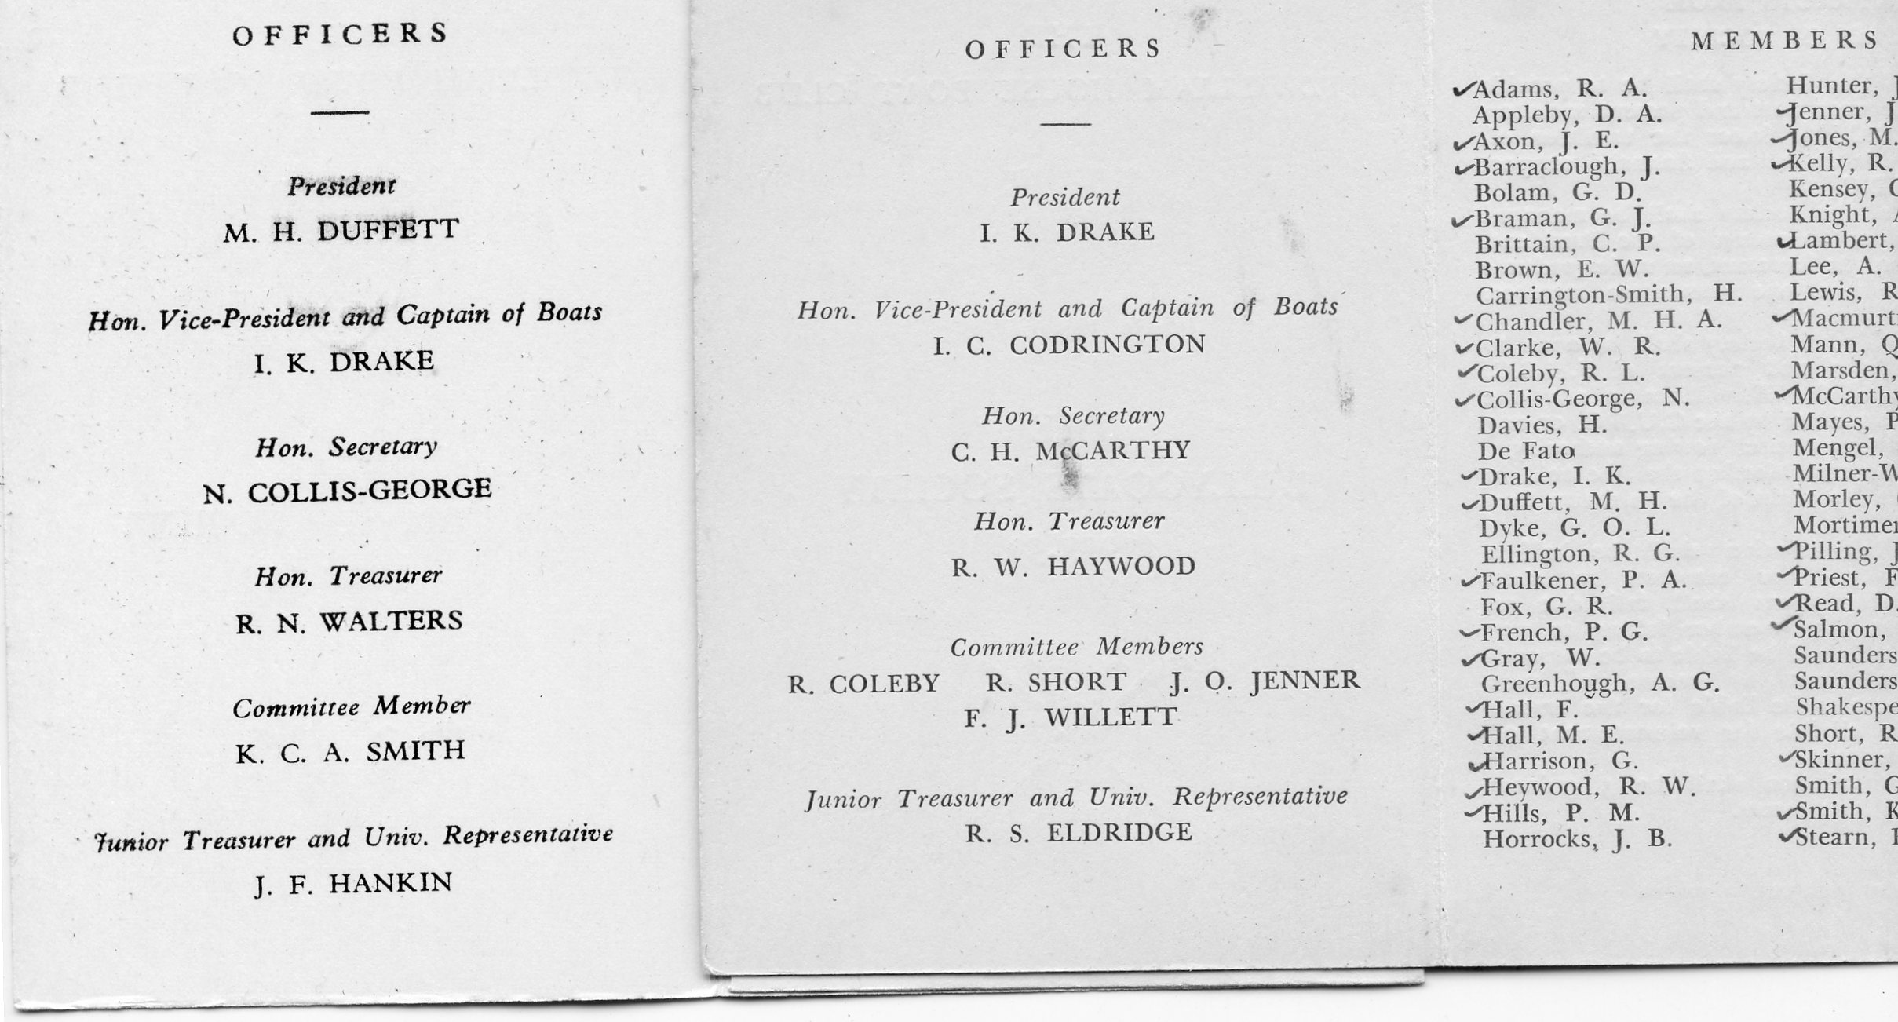
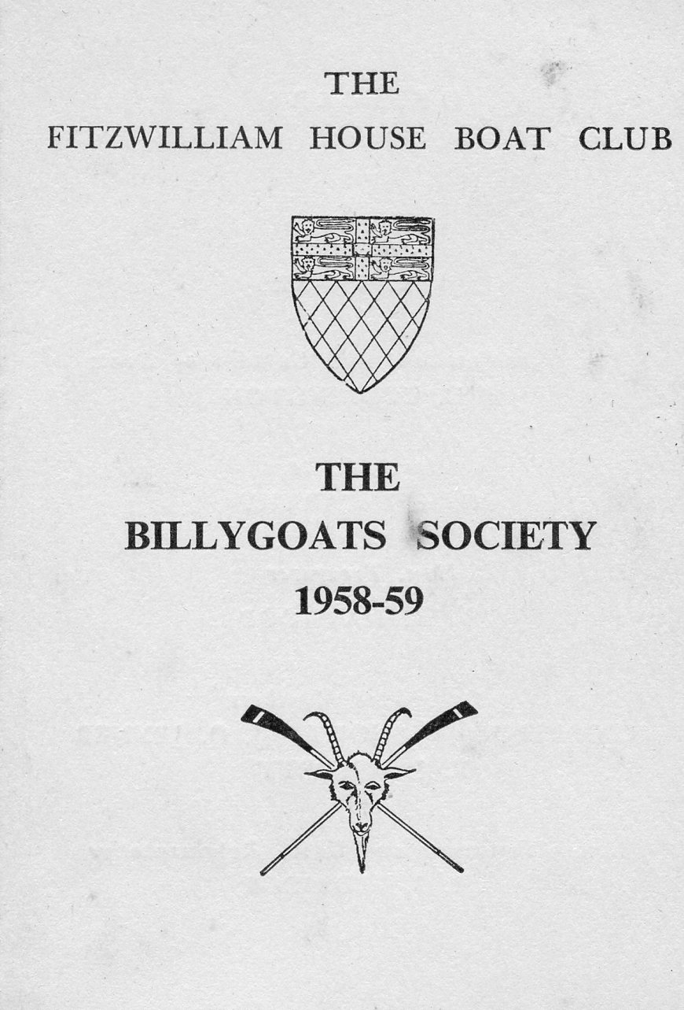
Whilst I was still up my predecessor as President of the Boat Club was Mike Duffett and when he went down he was elected as President of the Billygoats. Little did I realise that the same thing would happen to me so I was lucky enough to have been President of the Billygoats during the period 1958 to 1960.

Rowing with the Old Cantabs again
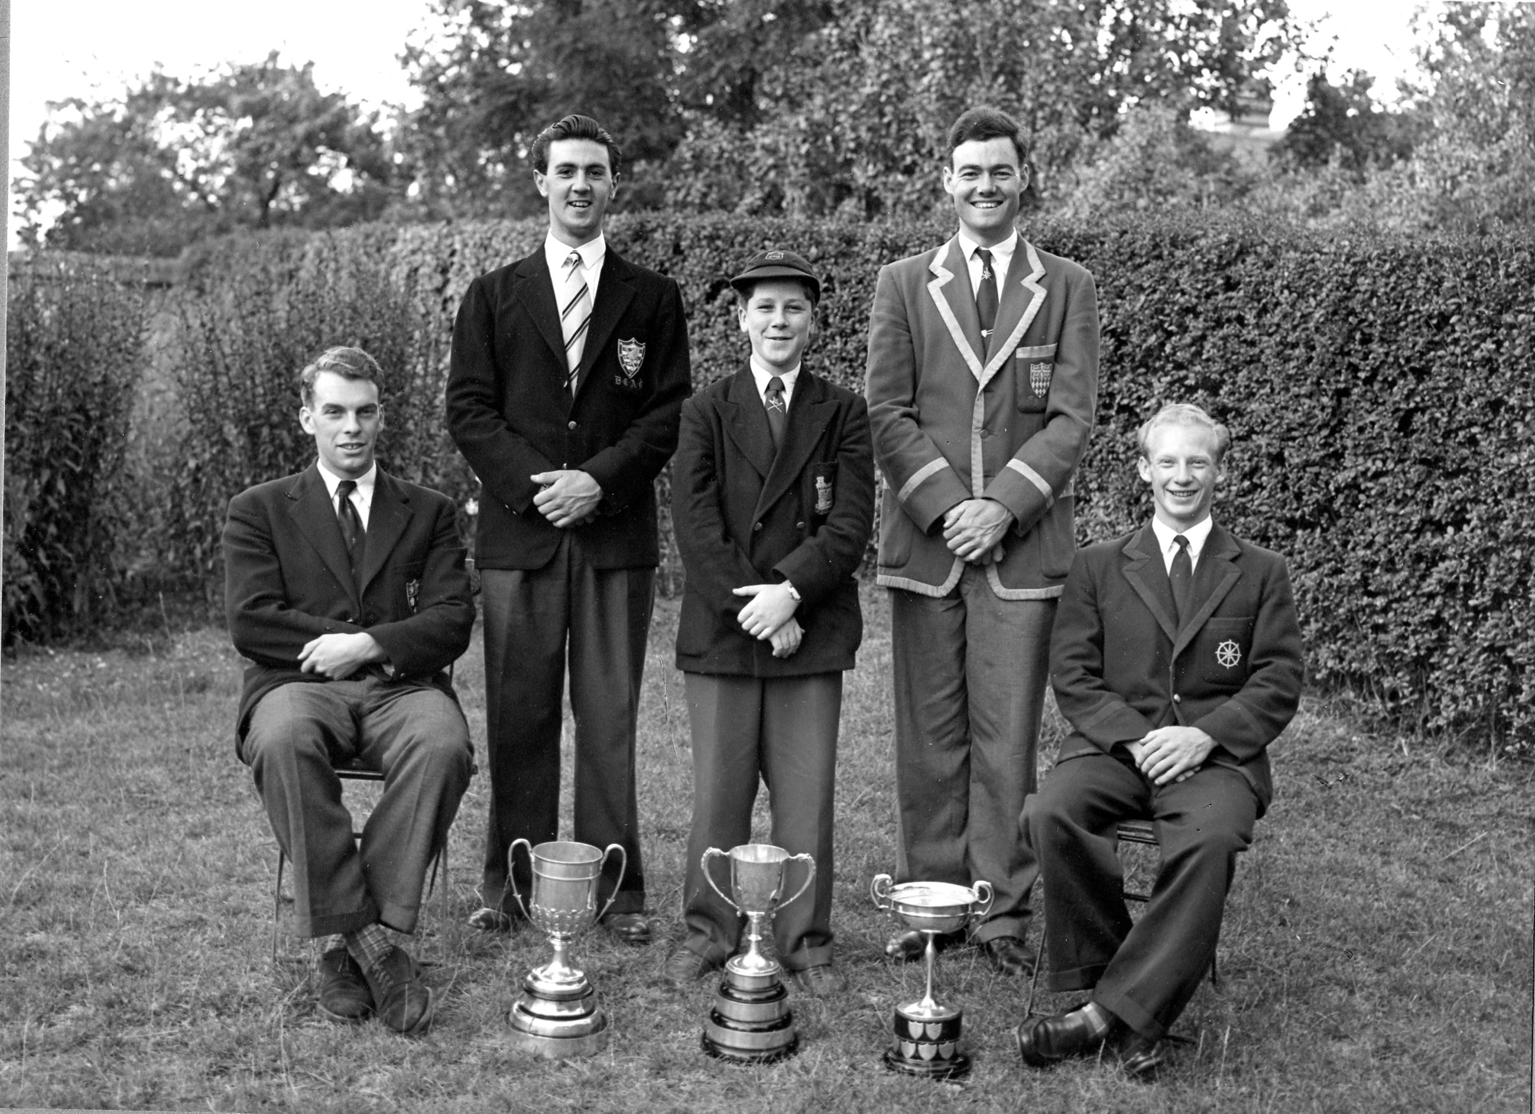
After the Mays with Fitzwilliam I rowed in the Cantabs crews in the CRA Town Bumps and after that we entered some of the local regattas. In 1954 we won the Walter Attenborough Maiden Fours at Bedford, one of the most prestigious local regattas. Later that year at Sudbury we won the James Osborne Memorial Cup Challenge Pairs and at St Ives the Junior Fours Enderby Challenge Cup.

Crew with Bedford Maiden Fours, Sudbury Challenge Pairs
& St Ives Junior Fours Trophies

In 1956 we won the St Ives Senior Fours. The trophy for that was the former Midlands Amateur Rowing Association Championship Trophy, a beautifully crafted silver four with crossed oars in a glass case.
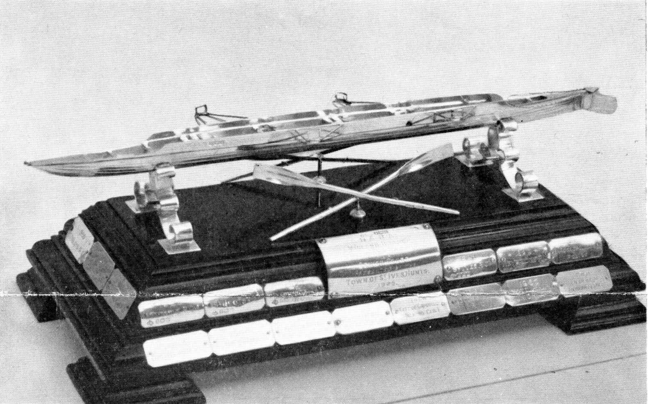
St Ives Regatta Senior Fours Trophy

I rowed in the Cantabs Challenge Pairs at the C.R.A. Regatta where we reached the final in which we dead heated with City but lost the subsequent re-row by just 1 second. I weighed 13s 10 lbs and rowed at bow with David Bailey, who was Captain of Boats at St Catharine's rowing at stroke who weighed only 10 st 6 lbs. It was amazing we didn't submerge like a submarine! That was my last competitive race. At a number of regattas I rowed in the Cantabs crew and also entered the Maiden Sculls, sometimes representing Fitzwilliam and although I won a number of heats that was as far as I got.
23rd June 1956
The 23d June 1956 was a vey special day for us. The postman brought me a letter informing me that I had been awarded the Reddaway Prize "for services to the college during my time of residence". This was a complete surprise - I had not even heard of the Reddaway Prize. Then at 11 a.m. Vivian and I were married at Wesley Church, which is at the Four Lamps between King Street and Short Street and from its front door you can see many boathouses. As we emerged after the ceremony we passed through a guard of honour made up of 6 Wolf Cubs, as Vivian ran the Cub Pack at Wesley, and six oarsmen holding Fitzwilliam oars (I was the Captain of Boats for that year). to make an archway through which we passed.

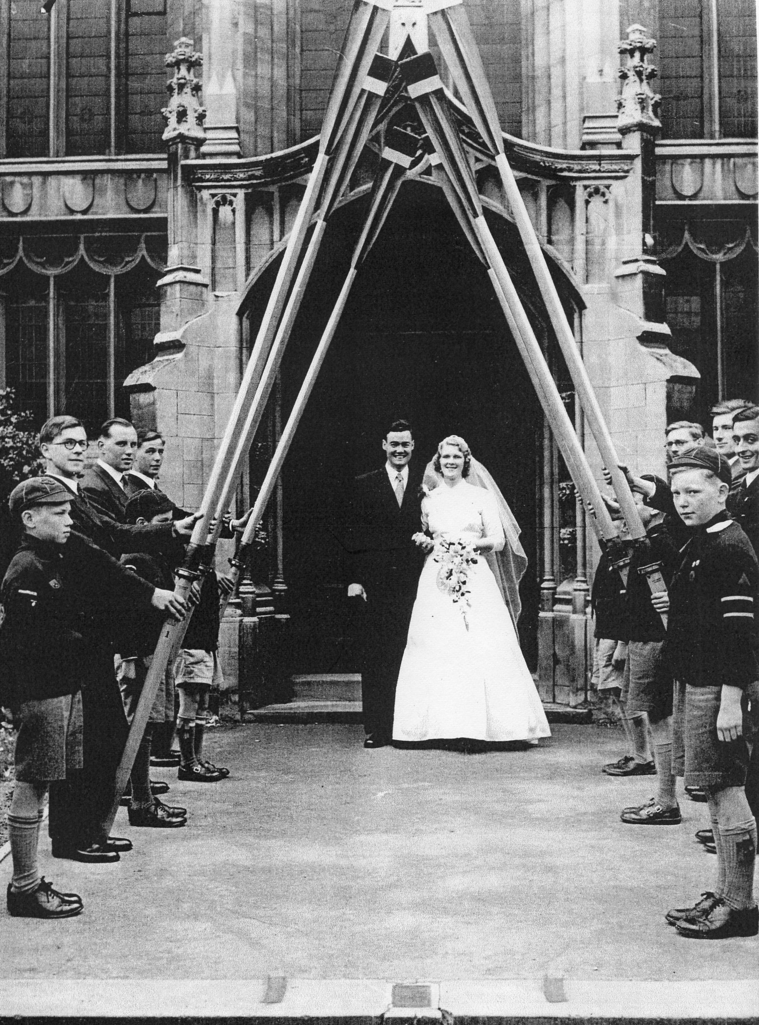Oarsmen holdingthe oars are from left front are John Jenner, Bill Clarke and Warren Gray, and on the right from the front Derek Read, Richard Salmon and Alan Warren. Frank Hall was my Best Man. After the reception in the Guildhall, as my wife-to-be was Secretary to the Mayor of Cambridge, we got changed and walked across King's Parade to the Senate House where the Vice Chancellor gave me a piece of paper to say that I was now a bachelor of this university. The previous night was supposed to be my stag party so I spent it with the others graduating the next day at a dinner in Fitzwilliam that evening. We remained in Cambridge for one more year whilst I did my Post Graduate Certificate of Education and continued rowing in the Billy 1st Boat.
On leaving Cambridge we named our house "Henley Tor" as we were engaged at Henley Royal Regatta in 1955 and had our honeymoon in Torquay. The name was painted on a Fitzwilliam blade which hung over our front door at Bedford and for a good many years thereafter.
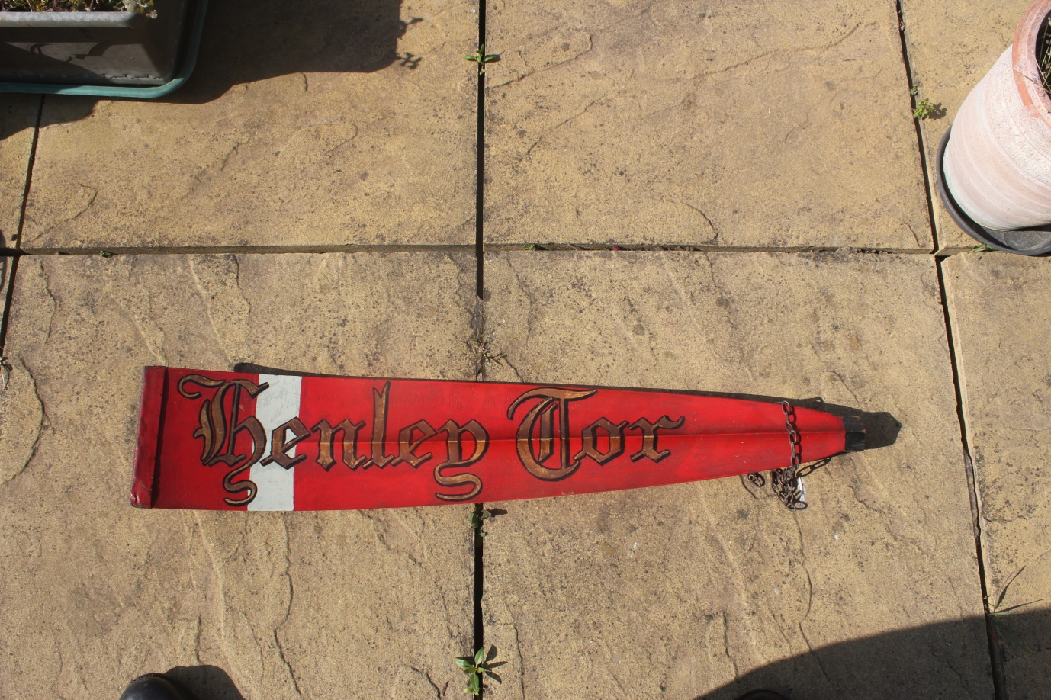
Our home name, "Henley Tor", on a Fitzwilliam blade
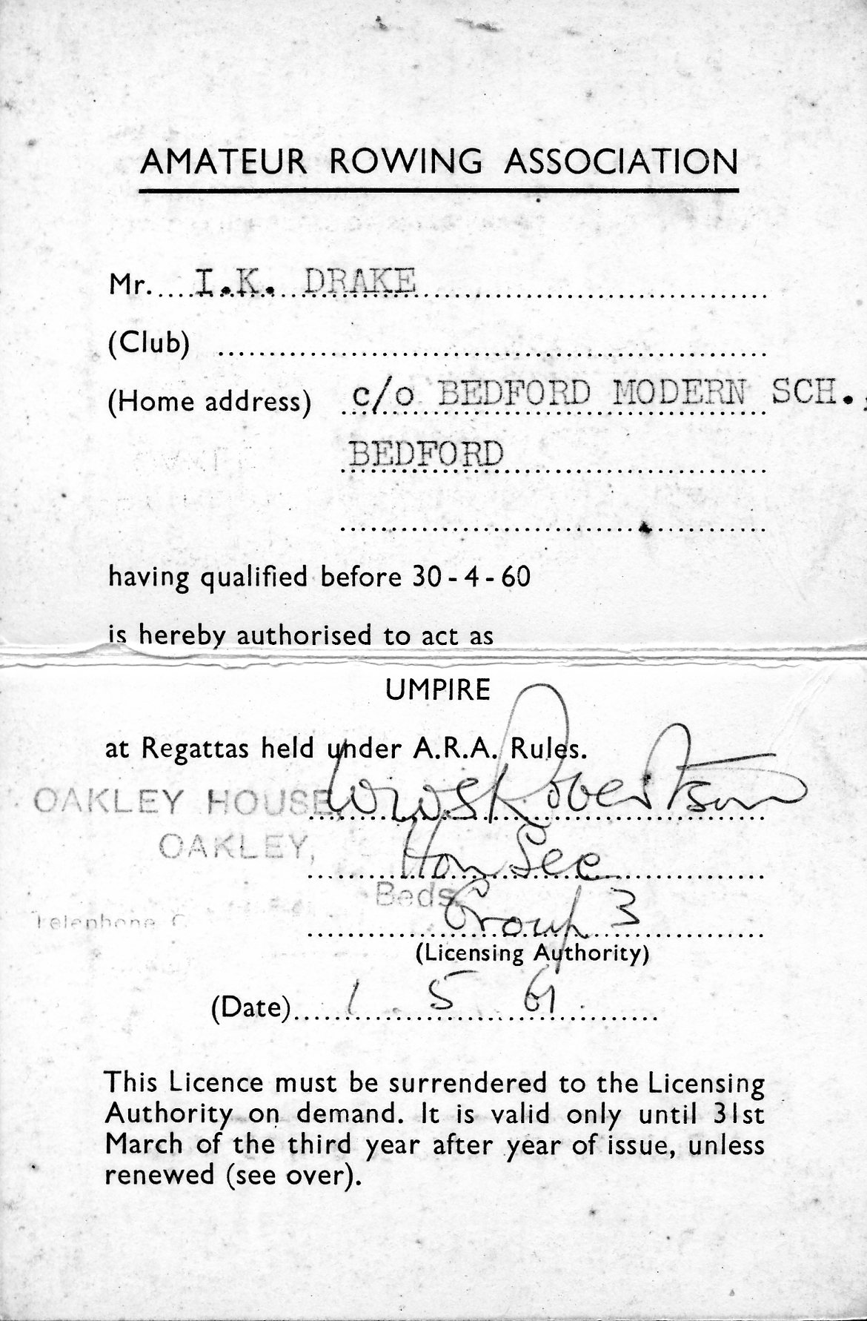
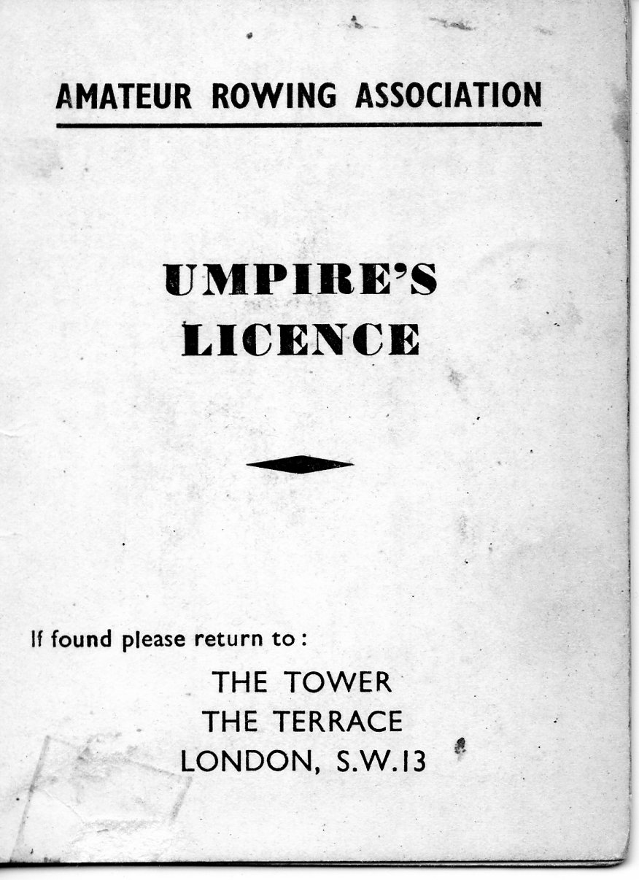
My professional life started with a teaching appointment at Bedford Modern School in 1957 where I was responsible for teaching Geography and Maths and coaching the school 2nd eight which regularly entered the Marlow regatta. As a rowing master at one of the two boys public schools in Bedford I was naturally expected to umpire at the prestigious regatta. There was no swotting up for an exam to acquire an ARA Umpires' Licence. As far as I can recall I did not even apply for it. I suspect my name was sent forward by the Master i/c rowing at B.M.S. and I duly did what was expected of me at the regatta during the time we were there. After three years we moved to Bancroft's School, Woodford Green, Essex as Head of Geography, which as a position in a boys' grammar school had been my aim and ambition since I was a boy at school. I thus ended my involvement with rowing but I took over running the school Sea Scout Troop instead. After ten years there I decided to transfer to comprehensive education and after a spell as Deputy Head at The Vyne School, Basingstoke we moved to Grimsby where I was appointed as Headmaster of Waltham Toll Bar School, a very large purpose built school of up to 2000 pupils including 180 in the sixth form and serving the rural area south of Grimsby. It had its own indoor swimming pool, a Sports Hall where we held full school assemblies at the start and end of each year and the playing fields were on the site. We retired in 1990 and moved back to Cambridge in December 1993. We had lived almost 40 years in the wilderness away from Cambridge and the River Cam!
The History of the Cantabrigian Rowing Club 1950-2010
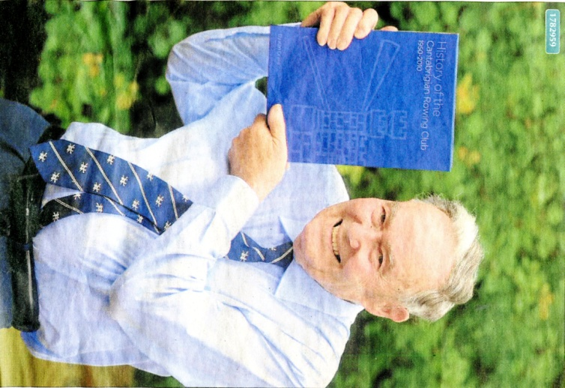
During this time I decided to try to write a history of the Cantabrigian Rowing Club. Three members had tried before but failed so I had a real challenge. The Cantabs Rugby Club, with similar origins to the Rowing Club, had recently had its history written by a couple of my friends so I naturally sought their advice. "Whatever you do, Ken, don't make it too detailed" was their advice. That was exactly the opposite of what I wanted to do so I ingored their advice and started to collect information and writing something. I appreciated that the demand for such a publication was not very great, in spite of the fact that the Cantabs Rowing Club is the largest rowing club in Cambridge so my original thoughts were that it could be put on a CD ROM. I had been on the Committee of the club since 1994 and later was elected President, a position I held for six years. All this gave me access to a great deal of material. Inevitably the Town Bumps formed an important part of the history so the Cambridge Daily News', as it used to be called, reports were obtained and quoted in full. I started writing an introductory chapter explaining how the bumps work and then separate chapters one for each year since 1950. Special charts were drawn up for the bumps for each of the 60 years. In those days they had a different programme for each night to show the current starting order of the crews so I did my best to collect as many as I could and in the end I was only 11 short of the 244 that were produced and these were put on an accompanying CD ROM. The book contains some 470 illustrations. When I was getting towards the end of writing it one of the grandees and benefactors of the Club who had been Captain and Vice Captain for a major part of its life, Andy Johnson, asked to see what I had done. He immediately told me that it would be published and he would undertake the responsibility for it. The result was "History of the Cantabrigian Rowing Club 1950-2010" was published. I had written so much, over1000 pages on A4, that he and his daughter, who actually published it, were forced to convert the text to two columns and to use a small font and to reduce the size of all the illustrations. There are many tables showing the names of the bumps crews and the results of the bumps. In addition to the main text there were fifteen appendices which included the names of the Presidents and other officers, a Progress chart of finishing positions of all crews racing in the bumps over this period, record of Ron Davies who rowed in more CRA Bumps races than anyone else - 216 races, advice for bank parties, outstanding people at the club including one who rowed in the Olympic Games GB Eight Crew, A History of the CRA and its clubs, Tips for Bank Parties and others. The result was an excellently produced book of which the Club and I are very proud. A copy has been sent to the British Library in London and copies have been presented to the Cambridge University Library, Cambridgeshire Collection in Cambridge Central Library, Cambridgeshire Arhives now based in Ely, Fitzwilliam College Library, the Rowing and River Musem at Henley, Hills Road Sixth Form College and the President of CRA. We know that copies of it have been sent far and wide, one recipient lives in Canada and another in Australia. In fact the latter has the rather unusual hobby of collecting histories of rowing clubs. I have no idea how many he has but he has emailed to say that the one I have written is far and away the best he has seen. It weighs 5 lbs or 2.20 kg! It costs £60, which represents about £1 for each chapter or year! It took me seven years to write it.

The Over 60s Reunion Rows which ran for 20 years
At the 1995 College Reunion a small number of us were chatting after the meal and agreed we would very much like to go out in an eight again as we had not done so since we went down in the mid to late 1950s. We were all over 60 so that was an appropriate name to call ourselves. That was fine but who was going to organise it? I had been their Captain of Boats and I did live in Cambridge so it was pretty obvious. The first year five oarsmen turned up so we swapped the crew so everyone had a go. The original six pioneers who launched this scheme were Geoff Harrison (cox), Tony Page, John Jenner, Richard Eldridge, James McQuhae and me. Every year after that we had enough for at least one eight and often more. It was very popular and we continued for 20 years.

Reunion Row of 1955 1st May Eight which won its oars.
In the middle of the time we were organising these reunion rows John Jenner had a bright idea. He and I were in the 1st May Crew in 1955 which won its oars. Wouldn't it be great, he said, if we could contact every member of that crew and if they were up to it to persuade them to come to Cambridge to join in the Over 60s Reunion Rows especially to row in a boat as that very same crew. Initially the college knew the whereabouts of most of the crew but three were what they call "lost sheep" which meant that they had lost contact so they had no idea where they lived, if indeed they were still alive. The Data Protection Act meant that initially they refused to help us find them but common sense prevailed and they gave us as much information as they had about them. Letters were sent to their old schools, the local newspaper of their home towns, professional organisations which they might have joined and even the Daily Mail which has a special column each week looking for lost people to meet at a reunion. Eventually all three were traced. The crew had by now scattered to the far ends of the country - such as Devon and Weston-super-Mare but the furthest away was Mike Duffett in Australia. We contacted them and they all agreed to come to Cambridge and to get into an eight provided they did not have to row the bumps course! On Reunion Saturday in 2005 we all assembled at the Boat House and had our photos taken standing and sitting in exactly the same places we did when we had the original photographs taken at the Fitzwilliam Museum with the lions.
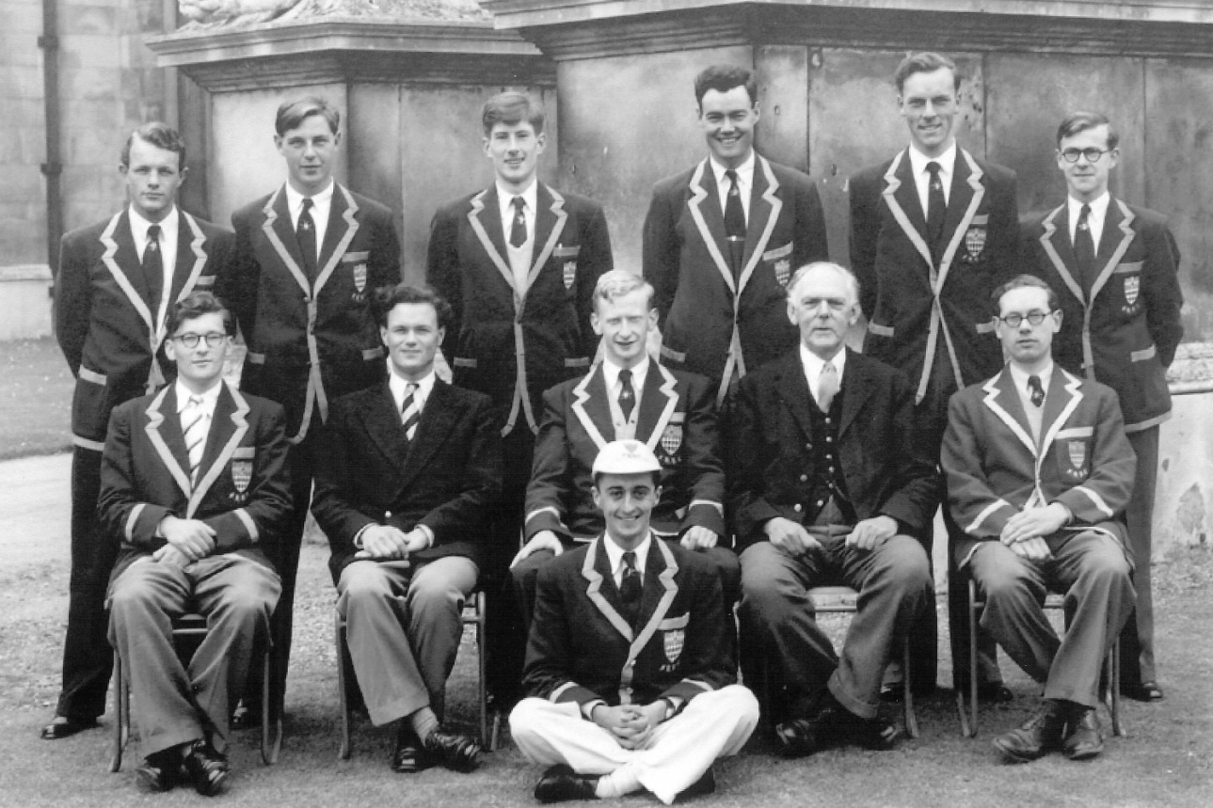
1955 1st May Crew which won its oars - photograph taken at Fizwilliam Museum
J F Hankin (Bow), Warren Gray (3), Richard Salmon (4), Ken Drake (6), Frank Hall (5), John Jenner (7)
Mike Chandler (Stroke), coach N. S. Dixon (Caius), Mike Duffett (President)(2), Coach Prof E A Walker, Coach Ken Smith (Fitzwiliam)
Derek Read (Cox)
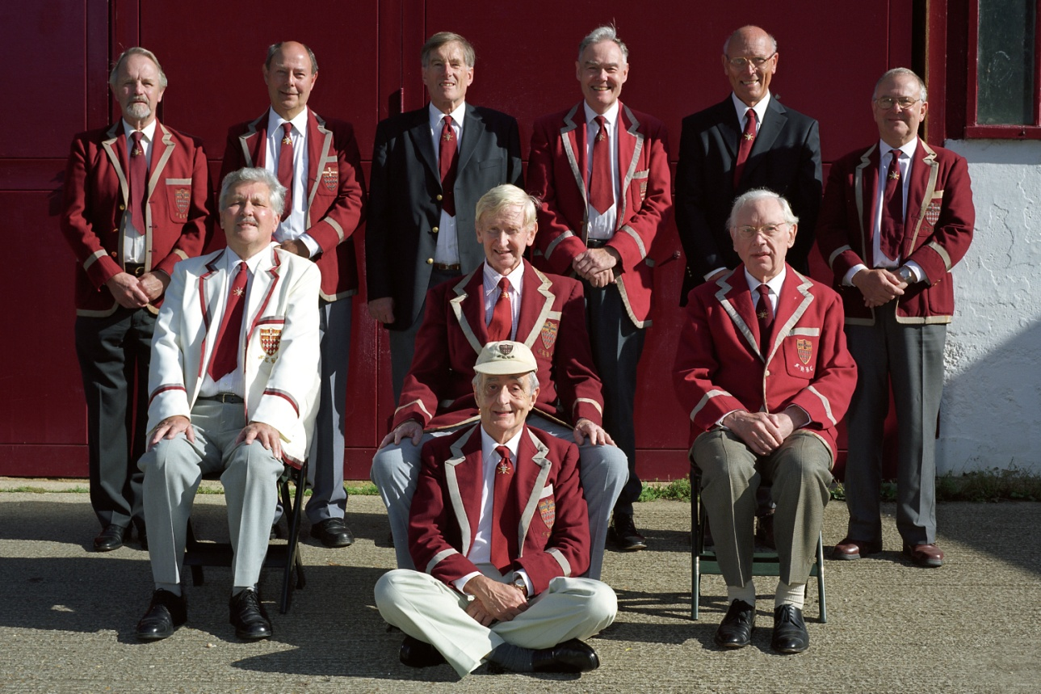
50 years later in 2005 the same crew in the same positions as indicated above

We then got changed and took out an eight and having placed it on the water began to experience the problems associated with having to fit our feet into the shoes that were provided - in our day we had a stretcher with straps into which we placed our feet and our own shoes so we had no problems. After adjusting the position of the stretchers we pushed off and gradually it all came back to us and before long we were almost sitting the boat and tapping it along quite well. We never paddled for more than 20 strokes unless cox forgot to count. It was an incredible experience. To be in an eight with the same crew we rowed in 50 years previously and to make our way round Ditton Corner, down Ditton Reach, round Grassy Corner, into the Gut, round First Post Corner to see the places where we made those bumps fifty years ago. That night at the Reunion Dinner we were introduced to the diners by the Master who got us to go to the front of the Hall and we received rapturous applause for our achievement. Whilst winning your oar or blade In the first place is very exciting the feeling of doing a reunion row fifty years later is an absolutely unbelievable experience. This is why I have often challenged present Fitzwilliam crews who get their blades to keep in touch so that in 50 years time they can do the same. I warn them though that the chance of all nine of them being alive or if alive being fit enough to do it is not very great. In our case our crew had experienced a number of serious illnesses including one who had a serious heart attack and two who had bowel cancer one of whom had MRSA at the same time and he was only given two hours to live if he had not reached hospital by this time. Indeed the following year one of our crew died and recently we lost another.
We attended the Mays Bumps Dinner that year and then we were invited by the Master and his wife to a luncheon on the Sunday that week-end. To commemorate this extremely rare achievement Derek Read, the cox, produced a booklet entitled "Probably the finest crew ever seen on the Cam." We had a colour two page spread in the local paper and even Regatta, the ARA Magazine, gave us a full page colour write-up. A separate article about this event is included with these documents about the Fitzwilliam Boat Club called "Record Breaking 1955 Fitzwilliam 1st May VIII".
Over 60s Fitzwilliam Reunion Rows
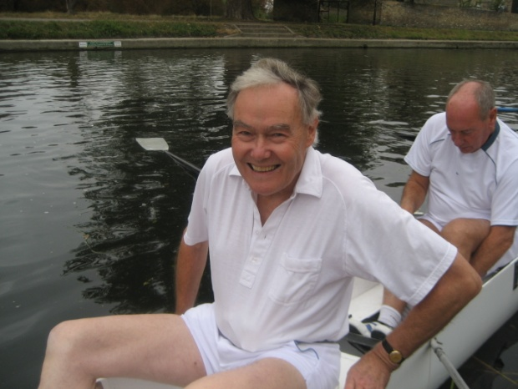
These reunion rows became a very important part of the reunions for those who participated and their wives. Some 20 years later we were now no longer over 60s but over 80s although we continued to call ourselves the Over 60s. We had a long discussion about how we should end these Reunion Rows. We realised that we could not go on for ever and that each year we were losing participants through failing health or old age so we had to ask ourselves serious questions about the wisdom of continuing. We had we thought two options. We could either continue as long as possible being very much aware that year by year the numbers actually able to row would decline until we could not even raise a crew for a tub Ken in a boat at one of these rows pair. No that idea did not appeal to us. Instead we agreed to finish in 2015, hopefully raise two eights and go out in a blaze of glory. We were thrilled to have enough men to put out two eights and we had a great deal of support from wives and friends as the photograph shows. Indeed since the very early days the wives were a very important part of the event, often going shopping when we went rowing and then meeting up for a lunch kindly provided by John Jenner in the Nines boathouse. Following a suggestion originally made by Fred Tiffin we also encouraged those taking part to make a donation to the Boat Club which we passed to the Billygoats, at John Adams' suggestion, so that advantage could be taken of the GiftAid scheme to add a further 25% to our donations. It was also most encouraging that at that final row of our Over 60s group we were able to introduce two younger over 60s who had agreed to take over what we had started for a much younger group rather like we were twenty years ago.
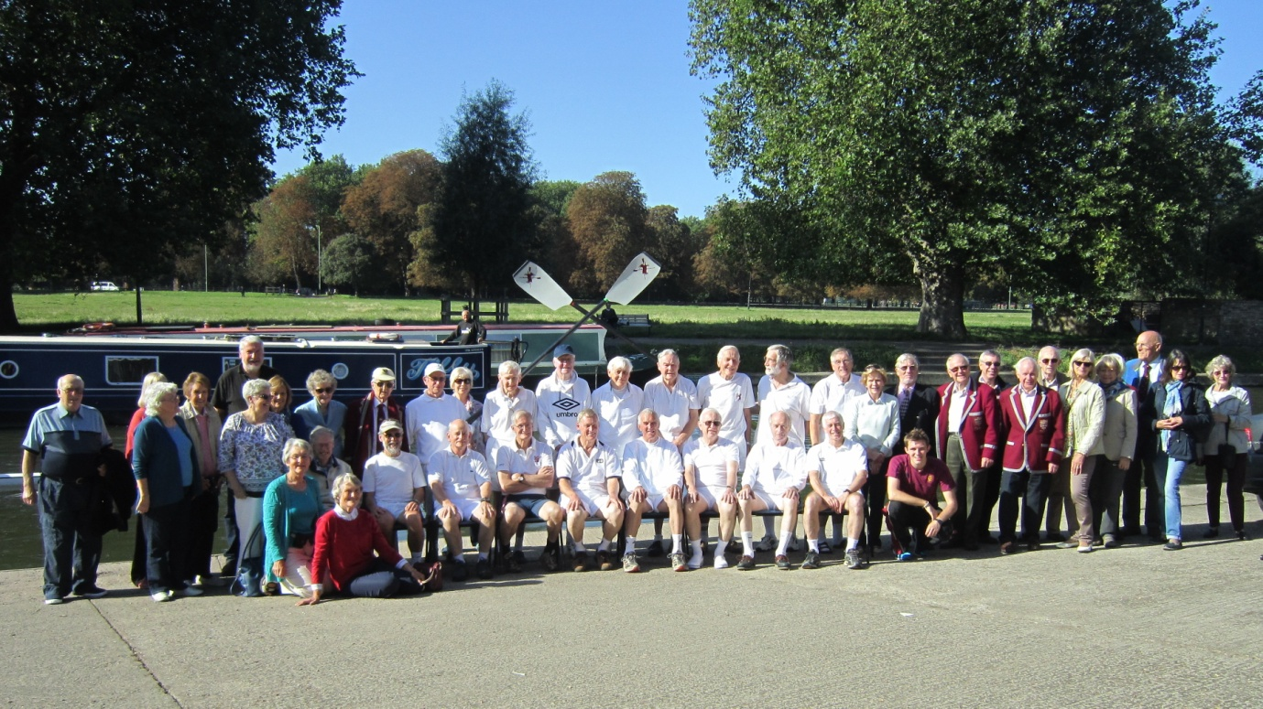
This group photograph includes all the many supporters as well as the two crews at our final Over 60s Reunion Row.

ARA Project Oarsome
In 2001 the Cantabrigian Rowing Club was selected as one of only 50 rowing clubs throughout the whole country to be selected by the then Amateur Rowing Association as a Project Oarsome Club. This was aimed at training youngsters to row and working with schools to produce a worthwhile programme that should produce some enthusiastic oarsmen and women. I was President of the Cantabs at that time and the naming ceremony of the new boats associated with that scheme took place in front of the old Fitzwilliam Boat House. I wore my Fitzwilliam Boat Club blazer, yes the same one I had in the 1950s.
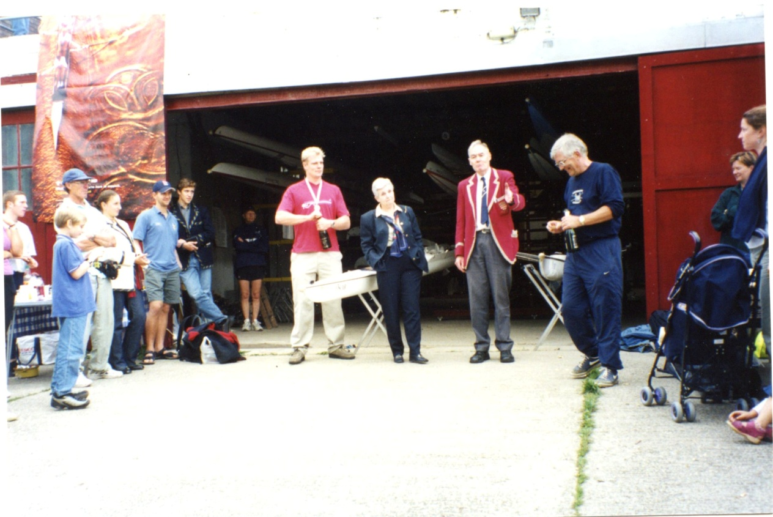
The President, Ken Drake, opening the launch of Project Oarsome. The four people in front of the open doors to Fitzwilliam College Boathouse are Rick Dunn, who had won a Gold Medal in GB's Coxless Four that year at the World Championships, Di Ellis, Ken Drake and Mike Arnold. Ron Davies is in the group on the left hand side.
The boats were named by the Chair of the ARA Executive Committee, Mrs Di Ellis, and two of the boats she named were a sculling boat, kept in Fitzwilliam Boathouse, called "Vivian", after my wife, and an eight called "Ken Drake". As a matter of fact in the 1960s I ran a Sea Scout Group at Bancroft's School and when I left they named a newly acquired gig "Ken Drake" so I am extremely lucky to have had two boats named after me and one after my wife.

Naming " The Ken Drake" on 2nd February 2002 or as the computer said it 02/02/2002.
During this time I was absolutely delighted to be asked by the women if I minded if they named their next new boat after me. I was naturally thrilled. It is a great honour and I was delighted to have the opportunity to officially name it and christen it with champagne .When we arrived for the ceremony I noted that the boat had my name clearly painted on the bow but in addition the definite article had been added to the front of it. So the boat is named "The Ken Drake". All colleges name their eights after people but I believe I am right in saying that the only other boat on the River Cam with the definite article was"The Ray Kelly" but even that has now been repainted and is now "Ray Kelly". That means I now have three boats with my name on them and a sculling boat called Vivian after my wife.
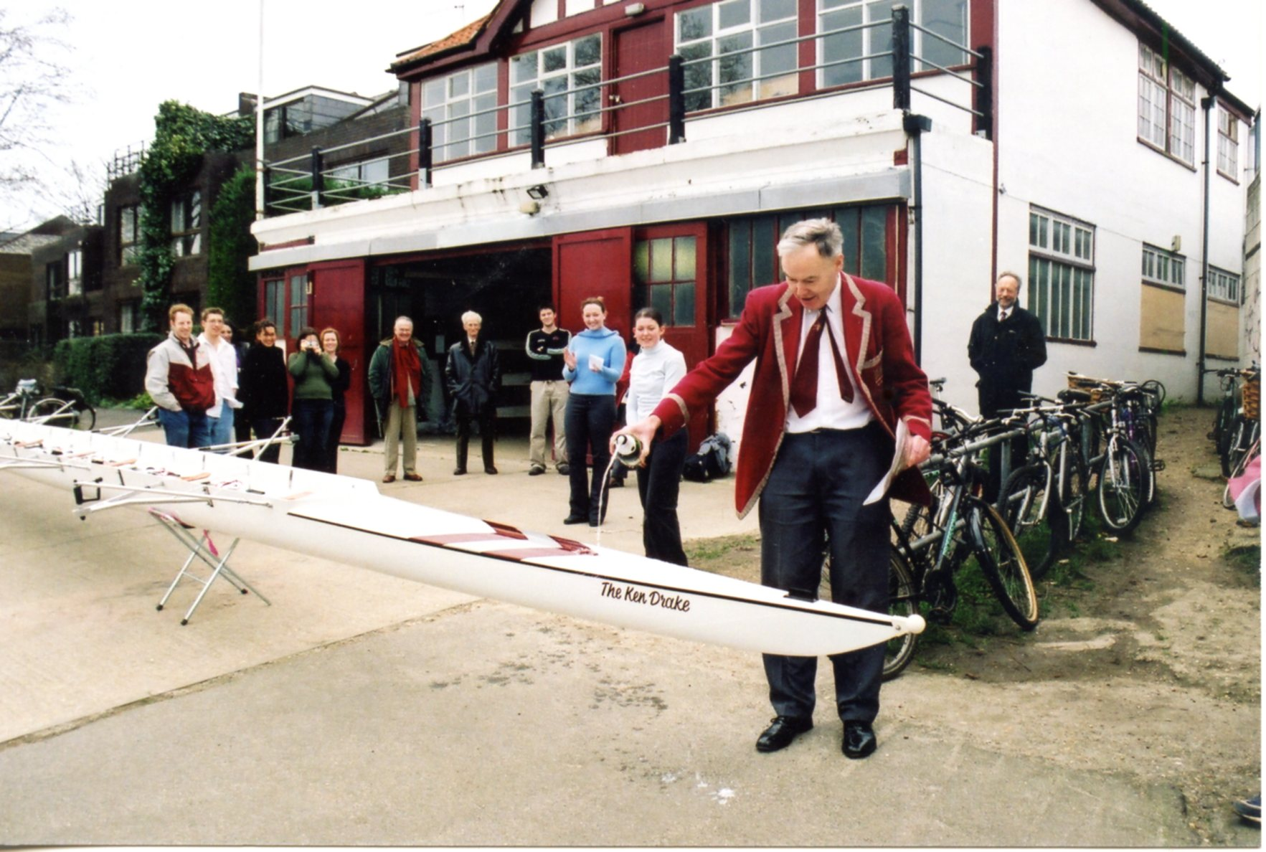
Ken performing the actual naming of the boat. Note Ray Kelly in the centre amongst the group.
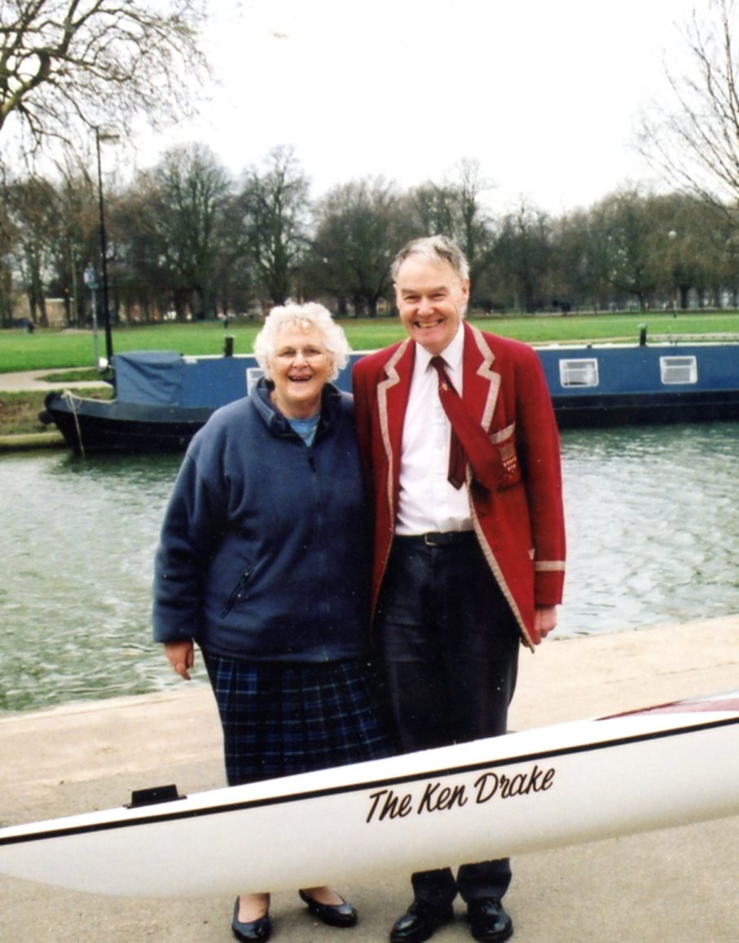
Vivian and Ken at the boat naming ceremony
Coaching and Pushing Out Fitzwilliam Crews from 1994
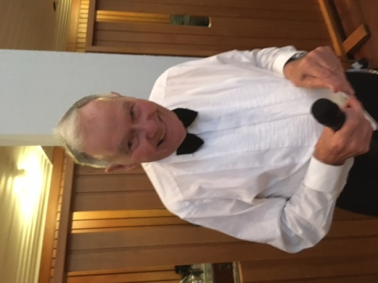
Having moved back to Cambridge in December 1993 I went down to watch the 1994 Lents, which was the first bumps rowing I had seen since I last rowed in them in 1957. It was also the 40th anniversary of me winning my first Billy oar. I linked up with the Fitzwilliam crews, introduced myself and so began the next phase of my rowing experience by coaching the 1st VIII for a number of years and joining the bank parties. George Chapman was the boatman and he refused to push out the women's crews so I volunteered to do it. I quickly became an expert at this rather unusual occupation. George retired soon after that and as his replacement had no experience of the bumps it was a wonderful opportunity for me to continue so I took over pushing out all the Fitzwilliam crews and I did this each year whatever the weather! New boatmen were appointed subsequently but whoever it was accepted that I would push out the crews. I was also pushing out the Cantabs crews in the Town Races in July where I pushed out a crew in each of the five divisions so my experience was growing all the time. Indeed I was privileged to be asked to push out the Cantabs 1st Men's VIII when they went Head of the River and retained that position for a number of years. For the next 20 years I made a point of being available for the bank parties of both clubs whatever the weather. I was sufficiently active that once I had pushed out the crew I would get on my cycle and pedal along opposite the bow of the crew so I could accurately blow whistles to indicate how close they were to the crew they were chasing and if they made a bump I would find the nearest willow tree (no other greenery should be used) pick nine pieces and give one to each member of the crew. In order to do this I needed an official pass and the Senior Treasurer kindly agreed to allow me to wear his badge authorising me to cycle with the crew during the races. As I got older I naturally found it more and more difficult to keep up with the better crews, especially the men's 1st VIII in the Long Reach where often there was a strong head wind. At the age of 85 I decided that the time had come to retire from pushing out Fitzwilliam crews from that year. The last crew I pushed out was the 1st Fitzwilliam women in which Ashton Brown, the C.U.W.B.C. President was rowing and they won their blades. What a way to finish. I have no idea how many crews I have pushed out but I must have pushed out in xcess of 800 times.

This is me announcing my retirement
at a Mays Bumps Dinner

My wife and I present a new flag to Fitzwilliam College Boat Club
In 2016 my wife and I celebrated our Diamond Wedding and one of the ways we celebrated this was by presenting to the Boat Club a new flag to be flown by crews winning their blades in the bumps and on other special occasions. We wanted a really special flag and Antony Moule, the Chief Coach and Boatman eventually found one. When I presented it at the Mays Dinner to Robert Machado, the incoming Captain of Boats, as I slowly unrolled it for everyone to see, that was also the first time I had seen it. The Boat Club gave a thunderous round of applause - they obviously appreciated it. Any crew winning their blades has the name of their crew engraved on a brass plate on this flag.
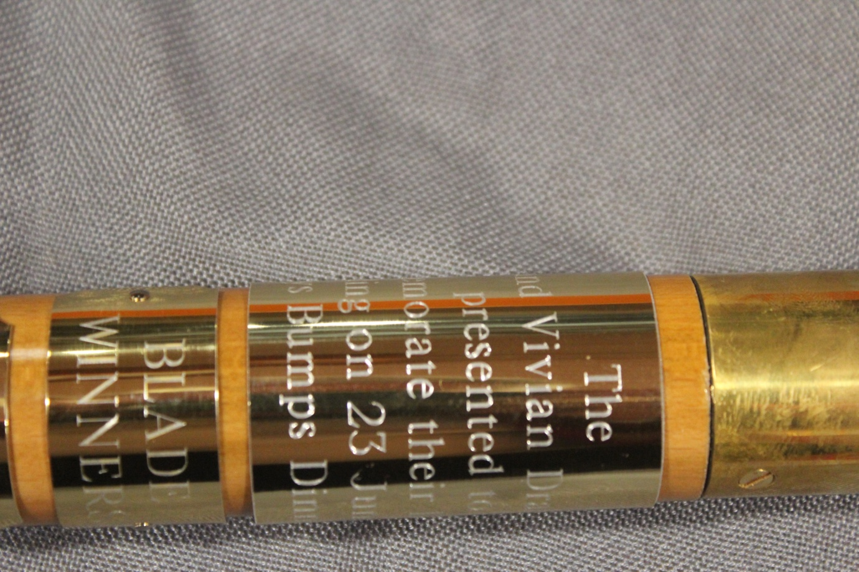
This picture shows some of the inscription - it is impossible to see it all from any single position.

The actual wording reads
The
Ken and Vivian Drake Flag
Presented to
Commemorate their Diamond
Wedding on 23rd June 2016
At Mays Bumps Dinner 2018
Below is a small plaque with the words BLADE WINNERS and below that another with the words 2017 Mays Women as the first winners of this trophy.
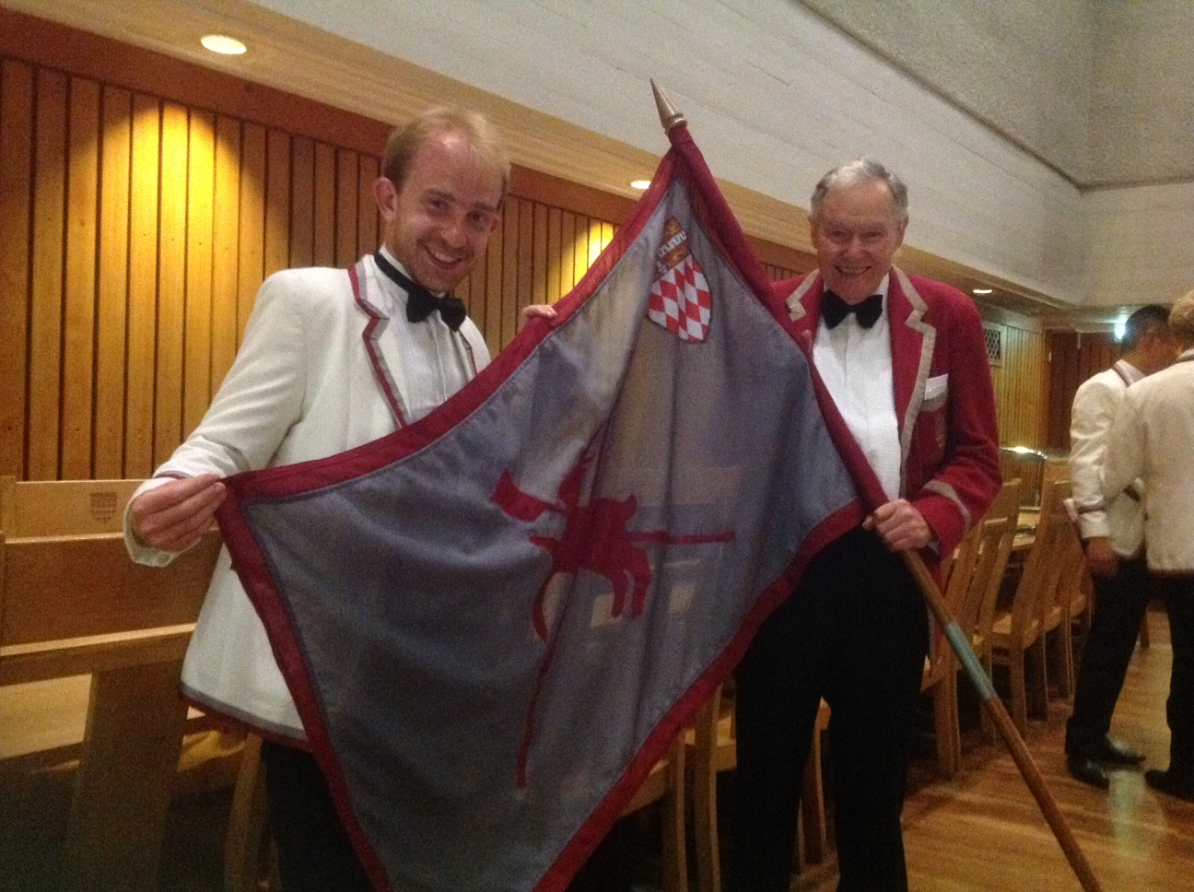
Ken presenting the new flag to Robert Machado, Captain of Boats Fitzwilliam College Boat Club
Thank you Luncheon for Vivian and Ken Drake organised by Nicky Padfield, Master,
and Ashton Brown (C.U.W.B.C. President)
Following the announcement of my retirement from pushing out Fitzwilliam crews Ashton Brown, who was President of CUWBC, discussed the situation with the Master and they decided the appropriate way to celebrate our contribution to Fitzwilliam rowing was to organise a special informal lunch for a small group of people associated with us and the Fitzwilliam College Boat Club.

Luncheon given by The Master and Ashton Brown to celebrate Ken's retirement from Pushing Out
Standing Alan Marron (Coach 1st Women's crews), Antony Moule (Chief Coach and Boatman)
Sitting or crouching Ken Drake, Vivian Drake, Sarah Winckless, The Master (Mrs Nicky Padfield), Mr Christopher Padfield, Ashton Brown, Prof James Elliott (Boat Club Senior Treasurer whose pass I had used to enable me to accompany crews on my cycle in the Lents and Mays) .Incidentally Sarah Winckless told me I was the first person to push her out. She went on to become President C.U.W.B.C. win a bronze medal in the 2004 Olympic Games at Athens and become World Champion Sculler in the GB womens Quad in 2005 and 2006.

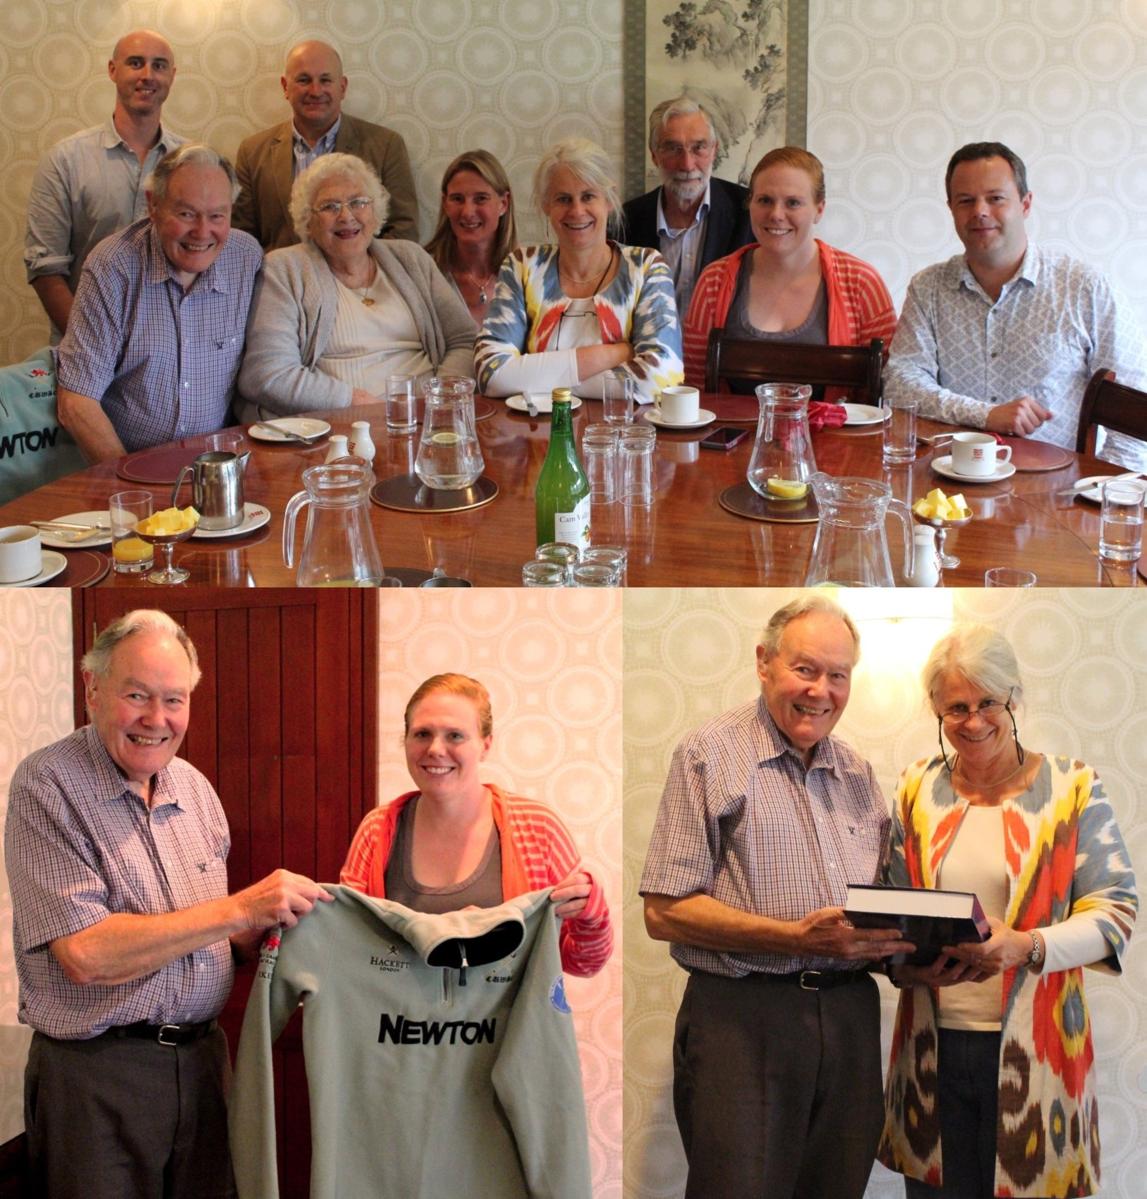
Ashton Brown, Cambridge University Women's Ken presenting to the Master, his book
Boat Club President, presenting to me the fleece "History of Cantabrigian Rowing Club
she wore when she took part in the spinning of the 1950-2010" for the Fitzwilliam Library.
coin to decide on which side of the river the crews This was where my rowing career
would race in the Women's Boat Race on the Thames. started.

All the information in these many documents was produced with a view to making it available to both the Fitzwilliam College Boat Club and the Billygoats. It has been a project which has been on the go for thirty years and it is hoped that it will answer many of the sorts of questions I was asked during my time as the Fitzwilliam College Boat Club pusher out. It is very much hoped that someone associated with each of these bodies will accept the responsibility for keeping the information up to date. For this purpose it is important that each receive a copy of the menu card for all subsequent Boat Cub Dinners.
Sadly my wife Vivian for over 66 years died on 24th July 2022. Without her support none of these records could have been produced.
Ken Drake
2022

