Record Breaking Fitzwilliam 1979 4th May Crew "The Elite VIII" which went up 11 places
I am grateful to Nick Tittle and John Wells who contributed a great deal to this story of this exceptional crew which is the second record breaking Fitzwilliam crew. The men rowing in this boat were of a much higher quality than is usually found in the 4th VIII. The reason was that despite their considerable experience they did not wish to commit themselves to the serious training and the time expected of those who row in the higher boats which several of them had done previously. Many of them were in their third year and wished to row in their final term. John Wells, for example, had rowed in the 2nd VIII in his first year but decided to work rather harder in his second year, 1978-9, to improve on his scraped third the previous year. The following year he rowed in the 1st VIII and at Henley.
This spreadsheet shows the experiences of the 9 people involved which confirms that it was no ordinary 4th VIII.
Name | DJ | DK | DL | DM | DN | DO | DP | DQ | DR | DS | DT | DU | DV | DW | DX | DY
Year/Term> | 77 M | 77 F 4s | 77 F | 78 L | 78 M | 78 F 4 | 78 F | 79 L | 79 M | 79 F 4s | 79 F | 80 L | 80 M | 80 F 4s | 80 F | 81 L
N R Tittle | 5/2 |  |  | 2/6 | 3/7 | Cl/2 | 1st Sq. |  | 4/1
M W Châlons-Browne | 5/6 |  |  | 4/4 |  |  |  | 3/4 | 4/2
P J Duquemin | 5/5 |  | 2/3 | 4/7 |  |  |  | 3/3 | 4/3
G D T Price | 5/8 |  |  |  | 4/6 |  |  | 3/2 | 4/4
T E Ladbrooke |  |  |  |  | 7/4 |  |  | 3/1 | 4/5
J H E Wells |  |  |  | 2/4 | 2/4 | L/2 |  | 3/6 | 4/6 | S/2 | 1/8 |  | 1/2
J J Leary | 5/3 |  |  | 2/5 | 3/3 |  |  | 3/5 | 4/7
A V Cooke | 3/7 |  | 2/8 | 4/8 | 3/2 |  |  | 3/8 | 4/8 | S/4 |  | 2/8 | 2/8 | C/4 | 2/8 | 2/8
J G Thorpe-Beeston |  |  |  |  |  |  |  | 3/9 | 4/9 |  |  |  |  | SB4/5 | 1/9 | 1/9
The columns headed DJ, DK etc to DY represent the headings used in the Fitzwilliam House/College Boat Club Database produced by Ken Drake which is part of these documents available via the Billygoats or Boat Club websites.
The second line of headings start with the year, followed by L = Lents, M = Mays, F = Fairbairn and F 4s = Fours crews in Fairbairn term.
The symbols in the columns opposite the names indicate the crew and the position in that crew e.g. 4/5 means 4th crew seat 5
Of the 1979 May 4th VIII, Nick Tittle had been in the 1st squad, Arthur Cooke, Pete Duquemin, Jerry Leary and John Wells and had all rowed in the 2nd boat. It is obvious from this that the crew were much too good to be a 4th crew as they had a great deal of experience.
Virtually all of this 4th May crew rowed together in the 1979 Lents as Fitzwilliam's 3rd crew which included Tim Ladbrooke (bow), Graham Price (2), Peter Duquemin (3), Martin Chālons-Browne (4), Jerry J Leary (5), John Wells (6), Pete Hale (7), Arthur Cooke (Stroke) and J Guy Thorpe-Beeston (cox). The crew was coached by Nick Tittle. In the Lents that crew rowed over twice and bumped Caius 3 and King's 2 thereby moving up two places.
Arthur Cooke was very much the leader of this crew. He was somewhat older than his crew as he was on a Ph.D. course. Arthur called his crew "The Elite VIII" and this name was also printed in the official C.U.C.B.C. Mays programme before the Mays actually started. The results in the Mays at the end of that term do suggest that Arthur's crew was an extremely good 4th VIII. John says that the naming the crew as "The Elite VIII" was very much a tongue-in-cheek decision and the crew was in fact nowhere near as good as the 1st VIII.
Nick Tittle matriculated in 1976, learning to row in his first term, and going on to win the Clare Novices that term. He rowed in the 1st crew in the Fairbairn Race in 1978 but decided not to row in the Lent Term and coached Arthur’s crew. When a seat became vacant in that crew for the May’s Arthur invited Nick to sit in at bow. He had some hesitation in accepting that particular position in the boat, as he explained to me that if your boat is making a bump the bow of the bumping boat is the nearest person to the crew being chased and if an accident did occur bow was the most likely to be injured. The same is equally true for the cox of the boat being bumped! So now Nick was a member of this 4th Mays Fitzwilliam crew and who could Arthur ask to take over the job of coaching it?
He turned to perhaps the most experienced oarsman in Fitzwilliam at the time, Ali Jelfs. Ali was an outstanding oarsman who had rowed in two Oxford and Cambridge Boat Races and had had the indignity of being in the Cambridge boat that sunk. He was rowing at 7 and was easily recognised by his headband and he was wearing glasses. He was a close friend of John Wells as they were metallurgy tutorial partners.
During the actual bumps Arthur invited the crew to his home off Victoria Road to a cooked meal before they assembled at the boat house which obviously helped form an even greater unity in the crew.
On the first day they got their first bump easily as Caius 4 quickly acknowledged the bump.
The boat this crew was using for the Mays was being shared with Fitzwilliam 2nd VIII crew. After the 4th VIII's bump on day 1 on Caius 4 the 2nd VIII were bumped by Lady Margaret 4 and subsequently ran into the bank. This badly damaged our boat which had a foot of its bow knocked off. There does not appear to have been a professional boatman capable of making the necessary repair so Arthur's crew took it upon themselves to repair the boat that night. John continues "There was drama overnight as one of the other crews using our old clinker built wooden eight ran it into the bank and it needed emergency repairs and it wasn’t clear until a couple of hours before the start of our race that we had a boat to row in for the second day. (Could they have borrowed a boat if necessary?)
On day 2 in their first race as the third of the three guns fired to indicate the beginning of their race disaster struck as Arthur, stroke, came off his seat. So for about ten strokes John Wells was setting the pace from 6. John says that “as a result by the time Arthur was rowing again the four boats in front had bumped out leaving us to chase Cats VI who were top of the division. We got them just in time and so had to row again at the bottom of the next division 45 minutes later. Once again the two boats in front bumped out but then we found our rhythm and caught Jesus V". What they did not know was this Jesus crew had literally overlapped L.M.B.C. 8 at Ditton Corner but Fitzwilliam IV eventually caught Jesus V at the Railings to record their overbump. One wonders if Arthur had not come off his seat at the start of that first race they might have made a single bump and would not then have created this phenomenal record!
So Fitzwilliam 4th May VIII in 1979 had made a considerable impression. They had made a double overbump in their first race on the second day of these races. That had put them into the position of sandwich boat and from there they made an overbump on Jesus to go up 8 places in one day. This is a very rare achievement.
John says that "The elation was very special and I was full of it that evening."
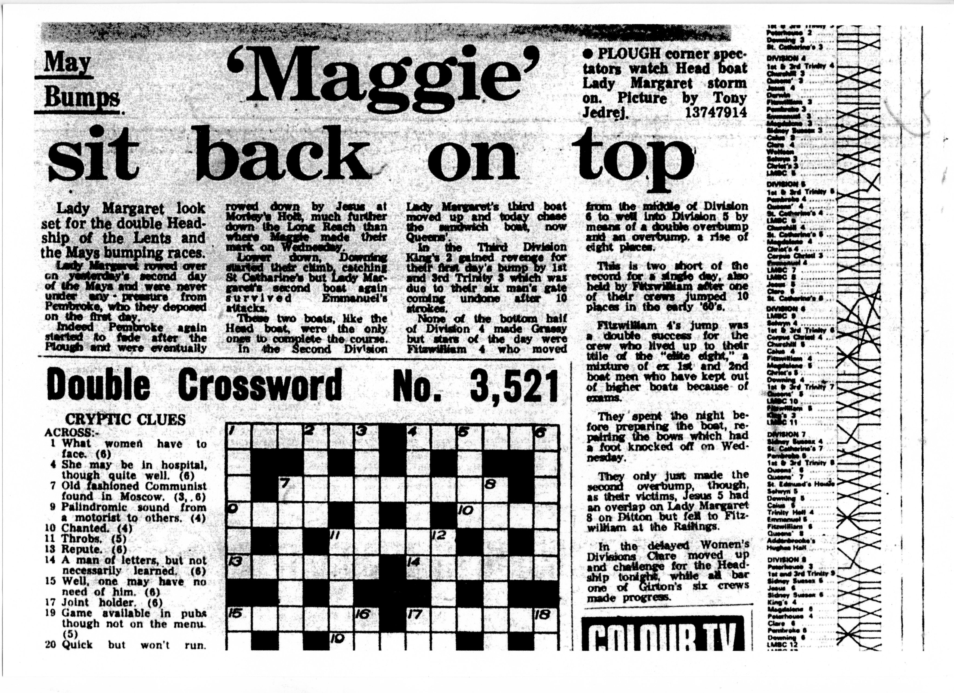
"The last two days were routine and so we completed our haul for our oar, bumping Lady Margaret 8 and Corpus Christi 3.
In the cox’s seat was Guy Thorpe-Beeston who as a medic later helped deliver either Prince William or Harry."
John admits that there was also a huge amount of luck involved.
The Cambridge Evening News reporting on the second day's racing in the Mays that year describes the Fitzwilliam 4th VIII as a star crew. This is the actual report.
The bumps chart on the right indicates that this crew bumped Caius 4 on the first night going up one place and on the second night they went up a lot of places, actually eight.

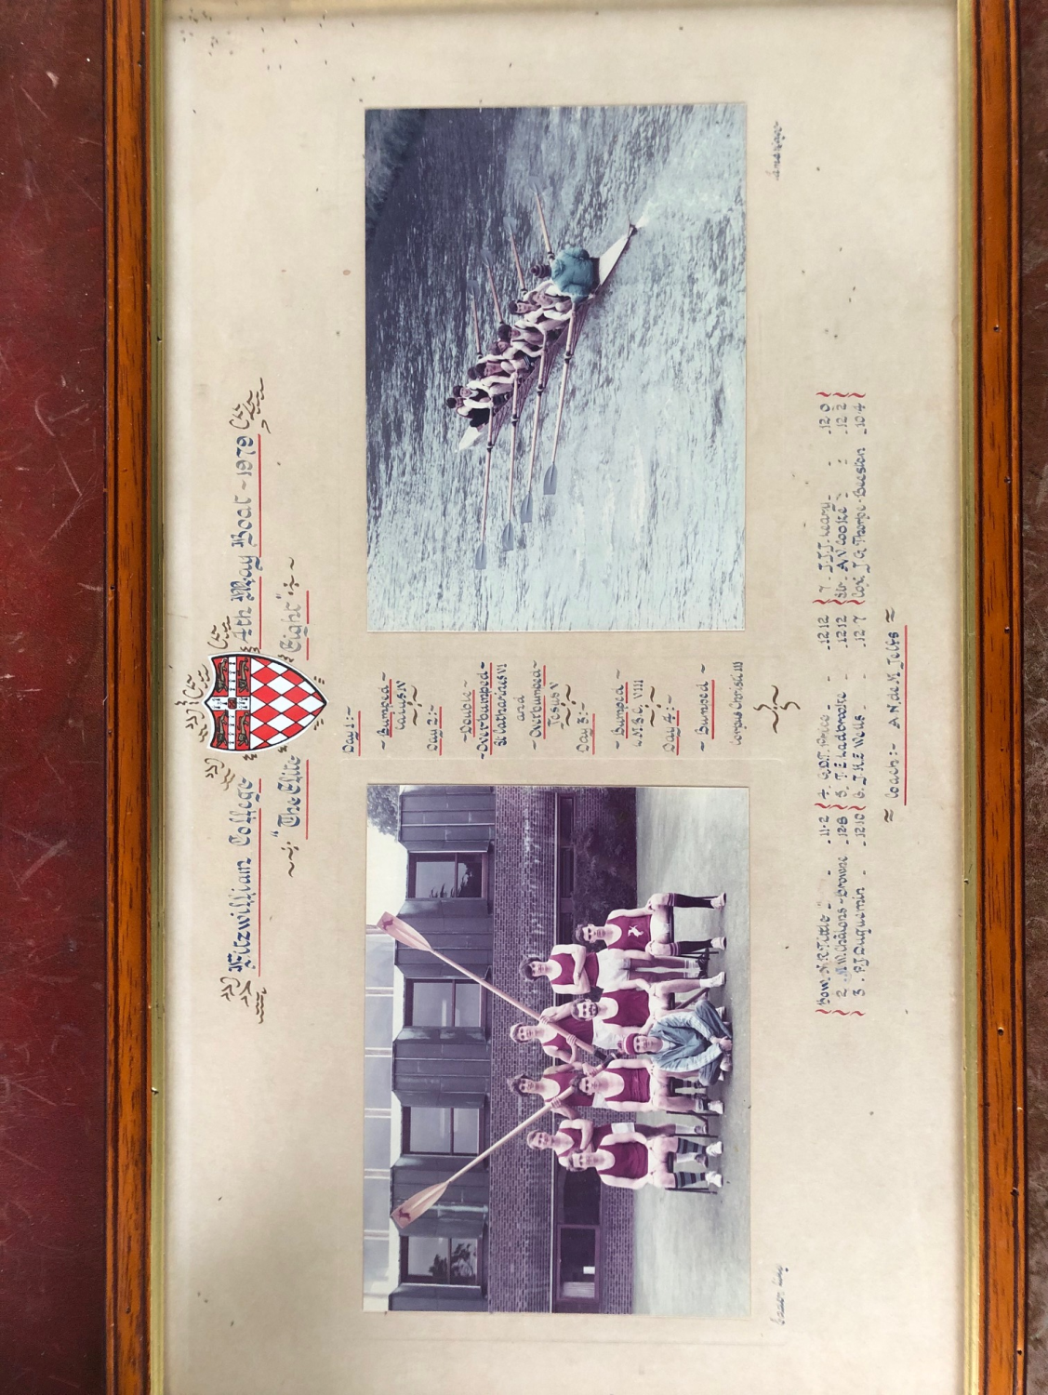
The traditional double photograph showing the crew as a group and in action.
Down the central panel between the two photographs we read of the crew's progress day by day through the May Races.
Day 1 Bumped Caius IV
Day 2 Double overbumped St Catharine's VI and overbumped Jesus V
Day 3 Bumped LMBC VIII
Day 4 Bumped Corpus III
The crews that were overtaken by the double overbump and overbump are not mentioned.

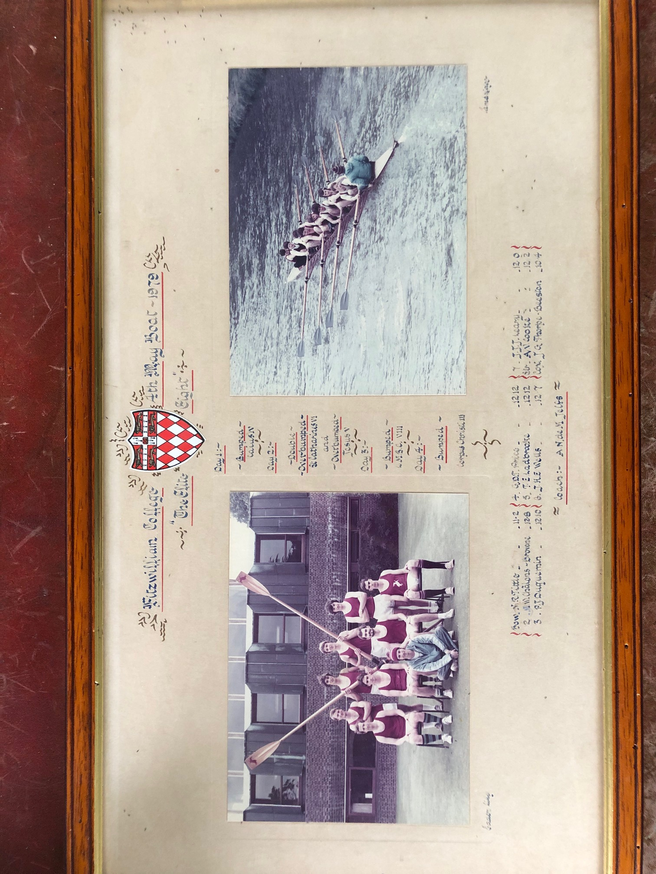
The Group Photograph

Back row left to right Arthur Cooke, John Wells, Tim Ladbrooke and Jerry Leary
Front row left to right Martin Châlons-Browne, Graham Price, Pete Duquemin and Nick Tittle
Sitting on cushion Guy Thorpe-Beeston

Bow N R Tittle 11.4
2 M W Châlons-Browne 12.8
3 P J Duquemin 12.9
4 G D T Price 12.12
5 T E Ladbrooke 12.12
6 J H E Wells 12.7
7 J J J Leary 12.0
Stroke A V Cooke 12.3
Cox J G Thorpe-Beeston 10.4

The crew are dressed in their rowing kit whereas in the majority of these group photographs the crew are dressed in their blazers and grey or white flannels. They usually include the coach or coaches but Ali Jelfs is missing from this photograph. The oars suggest the photograph was taken after they had won them and they are held in front of John and Tim rather than behind. The photograph was taken at Fitzwilliam College.

Fitzwilliam 4th men's Mays VIII in action
Fitzwilliam 4th men's Mays VIII in action
The Cambridge Evening News reporting on this extraordinary crew's performance said "None of the bottom half of Division 4 made Grassy but stars of the day were Fitzwilliam 4 who moved from the middle of division 6 to well into division 5 by means of a double overbump and an overbump, a rise of eight places.
This is two short of the record for a single day, also held by Fitzwilliam after one of their crews jumped 10 places in the early '60's.
Fitzwilliam 4's jump was a double success for the crew who lived up to their title of the "elite eight", a mixture of 1st and 2nd boat men who have kept out of higher boats because of exams.
They spent the night before preparing the boat, repairing the bow which had a foot knocked off on Wednesday .
They only just made the second overbump though, as their victims, Jesus 5 had an overlap on Lady Margaret 8 at Ditton but fell to Fitzwilliam at the Railings."

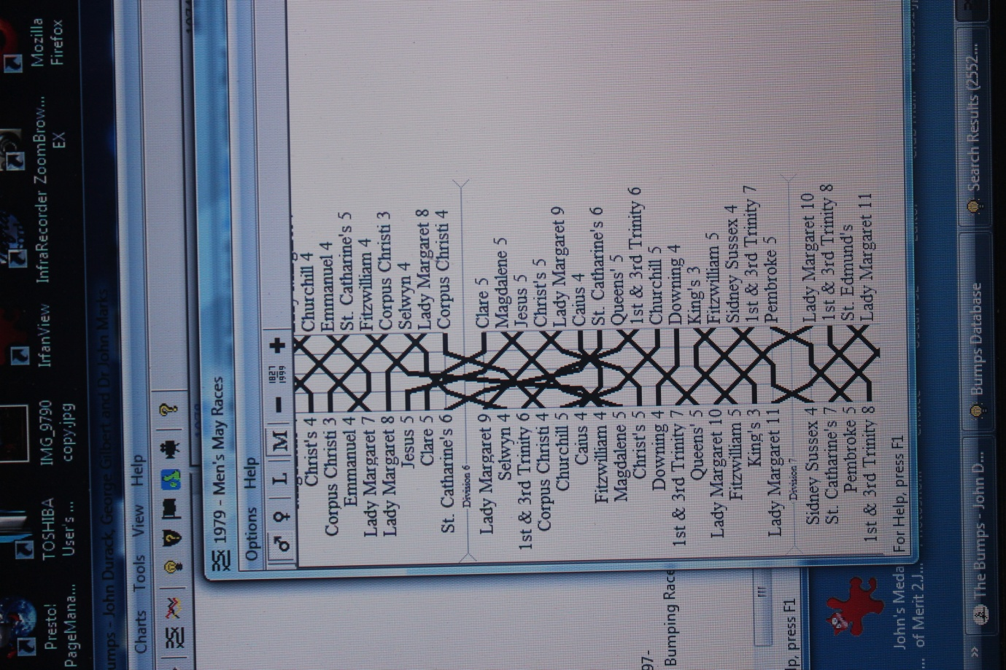
This chart is taken from the book entitled "The Bumps" and shows the progress or otherwise of all the crews. Fitzwilliam 4th May crew made a bump on Caius 4 on the first day. What happened on Day 2 is difficult to decode from this chart although it is obvious they did very well and moved up a lot of places, in fact they moved up 8. To make it clearer what they did on the second day I have produced two simple charts to illustrate what happened in their first race and in their second race on the Thursday.

In their first race on Thursday, Day 2 of the Mays, Fitzwilliam IV double overbumped St. Catharine's 6.
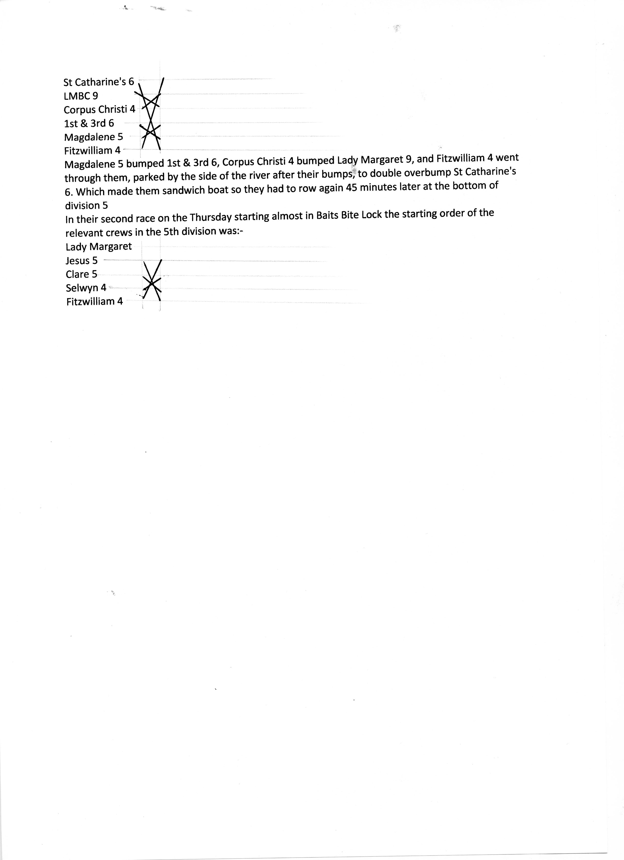
As the diagram shows Selwyn 4 bumped Clare 5 and Fitzwilliam 4 went on to overbump Jesus 5 who during this race had actually overlapped Lady Margaret 8 at Ditton Corner. Fitzwilliam 4 caught them at the Railings in the Long Reach. They moved up 5 places in their first race on Thursday and a further 3 in their second making a total of going up 8 places in one day. Their bumps on Wednesday, Friday and Saturday meant that in all they went up 11 places in the 1979 Mays, which at the time was a record in the Mays.

Both contributors to this article have sent me photograph of their oars. This is Nick's oar
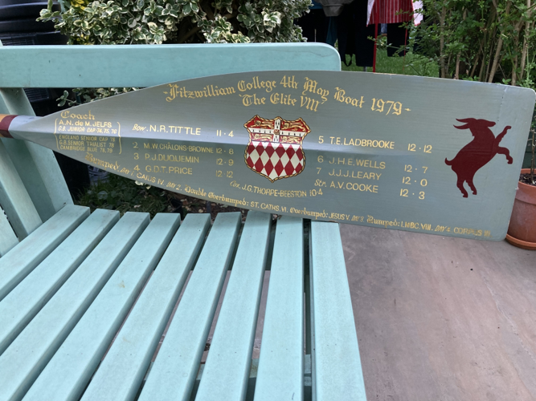
and this is John's oar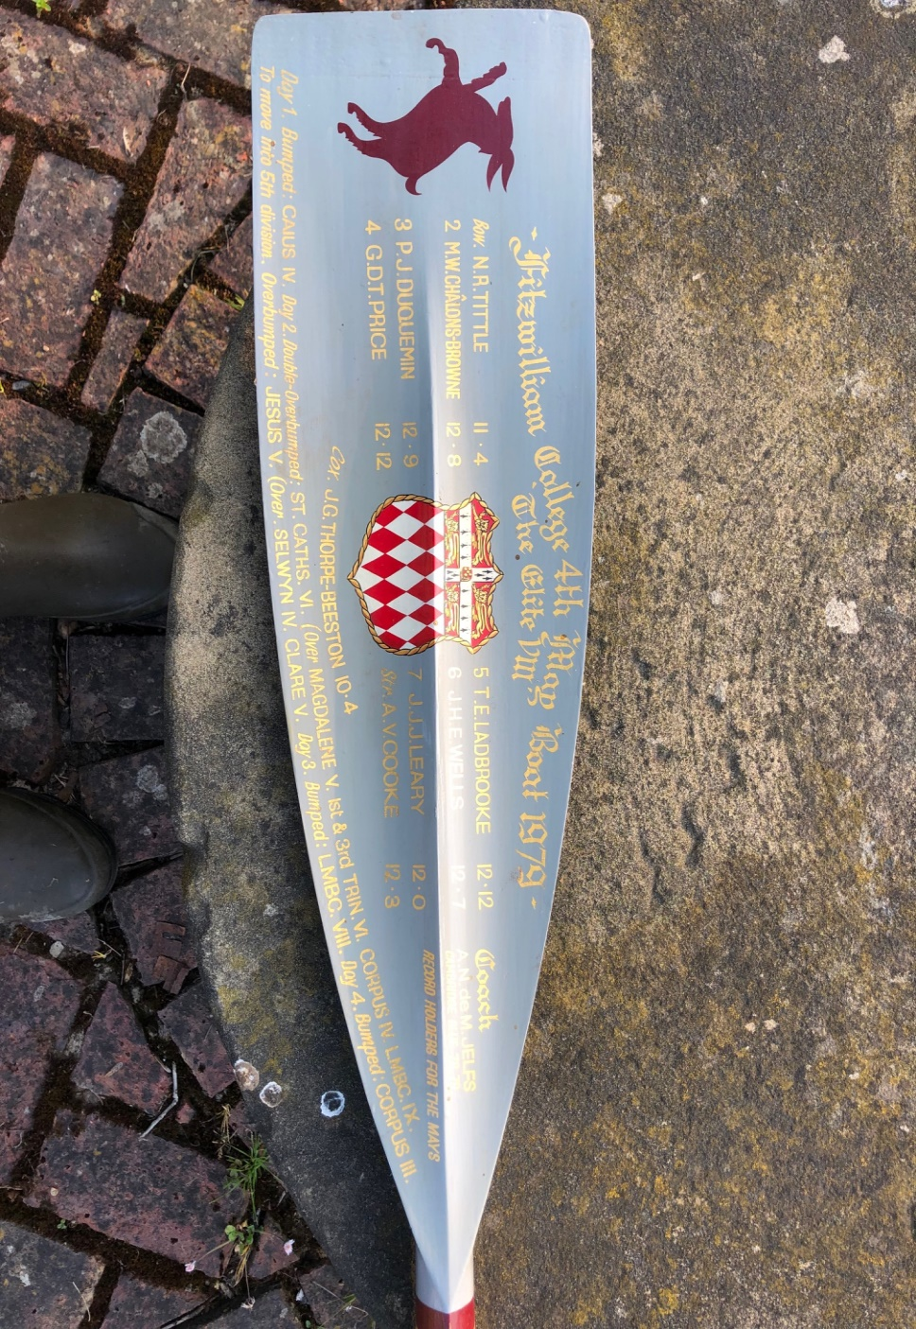
There are some very obvious differences between them. The sign writing for Nick's was done at Suttons Oars who used to be on Putney Embankment and John's was done at Cambridge.
(2) The first most obvious difference is that they are facing in different directions and this is because John rowed on stroke side whereas Nick rowed on bow side. In both cases the Billygoat is at the far end of the oar and is facing away from the loom.
John's oar also mentions the days, which is unusual but I can understand why they did it. There is no mention of days on Nick's oar.
John's oar mentions all the crews that were bumped or overtaken as a result of the double overbump and the overbump which are missing on the double photograph and on Nick's oar. The crew names on both oars use Roman numerals but these are not used in the Cambridge Evening News nor in the Bumps Chart from the book entitled "The Bumps".
Both oars name the crew as Fitzwilliam 4th Mays "The Elite Eight", list the crew and their weights and both have the Fitzwilliam College crest.
Both oars name the coach A. N. De M. Jelfs but underneath his name the two oars have different statements.
On Nick's oar it says On John's oar it says
GB Junior Cap 74 75 76
England Senior Cap 78
GB Senior Triallist 78
Cambridge Blue 78 79 Cambridge Blue 78 79

The main difference between the oars is that John's gives the details of all the races they rowed starting on Day 1 bumping Jesus IV, Day 2 double overbumped St. Catherine's VI (over Magdalene 5, 1st & 3rd VI, Corpus IV and L.M.B.C. IX) then moved up to 5th division and overbumped Jesus V (over Selwyn IV and Clare V), Day 3 bumped L.M.B.C.VIII, Day 4 bumped Corpus IV whereas Nick's only has the crews actually bumped, overbumped and double overbumped named on it, as on the double photograph.

Where "The Bumps" book got it wrong!!
The book called "The Bumps" by John Durack, George Gilbert and John Marks is an incredible book about the Lents and Mays up to 1999 when the book was published. It is advertised in all the Lents and Mays programmes, partly I suspect because George Gilbert was the editor of these programmes. It has on the accompanying CD ROM excellent bumps charts for each year of the Lent and Mays until 1999, names of those in the Head of the River crews named on an oar of their college boat club colours, lists of crews making the maximum progress in the bumps which also include the earlier races before the Lents and the Mays were introduced and numerous other things. I have been using it regularly since I bought my copy in 2000 and had never previously come across an error in it. However the achievements of this particular crew are not recorded correctly.
We read:-"The startling progress of Fitzwilliam 4 in division VI ought to be noted. On the first day they had overbumped Churchill 5. On the second day they first of all double overbumped St Catharine's 6 to become sandwich boat in Division V. In the Division IV race they pulled off an even more surprising coup. The boats in front having bumped out they were after Jesus 5. Jesus 5 were right up on Lady Margaret 8 and overlapped at Ditton. But Fitzwilliam 4 came up and overbumped Jesus 5 at the railings, while Lady Margaret 8 escaped."
However, on the first day they bumped Caius 4 and did not overbump Churchill 5. The remainder of what they say about this crew is correct.

The Fitzwilliam Journal said:-
"But the achievement of the Fourth Boat was unique both in the Boat Club and in the University. It went up eleven places, including a triple overbump and an overbump.
There have been a number of individual achievements. A. N. de M. Jelfs gained his second blue and was secretary to the C.U.B.C. and in Michaelmas Term won the Colquhon Sculls and Head of the Cam Sculls. B. W. K. Booth was a member of the winning Lightweight crew against Oxford, and was re-awarded his Colours. R. W. M. Beevor won the Clinker Division of the 1st and 3rd Trinity Sculls."
It was interesting that it did refer to the coach's rowing successes, although the spelling of Colquhon should be Colquhoun, as well as the Captain Roly Beevor's success.
However, in actual fact the Mays 4th VIII made a double overbump and an overbump on one day, not the triple as the Journal report stated.
It was not unique in the Boat Club as the Fitzwilliam 3rd Lent crew of 1962 did even better actually making an overbump and then on the same day the very first triple overbump ever made in the Lents or Mays.
The 3rd Lent 1962 crew made three University records:-
(a) the first crew ever to make a triple overbump
(b) the first crew to go up 10 places in one day in the Lents or Mays
(c) the first crew to go up 13 places in the Lents or Mays
These University records were made in 1962 and now in 2022, 60 years later these records still stand. A separate article about this record breaking crew appears with this series of documents.
However, what the 1979 4th May crew achieved was the outstanding performance of all crews in the Mays up to that time and it was not until 2018 that 4th Magdalene Mays crew made what was thought at the time to be the very first quadruple overbump in the Lents or Mays. This meant Magdalene went up 9 places in one day, one less that the 1962 Fitzwilliam 3rd Lent crew had done but one more than the 1979 Fitzwilliam 4th May crew had done. The Magdalene crew made a further two bumps thus rising 11 places which equals the achievement of the Fitzwilliam 4th 1979 May crew and was a University record and over 40 years later it still is. However, the Fitzwilliam 4th 1979 Mays VIII did make a bump every day thereby qualifying for their oars whereas Magdalene rowed over one day so they may not have qualified for their oars if Magdalene follows the example of most colleges, including Fitzwilliam, which now insist that crews must make a bump each time they row chasing another crew to qualify for oars, or blades as they call them now. So the Fitzwilliam 1979 4th VIII achieved the following University records:-
(a) First crew to go up 11 places in the Mays now equalled by Magdalene 4th in 2018
(b) First crew to go up 8 places in one day in the Mays until overtaken by Magdalene
But let us return briefly to the first crew to actually make the very first quadruple overbump which was Peterhouse Women's 1st VIII in the 1986 Mays who went up 9 places in that one day. Quite how all the experts forgot this event is unknown but it was not recorded in the text of "The Bumps", another rather serous omission, although it is obvious from the chart for those races. Sadly for this Peterhouse crew on the other three days they rowed over once and were bumped twice so overall they only went up 7 places!
Sadly Arthur Cooke died prematurely in 2015. This is the obituary that was published in the Fitzwilliam Journal.
ARTHUR VICARS COOKE (1975)
Arthur Cooke was born on 22 February 1956 in Tel Aviv, and was educated at the Judd School, Tonbridge. He came to Fitzwilliam in 1975 to read Natural Sciences. After obtaining a First in 1978 he went on to do research in Metallurgy and Materials Science, securing a PhD in 1985. He went to the USA to work in Signal Technology in Maryland, and became President of the firm he founded in 1995, Active Signal Technologies. He was an active outdoors person, enjoying mountain climbing, cycling, running and rowing and serving as President of the Baltimore Rowing Club for five years. He was 'much admired by friends and colleagues for his vitality, generosity, loyalty, precision and irrepressible humour, according to his family. He died on 27 July 2015.

Ken Drake 2022

