Record-Breaking 1962 Fitzwilliam 3rd Lent Crew - a composite article - Part 2
[The letter finishes with an invitation to the Bumps supper - elegantly declined! - and thanks for the interest.] David Knowles Vice Captain [Transcribed in 2020 from the handwritten draft]
Michael Bucher continues "The average weight of the crew was 11 stone (70 kilos). I don’t think any of us had ever seen or experienced a bumps race and we had no idea what was going on or what to expect. That year there were 5 divisions and Fitzwilliam House III was 4th in the 5th division. Churchill’s 1st VIII were 6 places lower down from us as it was their first year of the bumps, they went up 4 places, Churchill were just above C.U.W.B.C. who went down 4 places during the 4 days."

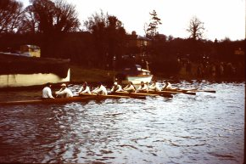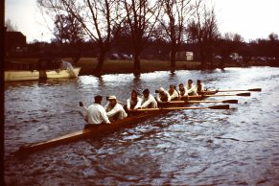
We bumped Caius III, Peterhouse III and Lady Margaret V over the next 3 days ending halfway up division IV for a total 13 places gained.
Here is the Boat Club Secretary’s entry in the Boat Club Book for Lent 1962.
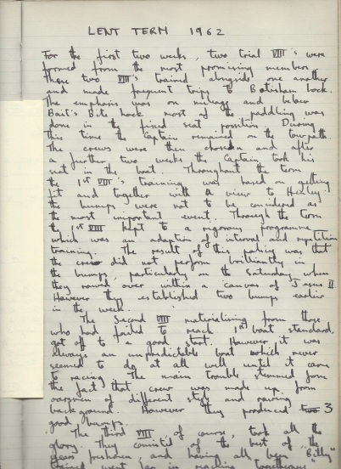
Report from the Boat Club Book where the Boat Club Secretaries reported on the progress or otherwise of the crews during the term. Reporting on this 3rd Lents 1962 crew the book records that "The third VIII of course, took all the gory. They consisted of the best of the year's freshers and having all begun "Billy" in Michaelmas 1961.
The next page continues:- A long full stroke at a moderate rating. It is worth here noting a trend in Fitzwilliam coaching, more length in the water and a tendency to lie back at the finish seem to be creeping in. It was the crew's ability to keep their blades covered consistently which gave them the ability to row down the treble overbump. Full marks to them: thirteen bumps is an all time record.

The full page names all the crews and indicates their results in these races
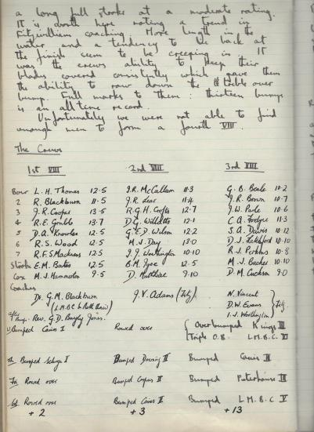
The outstanding success of this crew not unnaturally produced a considerable number of comments from the National Press in addition to the Fitzwilliam Censor's Letter and the report from the Fitzwilliam Amalgamated Clubs and the Cambridge Daily News. I am very grateful to Chris Fordyce who kindly provided them and other records for me.

This is how it was reported in the Daily Telegraph
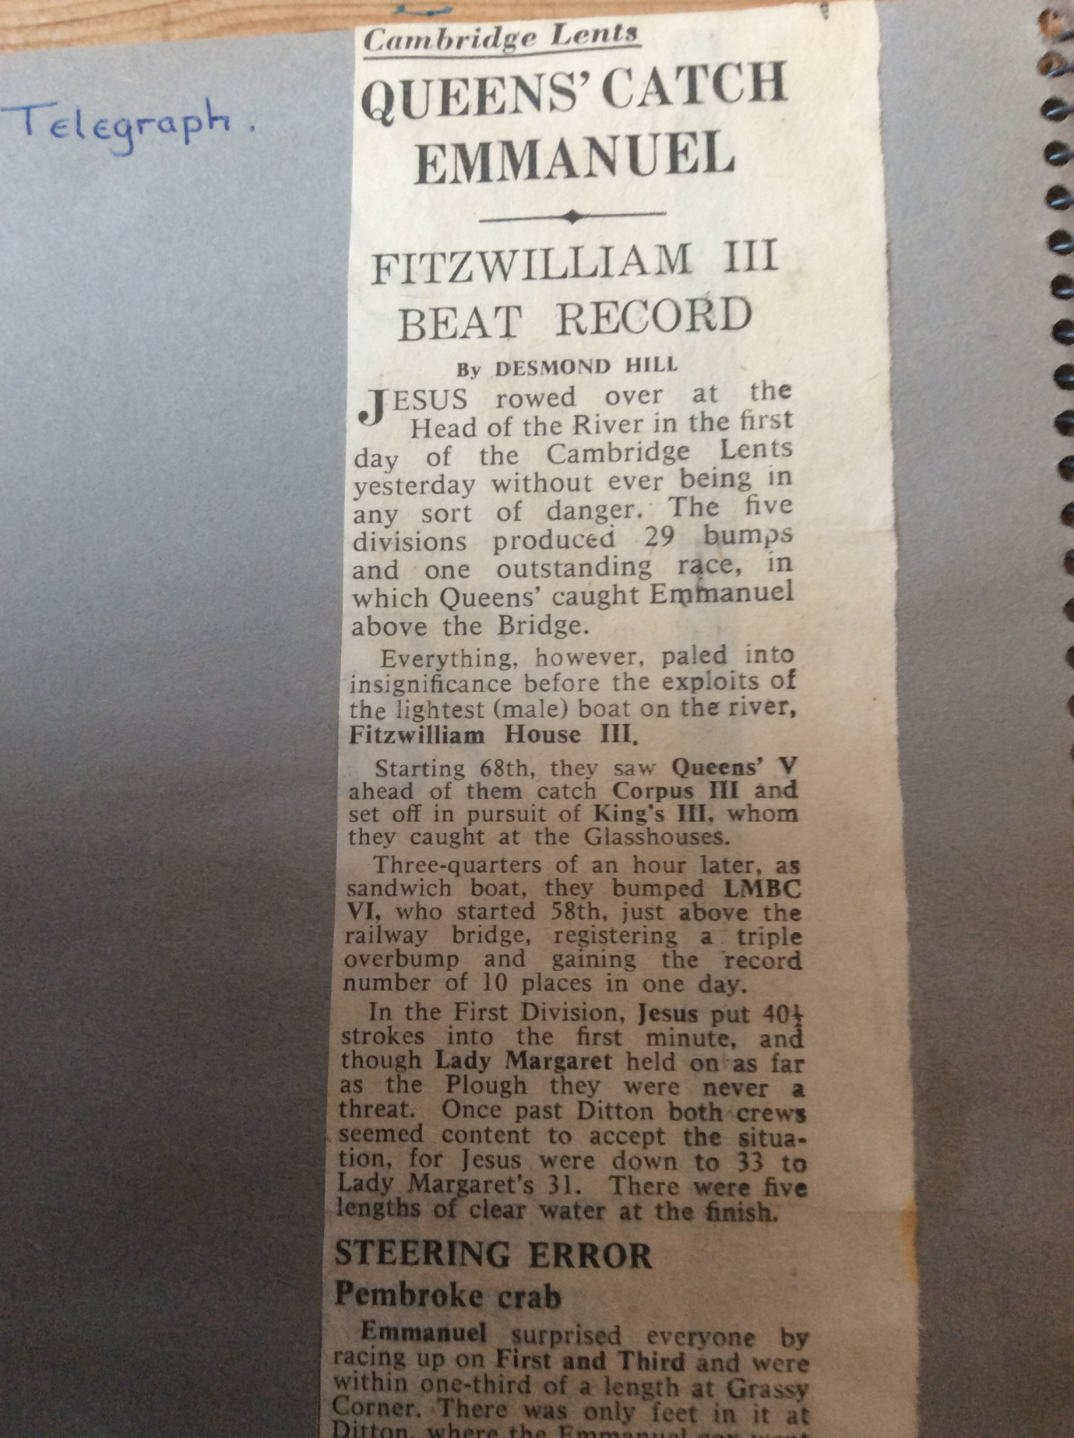

The Guardian Report
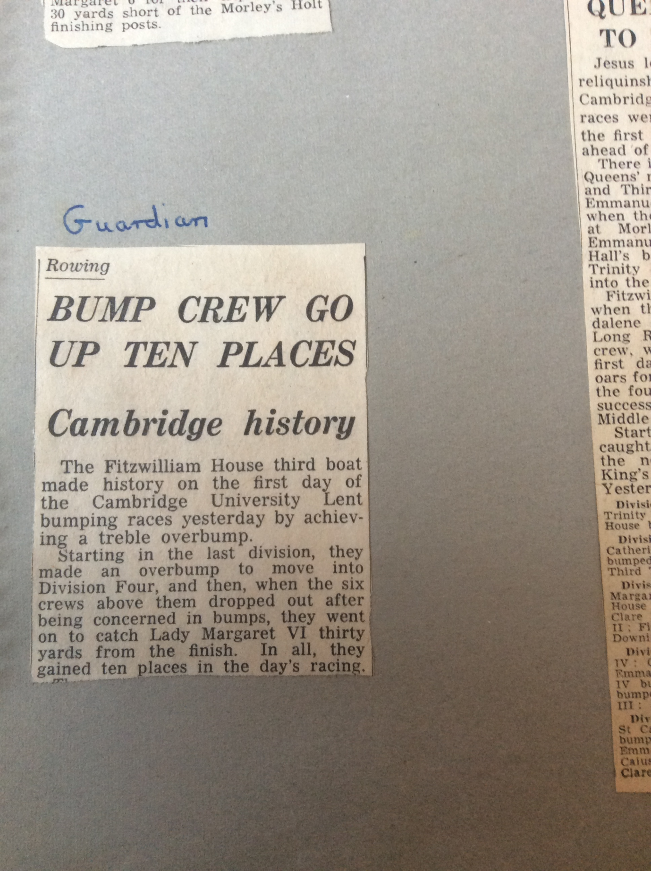

Cambridge Daily News
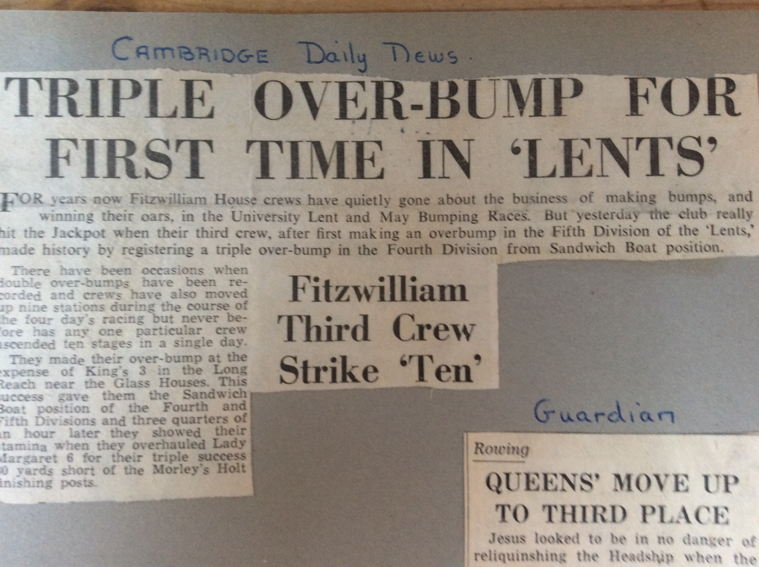

The Times
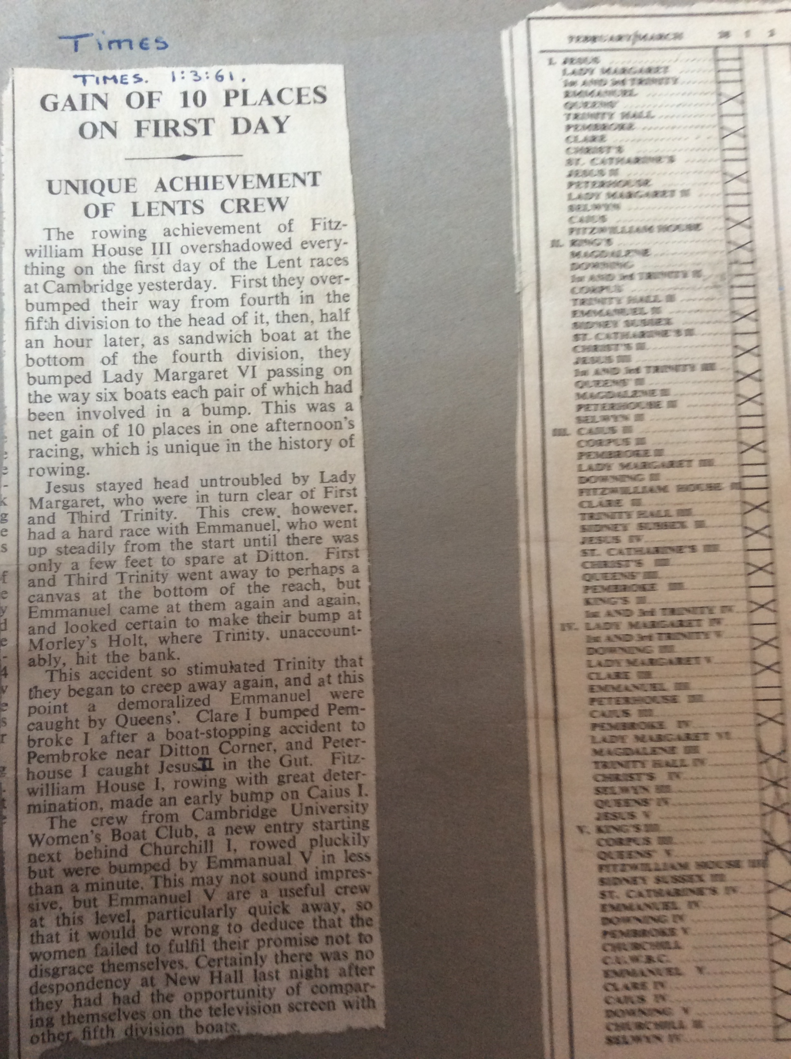

Fitzwilliam Amalgamated Clubs 1961-62 quoting The Times

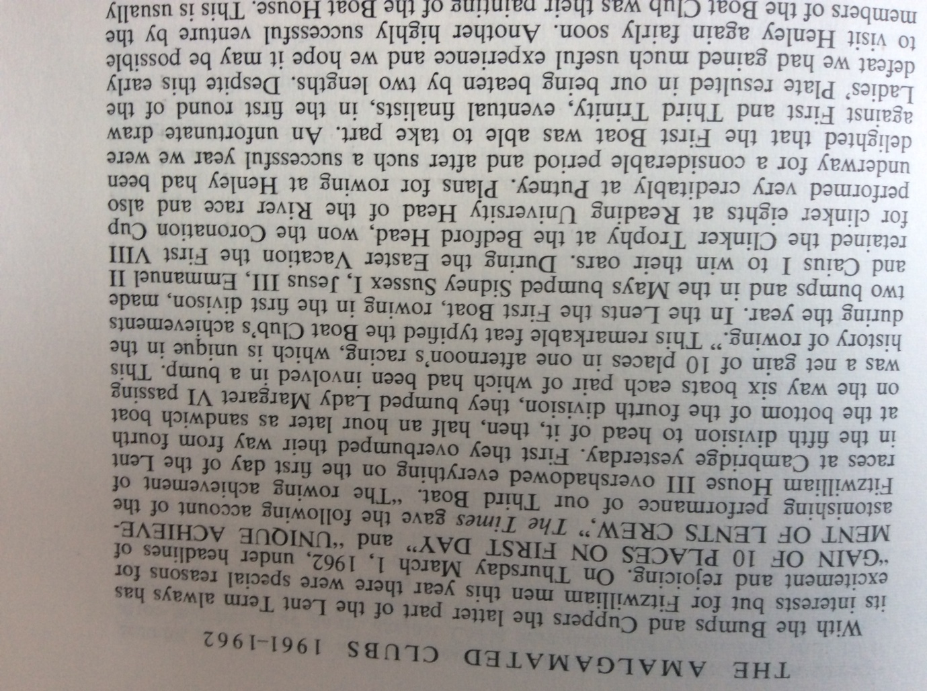

The Censor's Letter
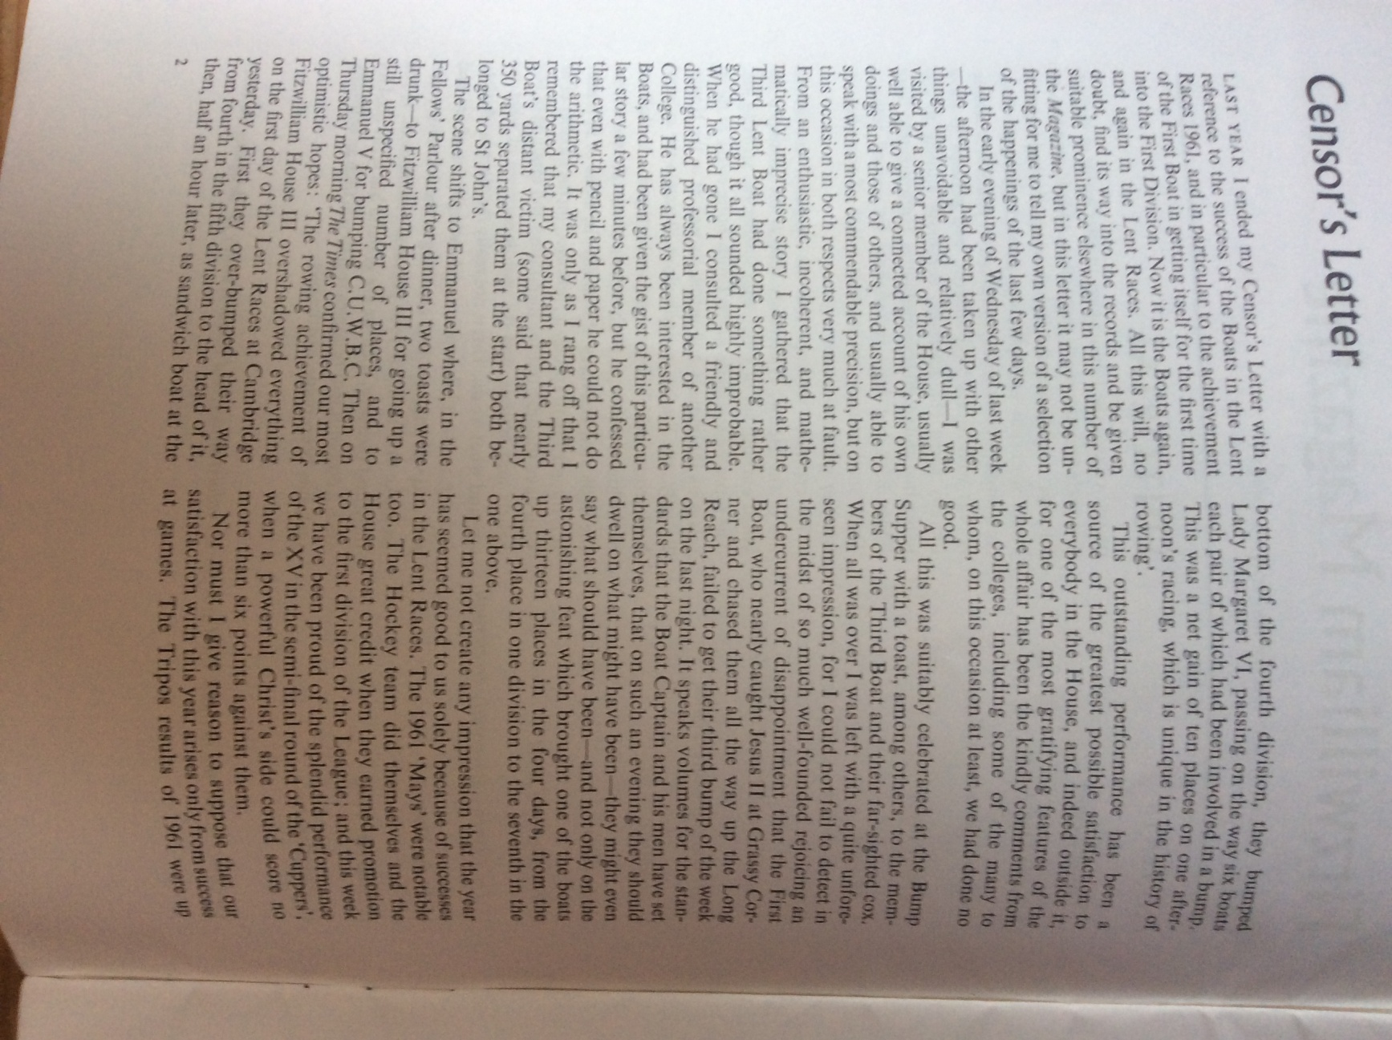

And finally the last quote on this exceptional achievement comes from the book appropriately called "The Bumps", by John Durack, George Gilbert and John Marks which is advertised regularly in the Lents and Mays programmes. Under the year heading 1962 Lents it says that these were notable for two firsts. It marked the first appearance of oarswomen, the CUWBC being let on for the first time. It was, of course, unfair to make them compete against men and the boat did not prosper, as will be seen. For example in this race (the first day of the Lents) it was bumped in 25 strokes. The ladies coxswain temporarily lost control of her rudder lines after the impact and the craft shot up the far bank and some of the oarswomen had to scramble ashore. " (CDN)
The second novelty was the first triple overbump scored by Fitzwilliam 3 on Lady Margaret 6, after Fitzwilliam scored an overbump to become sandwich boat in Division IV, thus gaining 10 places in one day, a record.
It is quite incredible that the achievements of this Fitzwilliam 3rd Lents crew of 1962 still hold records in 2022 that they made in 1962, 60 years later. They are
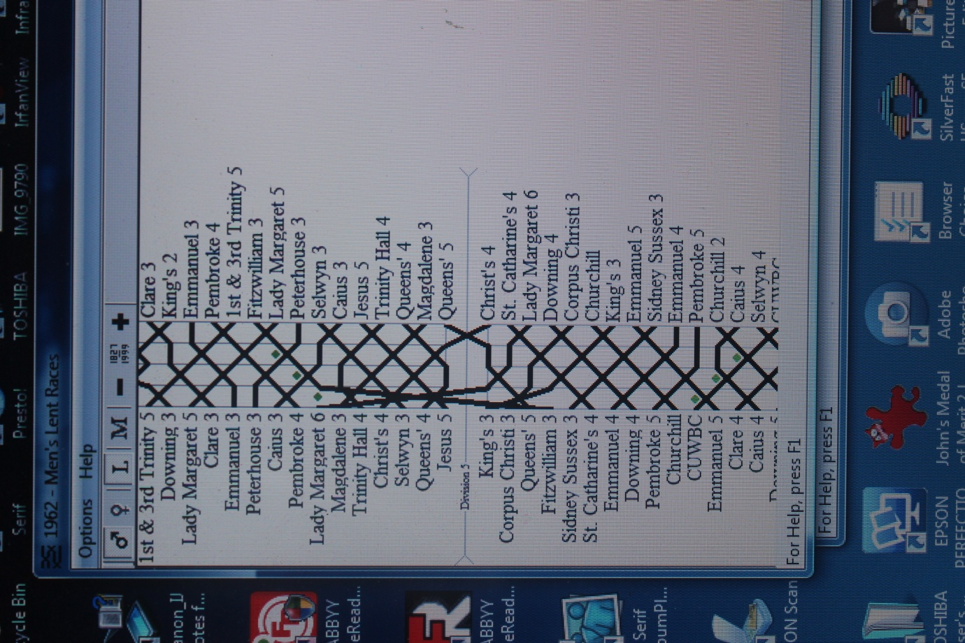
(a) The very first crew ever to make a triple overbump in the Lents or Mays
(b) the very first ever crew to go up 10 places in one day
(c) the very first crew ever to go up 13 places in one Lents or Mays.
The bumps chart from the book called "The Bumps" which is regularly advertised in the Lents and Mays programmes is as shown on the right.
The dots along the part opposite Lady Margaret 6 and NE wards indicate where these bumps were made is available by clicking on them. They bumped or rather triple overbumped Lady Margaret 6 at Morley's Holt and it also says "[ note that this was the first ever triple overbump]". They bumped Caius 3 at The Ditch (which was in First Post Reach) and Peterhouse 3 at Grassy. No mention of where they got Lady Margaret 5. Do you remember?
It is interesting that in the 2018 Mays Magdalene 4 made a quadruple overbump but that still only took them up 9 places, 1 below the Fitzwilliam record!

The college names on the blade in the Fitzwilliam College Bar should be as follows:-
Top row: Overbumped KING'S III, Triple Overbumped L.M.B.C. VI, bumped CAIUS V, PETERHOUSE III, L.M.B.C. V
Bottom row: Over CORPUS CHRISTI III, QUEENS' V, MAGDALENE III, TRINITY HALL IV, CHRIST'S IV, SELWYN III, QUEENS' IV, JESUS V
So the errors are in the apostrophes which are missing from Christ's and King's (once each) and from Queens' (twice).
I quite thought that was all the publicity this outstanding achievement attracted had been published but when researching the publicity for the outstanding 4th Mays 1979 crew I came upon the following:-
The Cambridge Evening News reporting on this extraordinary crew's performance said "None of the bottom half of Division 4 made Grassy but stars of the day were Fitzwilliam 4 who moved from the middle of division 6 to well into division 5 by means of a double overbump and an overbump, a rise of eight places.
This is two short of the record for a single day, also held by Fitzwilliam after one of their crews jumped 10 places in the early '60's.
Fitzwilliam 4's jump was a double success for the crew who lived up to their title of the "elite eight", a mixture of 1st and 2nd boat men who have kept out of higher boats because of exams.
They spent the night before preparing the boat, repairing the bow which had a foot knocked off on Wednesday .
They only just made the second overbump though, as their victims, Jesus 5 had an overlap on Lady Margaret 8 at Ditton but fell to Fitzwilliam at the Railings.
I am very grateful to all who have contributed to this article about this outstanding crew
Ken Drake 2022

