**Record-Breaking 1962 3rd Fitzwilliam Lent Crew - a composite article - Part 1**

A composite account by Michael Bucher (stroke) and Ken Drake with contributions from other members of the crew including George Beale, David Cuckson, Chris Fordyce, Robert Perkins, John Adams who was coaching the 2nd VIII and the Vice Captain of Boats that term, David Knowles.

I am very grateful to all who have sent me photographs, newspaper cuttings and their own personal memories of this extraordinary crew. They have all helped me to bring together what I hope is an interesting story of this very exceptional crew.

The Lents in 1962 took place over the four days February 28th to March 3rd.

I was aware that in the Fitzwilliam Bar there is an oar commemorating the record breaking achievements of this crew. Whenever I have an opportunity when chatting on the bank between the races in the Lents or the Mays or even in the Town Bumps, which take place in July, I explain that the record for these races is that which was achieved by this incredible crew. I got to know one of its crew when one of its members, Robert Perkins, joined the Over 60s Reunion Crews which I organised until recently and it was great for me to get to know someone who was actually in that boat and to hear his tale.

He told us that no one expected much of this crew and certainly not the overbump which happened during their first race. There was no one booked to act as bank party when the crew rowed again 45 minutes later and the then Vice Captain, David Knowles, happened to be there and available so he took it upon himself to act as the Bank Party. He was, according to Robert, a real slave driver and he made the crew row flat out all the way in spite of the bumps which were taking place ahead of them. As a result they gradually got within reach of Lady Margaret VI and caught them to record the first ever triple overbump.

But let's get back to the very beginning. The crew was made up of the best novices who started rowing in the previous Michaelmas Term in 1961 and rowed in the Fairbairn Races organised by Jesus College Boat Club. They had no other experience than that. They had not even seen a bumps race let alone rowed in one. They were regarded as a competent eight which was expected to at least hold their own but there was nothing to suggest that they would break any records. So who was in the crew?

**Full** **name Name on Oar Weight Position in crew**

George Beale G B Beale 11.10 Bow

John Brown J R Brown 10.7 2

John Parle J W Parle 10.00 3

Chris Fordyce C A Fordyce 12.6 4

Simon Davis S A Davis 12.2 5

David Latchford D J Latchford 10.10 6

Robert Perkins R J Perkins 10.10 7

Michael Bucher M J Bucher 10.8 Str

David Cuckson D M Cuckson 8.12 Cox

The crew started 4th in Division V. This is Michael's description of that particular row. "*At the start gun, we just rowed like hell, but not very tidily judging by the photo. By first post corner we were gaining a little on Queens V but who soon put Corpus III out of their misery by bumping them in the Gut. With those two boats out of the way and with clear water we rowed down Kings III for* ***an overbump*** *by the Glass Houses. The bank crew then instructed us to turn around and row down to Baitsbite Lock and prepare to row again at the bottom of division IV. Our boat was due back at the Fitz boathouse for the 2nd VIII crew to row in Division III and as the college only possessed two eight’s at the time, another eight had to be borrowed!" So the crew had moved up three places and still had another race that day so hopefully that total would be increased.*

*The official Lents programme displayed the result of this first row on the first day as:-*

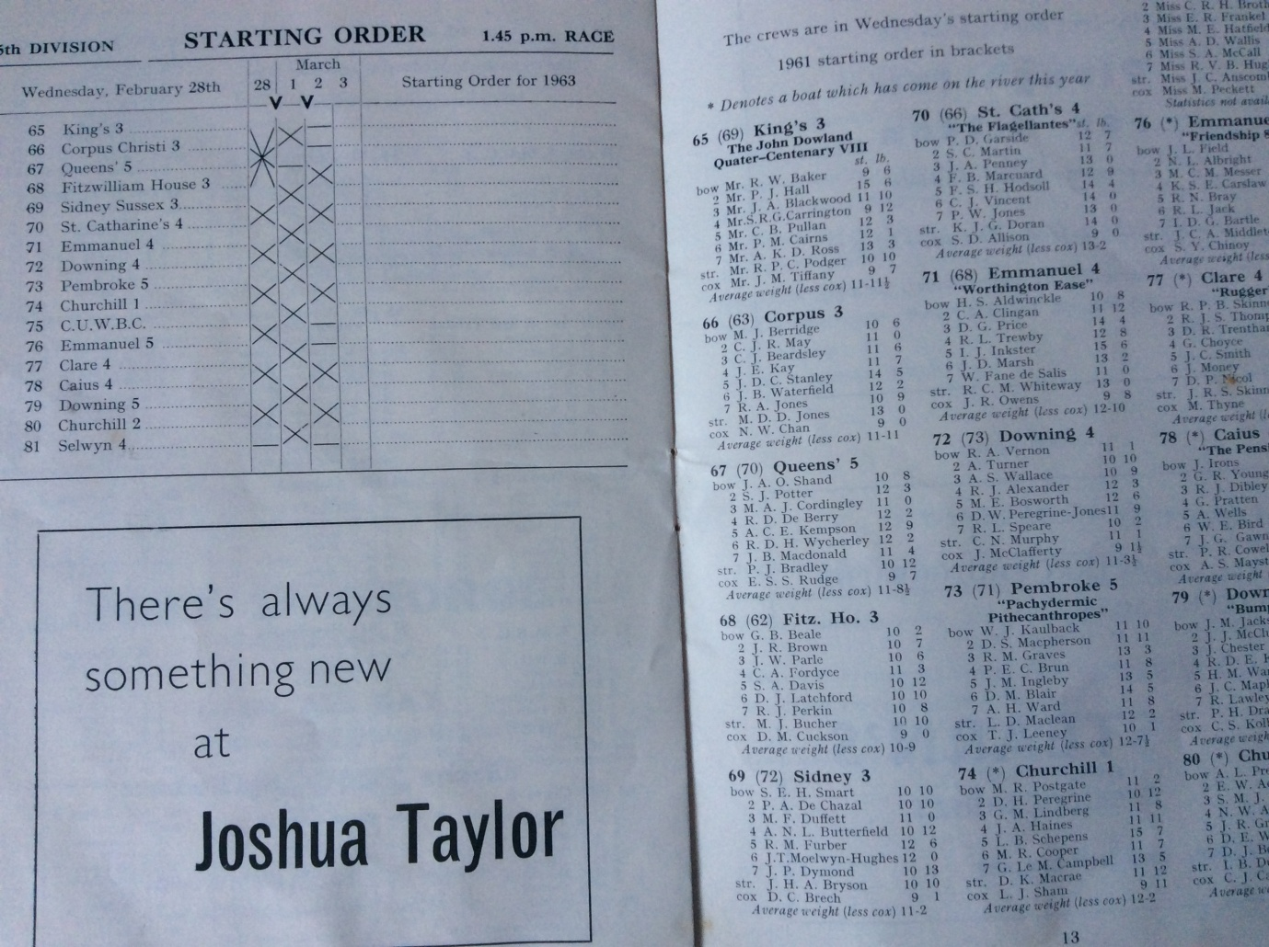

*The left hand page shows the chart of what happened. The right hand side shows the starting order of the crews at the top of the 5th division. The top crew shown is Kings 3 and as they are at the top of this division they are known as the sandwich boat and if they row over they row again at the bottom of the next division. King's 3 were followed by Corpus 3 and Queens' 5 who bumped Corpus making way for the 4th crew, Fitzwilliam 3 to chase and eventually to overbump King's 3 and they then became the sandwich boat, which meant that they had to row again 45 minutes later at the bottom of division 4.*

Robert Perkins told us that no one had expected this overbump to happen. When planning for bank parties you have to make basic assumptions and the hope was that this crew would make a bump which would not involve any further rowing that day. However, the overbump did mean another row and therefore another bank party was needed. The only person who appeared to be there was the Vice Captain, David Knowles, so he took responsibility of being in charge of that small group of cyclists who were to accompany the crew at its next row later that day.

Robert recalls that the crew were being urged by David to row as hard as they could all the way whatever was happening ahead of them. Indeed Robert referred to David as slave driver and he is convinced that without that drive what happened would not have happened. For the very last of our Over 60 Reunion Rows in 2015 we managed to get Robert and David to join us and they both rowed in the same crew. Subsequently we took a photograph of them which appeared in the Fitzwilliam Journal and is repeated here.

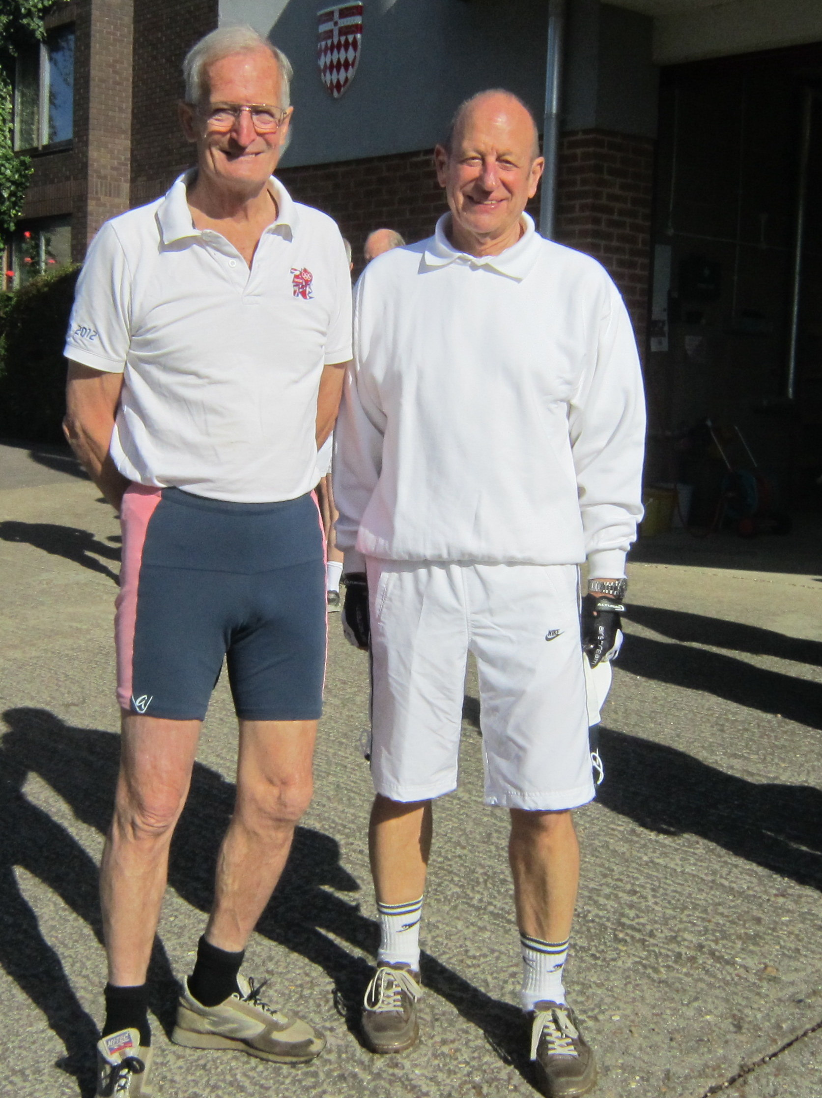*Vice Captain of Boats David Knowles meets Bob Perkins at the 2015 Over 60s Row*

Now let us now read what the stroke had to say about the crew's second row on their first day of bumping races. "*Back down at the lock, we had half an hour to get out of the boat, congratulate ourselves and generally get pumped up before the division IV boats arrived. Confidence levels were very high for a quick bump, these novices had got it all sorted!*

*The start gun is slightly muffled near the lock but we took off fast and this time the balance and feel of the boat was definitely better. However, with no boat chasing us it was slightly weird as we had no idea how we were doing. Very soon boats seem to be drawn up to the banks on either side and I remember thinking that if there were 16 boats in a division and we are the 17th boat there may be no boats at all ahead of us to bump. By the time we got to the Gut we had already rowed about half of the course almost flat out**and we were beginning to flag as well as losing our confidence. I kept asking the cox what he could see ahead but he was busy steering us round the confusion of bumped boats and he couldn’t see much. As we rounded* ***Grassy Corner*** *and the Cam opened up into the* ***Plough Reach*** *I again asked and he replied that he thought he saw the stern of a boat rowing around* ***Ditton Corner*** *heading up the* ***Long Reach.*** *I asked him to call out to up the rating for 10 and 10 and say there was a boat ahead but not to mention how far it was ahead, the river was clear and we were rowing well. As we turned round* ***Ditton******Corner*** *I glanced up the Reach over my shoulder (how many times have I told crews NEVER to look round to see how far they are away - that is the purpose of the bank party and their whistles! KD) and saw a rather ragged boat, gently rowing, about 70 yards ahead. By this time our bank crew were beginning to shout and become generally excited. The whole boat crew were now really getting it together and I remember thinking that if the bumps course is only about half the length of the Fairbairn course we couldn’t really be that tired so I kept the rating up to the max. We made a bump 30 yards from the finish line while the bank crew worked out that we had bumped Lady Margaret VI and made a* ***triple******overbump*** *and a gain of 16½ boat lengths. (I* ***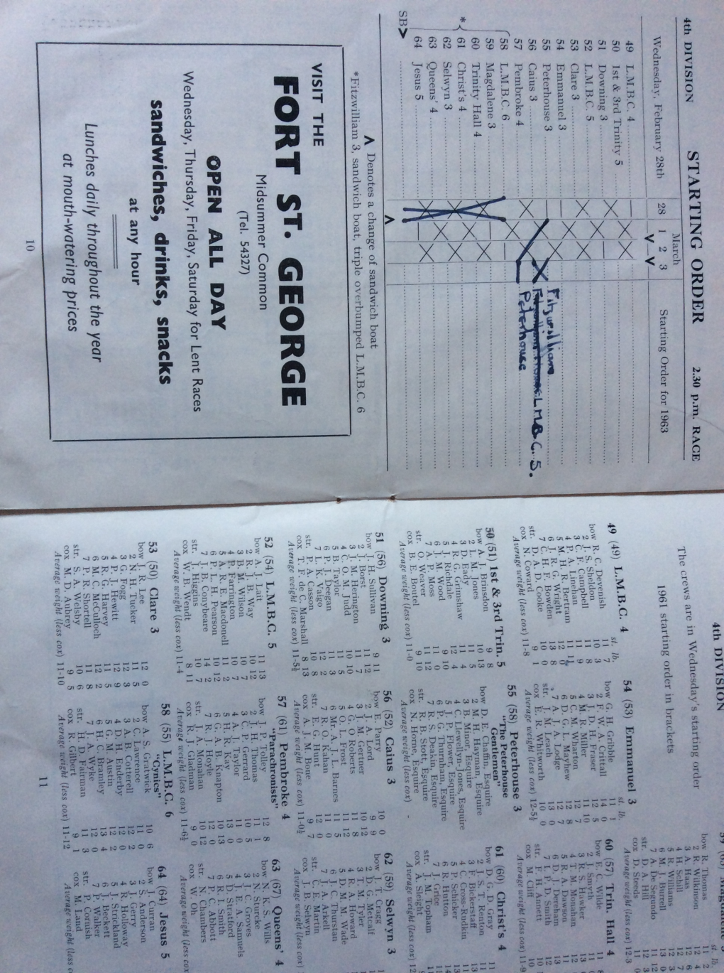****calculated 7 gaps between the boats each of 1 1/2 lengths = 10 1/2 lengths plus the lengths of the 6 boats overtaken = 16 1/2 lengths* - that's 330 yards (in old money) and that's a very long way!) The crew had moved up 10 places in the day. This was the first time that any crew in the Lents or Mays had ever achieved that amount of progress in a single day. **This was the first crew ever to make a triple overbump.*"***

This is how the next page of the Lents Programme illustrated the second race on the first day for this crew:-

***The second race of the first day from the official Lents Programme for 1962 for Fitzwilliam 3rd crew.***

The left page illustrates what happened. The V at the bottom indicates that the sandwich boat comes up from the lower division to row at the bottom of this one. It can be seen that there were three bumps in front of Fitzwilliam 3rd crew and they went on to bump L.M.B.C. 6. in what was the very first triple overbump ever achieved in these races. This meant that with their overbump in the previous division they went up 10 places on the first day and this not unnaturally received quite a lot of publicity in the press. The crews listed on the right hand column of the right hand page are those overtaken as the Fitzwilliam crew caught L.M.B.C. 6.(which is at the bottom of the middle column of crews).

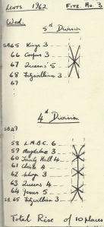These results were illustrated by these two simple drawings which are much clearer than the formal bumps chart. The top one shows the simple overbump on King's 3 to take them to sandwich boat position of the 5th division. Below that, now in the 4th division you can see the three bumps between where Fitzwilliam 3rd crew started and them making their triple overbump on L.M.B.C. 6.

It was interesting to read that the crew was one of the lightest rowing in the 1962 Lents. This may have been true but the weights which were published in the programme for the Fitzwilliam crews were estimates and it was not until formal photographs were taken and oars had to be painted that accurate weights were taken and used. Whether they were then the lightest crew is not known as I do not have access to the C.U.C.B.C. Lents 1962 programme. Their actual weights are those recorded on the official photographs and on the oars.

I was also unaware how few boats Fitzwilliam had and that the 3rd VIII were expected back at the boathouse so the 2nd VIII could use it for their race. We are not told who lent them a boat to race in that day.

John Adams was responsible for coaching the 2nd VIII during the Lents and he and others were rather concerned that the 3rd VIII had not got back when the 2nd VIII was due to leave the boathouse. John describes the situation as it was unravelled to him as he took his crew to the start for their race. "First, as I assembled my crew in the boathouse I remember the concern amongst them that the 3rd VIII had not yet returned. The 3rd VIII were in the 5th division - my crew were getting ready to row in the 3rd division - the 3rd VIII should have been back in the boathouse before we left. What could have happened to them - had their boat been damaged so they could not row back? I recall Ian Worthington (who was in the 2nd VIII and was finishing coach for the 3rd VIII), being particularly concerned. He was Boat Club secretary and was beginning to plan how he could get hold of another boat for them to use the following day. My crew left the boathouse on time and I accompanied them by bike. After crossing the river by the Green Dragon bridge as you will know, coaches are unable to be alongside their crews until just after what at the time was the *Pike & Eel*. It was on this stretch of road that I met David Knowles cycling in the opposite direction. He was excited and speaking fast, normally composed and articulate, he could not give me a clear story about the 3rd VIII. I did gather their boat was undamaged, that they had made an overbump and become sandwich boat, but what had happened after that was unclear. They had bumped again - but the story made no sense - David could not explain which crew they had caught! But our conversation was brief - we both had to get back with our respective crews. My crew had of course seen the 3rd VIII going in the opposite direction by the time I got alongside them again. They and I were relieved the boat was undamaged and pleased that they had gone up - but the magnitude of their rise was unknown - and remained so until after our outing. Incidentally this disproves the fact that the 2nd VIII were waiting for the 3rd VIII to return so they could row in that same boat. Something else that interested me was that by 1962 the Boat Club blazers were no longer maroon but had become white. When I went down in 1957 they were still maroon so when did they change and why and who instigated this quite dramatic change in what had long been the traditional Boat Club blazer?

That crew was indeed the first ever to make a triple overbump, a feat which has been equalled and indeed exceeded since as in 2018 Mays the Magdalene IV crew made a quadruple overbump, which meant that they moved up nine places in one day which is one less than the Fitzwilliam crew. That Magdalene crew made two other bumps but rowed over on the third day thereby failing to qualify for their blades if that college obeys the same rules which now appear to be common throughout most of, if not all, the colleges that you have to bump on each occasion you row chasing another crew to qualify.

What the article by Michael Bucher does not say is that there is in the College cafe bar an oar commemorating this wonderful achievement. It is like any of the other oars except that they bumped, overbumped and triple overbumped so many crews that instead of their names being on the blade they are inscribed on the loom.

Here are the photographs of the blade and the loom.

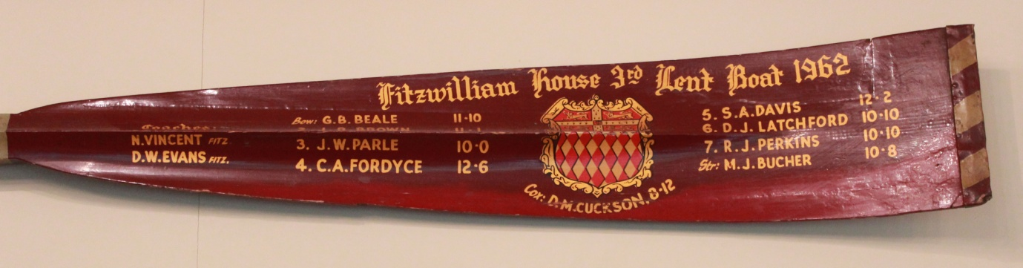

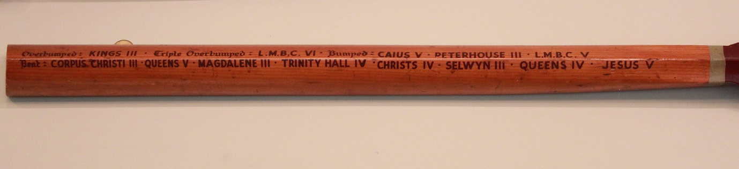

To assist the reader I repeat here the names as they are inscribed on the loom. The top row is made up of the actual bumps they made and the bottom row is the list of the crews they overtook as a result of making an overbump and a triple overbump.

Top row Overbumped KINGS III, Triple Overbumped L.M.B.C. VI, bumped CAIUS V, PETERHOUSE III, L.M.B.C. V

Bottom row Over CORPUS CHRISTI III, QUEENS V, MAGDALENE III, TRINITY HALL IV, CHRISTS IV, SELWYN III, QUEENS IV, JESUS V

I have only just realised that there are some errors on the loom. Can you see what they are? As Loyd Grossman used to say in "Through the Keyhole" the clues are all there, or at any rate in Michael's invaluable contribution to our knowledge of this extraordinary achievement. I wonder if the oars of those members of the crew who have them are correct or are as the one illustrated here? The answers appear at the end of this article.

***This is David Cuckson's rudder which he has instead of an oar as he coxed the boat***

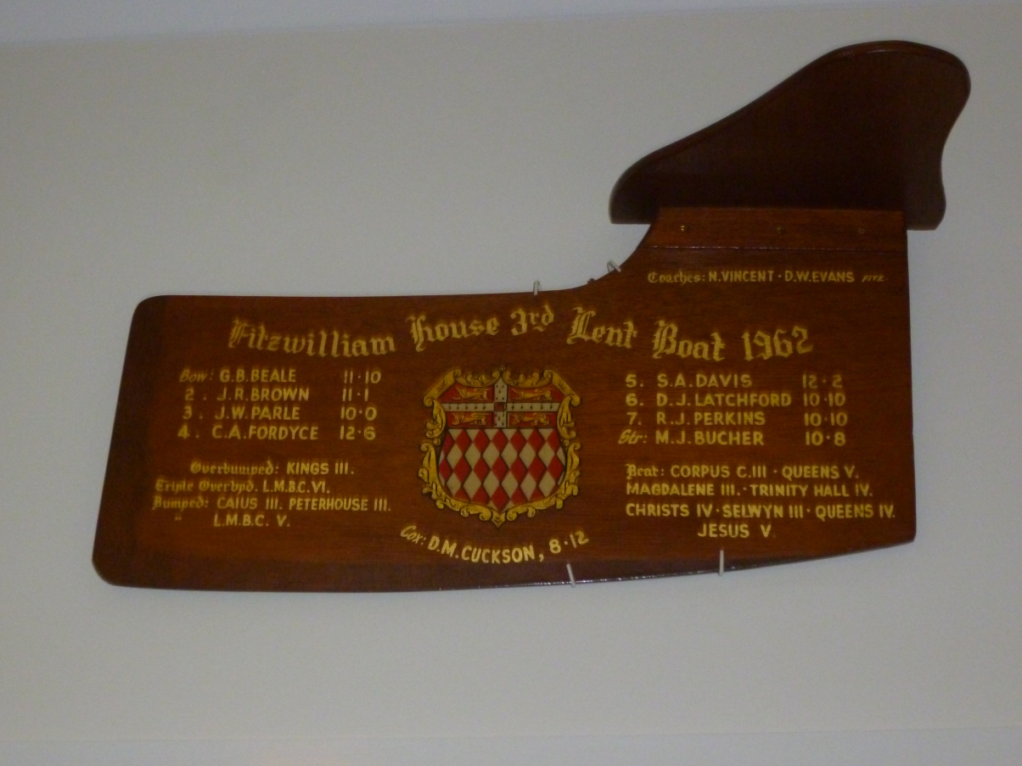

***It is interesting that they have managed to get all the crews bumped and overtaken on it. The rudder in fact has the same errors as on the loom mentioned above. David was particularly pleased to read in the Censor's Letter he was mentioned in despatches!***

**Not surprisingly the crew celebrated their success by having a double photograph - one of the group and one of the crew in action. These are those photographs**

**(a) the double photograph**

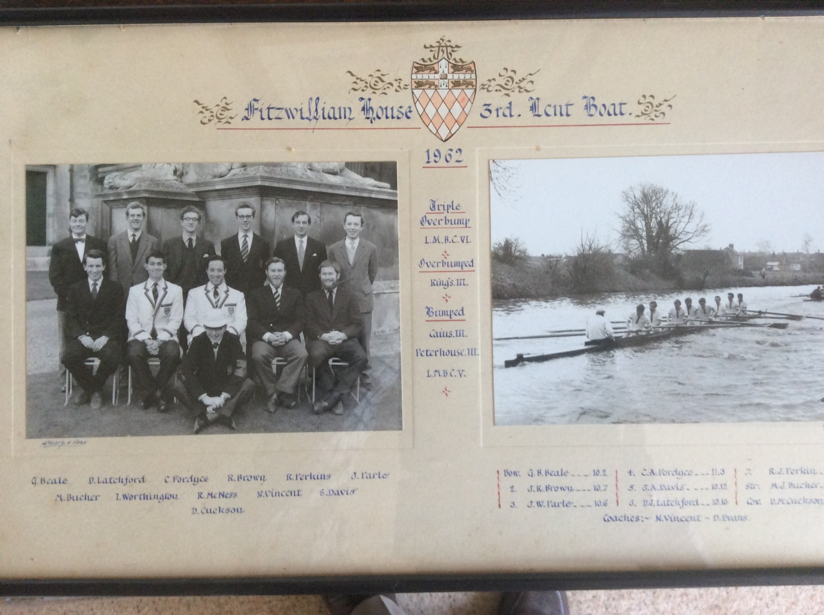

It is interesting that no mention is made of the crews that were overtaken as a result of the overbump and the triple overbump. There is no mention of moving up a division. It doesn't give the impression of being a record breaking crew that it was and still is in 2022. They went up 10 places on the first day when they rowed first at station 4 in Division 5, overbumped King's (over Corpus Christi III, Queens' V,) to become sandwich boat and therefore rowed 45 minutes later at the bottom of Division 4 where they made the very first triple overbump ever made in the Lents or the Mays (over Magdalene III, Trinity Hall IV, Christ's IV, Selwyn III, Queens' IV, Jesus V). On the next three days they made just one bump on each day bumping Caius III, Peterhouse III and Lady Margaret V so that they went up 13 places in all, still a university record.

**(b) the group photograph**

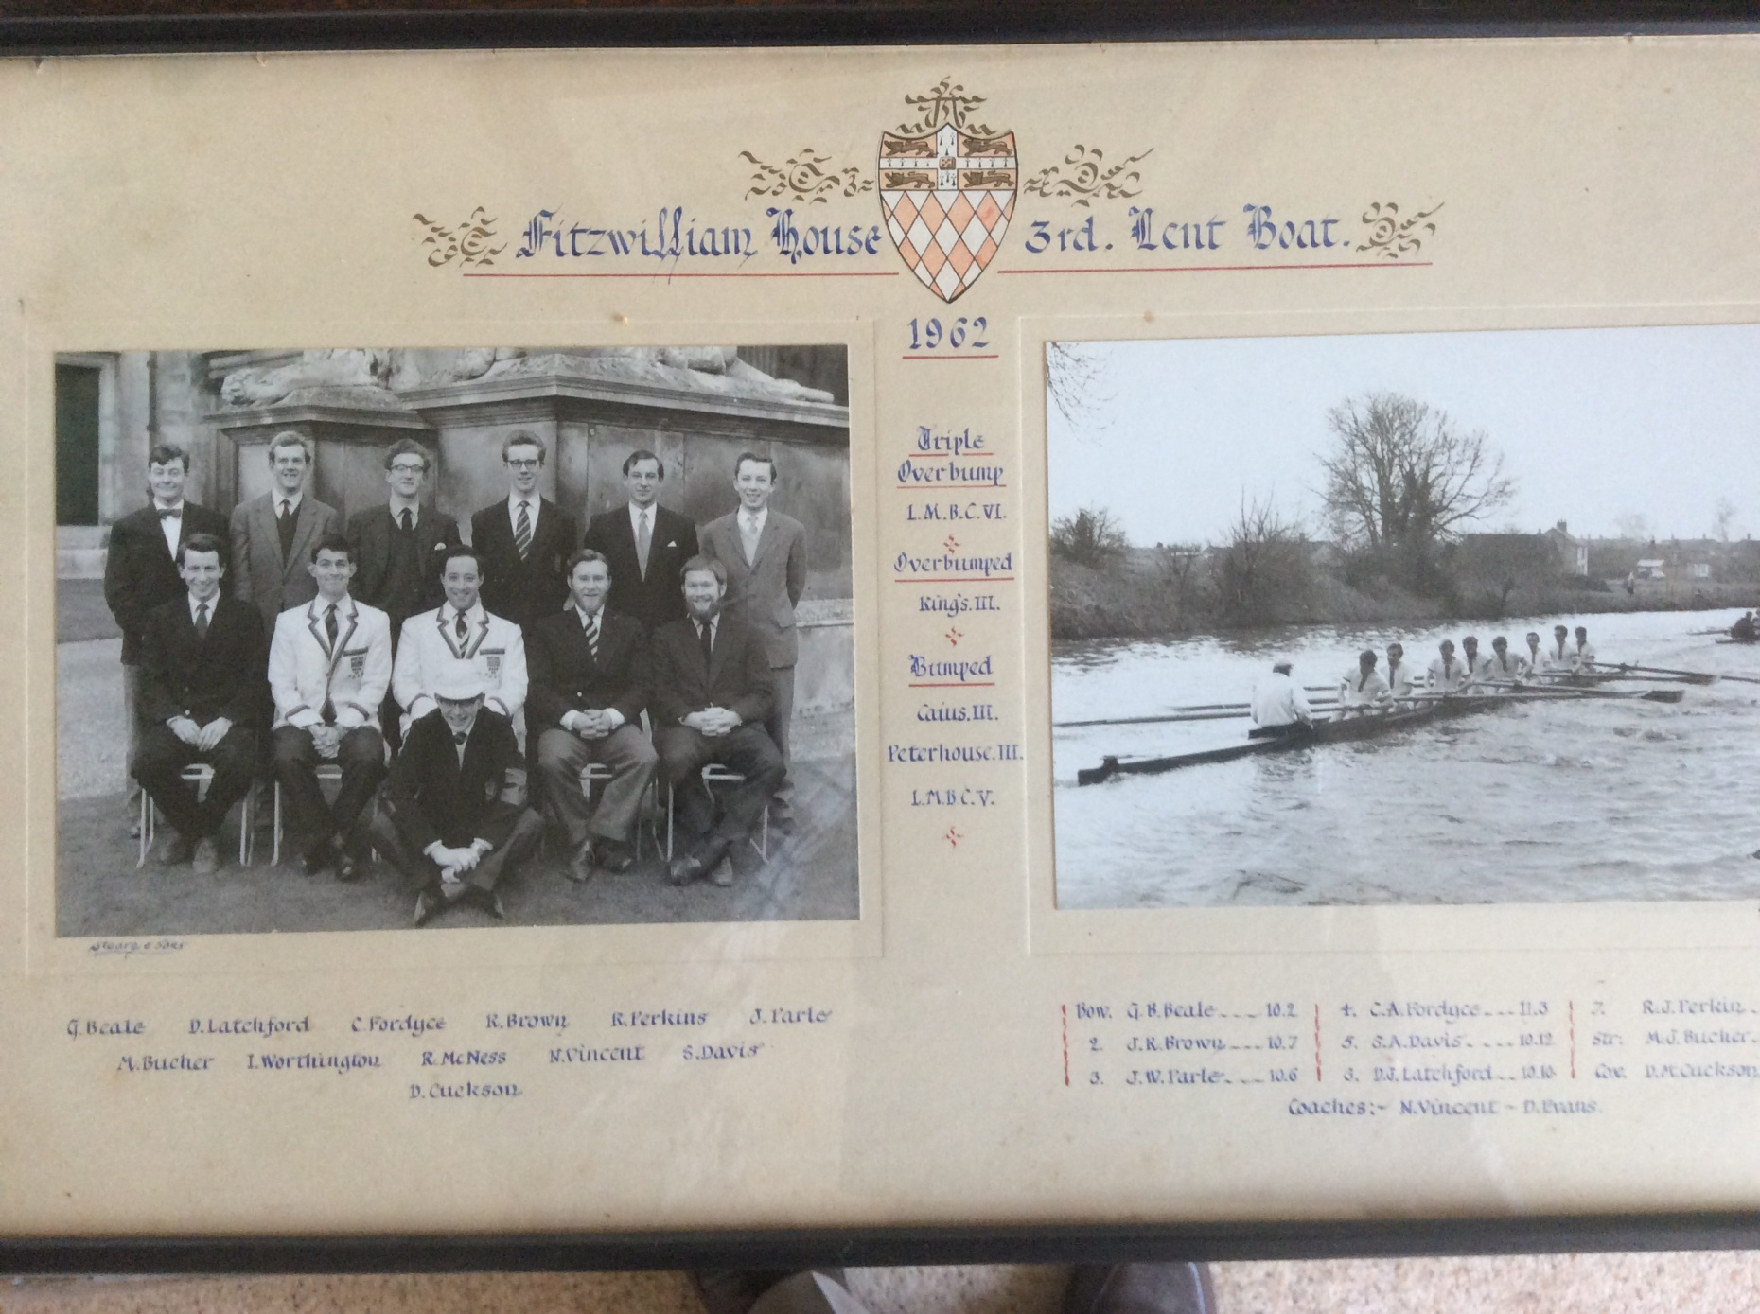

Back row – George Beale (bow), David Latchford (6), Chris Fordyce (4), John R Brown (2), Robert Perkins (7), John W Parle (3),

Middle Row –Michael Bucher (str), Ian Worthington (coach), Robin Mackness (Captain), N Vincent (coach), Simon Davis (5)

Floor – David Cuckson, (cox),

**(c) the action photograph**

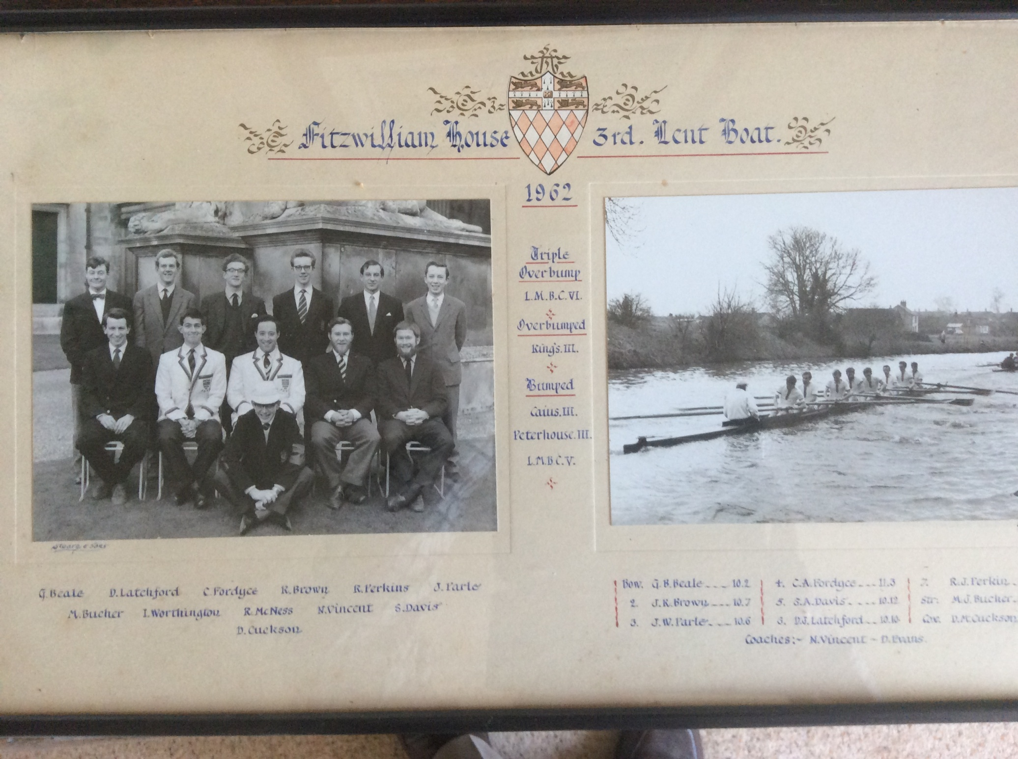

**Letter from David Knowles to Lord Brabazon following the latter's enquiry about the remarkable achievement of this crew.**

Extract from a reply to Lord Brabazon of Tara [an aviation pioneer and former Minister] who had written to enquire about the 3rd Lent Boat’s performance. From: The Captain (David Knowles succeeded Robin Mackness as Captain at the beginning of the Summer Term) Fitzwilliam House Boat Club 10 May 1962 Dear Lord Brabazon, We were all delighted to receive your letter today and think it quite splendid. I was flattered to hear that our 3rd Eight’s efforts were noticed and are still being talked about. As we are trying to make ourselves a rowing college and with high ambitions are determined to compete at Henley for the first time, this is valuable publicity indeed. I will gladly enlighten you to the best of my ability about the quite incredible performance of our 3rd boat in the Lents, and the mechanics behind it. My apologies in advance if I fail to explain it well or insult your knowledge of rowing by making the assumption that I write to one who knows little of bumping races. The 3rd boat was in the fifth division with a start position near the Guns. By the Ditch, Corpus 3, Queens 5 and Billy were equally spaced a mere canvas apart. Fortunately - as it turned out - Queens 5 caught Corpus 3 on the corner just before we caught them. As both boats involved in a bump immediately stop rowing, there was some chaos in getting past. Also it is quite a disappointment to see one’s prey in the bank. However, the crew kept going well and coming out of 1st Post Corner, Kings 3 were just entering Grassy corner 100 yds ahead. They made up this distance remarkably quickly, bumping just round Ditton corner. This was an overbump, a not uncommon occurrence and remarkable only for the ease with which it was made. It made the crew into the sandwich boat, which has to row twice, first at the head of its own division and then again 3/4 hrs later at the bottom of the next division. Hence, rather apprehensively they turned round and rowed back to the start with a sprig of greenery in the bows showing they had made a bump. It was jokingly mentioned that if Jesus 5 in front of them and known to be fast, did bump early another overbump would be made. The secret fear however was that they would fail to bump and would have to row over the full course which would also mean rowing over twice on the morrow, still as sandwich boat. I was therefore horrified to see Jesus 5 make a very quick bump by the Little Bridge and the Crew must have been even more worried. Then Selwyn 3 caught Christ's 4 by the Guns and Trinity Hall 4 caught Magdalene 3 by the Ditch. There was now clear river ahead for 300yds, the nearest crew - LMBC6, 7 places higher, just disappearing in the distance round 1st Post. Even the most optimistic stopped hoping for a bump and the crew settled to row over. However the next time we saw LMBC they were still in the Gut, definitely nearer and the Crew started to take it seriously. We don’t know if LMBC took the challenge seriously at this stage. Rounding Ditton corner the crews were 150 yard apart and we could see how fast our boat was closing, still rowing well. The umpire cycled back, decided we might make it and looked up his book of rules. By the Glasshouses things were getting very tense. Two lengths separated the crews, excitement was very high, a huge crowd was running after the crews and both boats were racing hard for the finish at Morley’s Holt. I particularly remember the Umpire saying “I’ll have to allow it, I’ll have to allow it”. As you know they made it - just. It was never publicised that this bump - a treble overbump was made just 50 yards from the finish, very dramatic and a most exciting finish. Great jubilation on the bank as a treble is extremely rare, having occurred only once or twice in the history of bumping races. (This sentence is in fact incorrect - this was the very first triple overbump that had ever been made in the Lents or the Mays). Combined with the overbump made in the fifth division the crew went up 10 places in one day; they went on to make a further 3 on following days. In the House, champagne was served in Hall and the 1st eight took the 3rd boat to dinner. As all the crew are rowing again this term we hope to have equal success in the Mays. Indeed we hope that all our boats will continue winning their oars with the monotonous regularity that they have in the past. In all fairness and the crew themselves are the first to point it out, it must be said that such a feat requires the favourable combination of many factors. It is no mean achievement to be 330 yds faster over 1.5 miles - 1 minute in 10 - than a crew about a whole division above you - but it requires much luck to demonstrate it. If Queens 5 had been just a shade slower we would have bumped them before they got Corpus and made a ‘mere’ 4 bumps. However it is these occurrences and possibilities that give Bumps their charm.