Record Breaking 1955 Fitzwilliam 1st May VIII
The Fitzwilliam crews at this time were on the whole going up but that did not mean all the crews all of the time. The 1st Lent crew this year had actually rowed over three times and was bumped on the second day. We had no idea what would happen in the forthcoming Mays.
This year the C.U.C.B.C. organising the Mays had decided to increase the number of boats in each division from 15 to 16. This meant that instead of starting 5th in Division 3 we had moved up to 3rd without rowing a stroke!
On the first day the person rowing at 6, me, broke his oar going down to the start of their race. I have no idea how I did it but it was certainly useless for rowing. Fortunately our boatman, Cecil Phillips, was prepared for any eventuality and somehow he had a spare oar available where the crews start the bumps. He was Boatman to both Sidney Sussex and Fitzwilliam and the spare oar happened to be a Sidney one. It was an Ayling oar and the ones Fitzwilliam were rowing with at the time were Collar's. The crew we were chasing, Peterhouse 2, were in a different class to us and we were nowhere near catching them. Indeed they bumped Trinity Hall 3 to become the sandwich boat so we had no one to chase and therefore rowed over on the Wednesday. I wonder if this had anything to do with my different oar! So a row over on the first day did not bode well for the next three days. The next day we bumped Trinity Hall 3 at the Railings to move us into second place in Division 3. On Thursday we started behind the sandwich boat, 1st and 3rd Trinity 3, and set off to try to bump them and eventually we caught them at the Railings, the same place as we caught Hall 3. This meant that we were now sandwich boat so we turned round and rowed 45 minutes later at the bottom of Division 2. We were starting virtually in Baits Bite Lock now chasing Selwyn 2 and we caught them at the cables, situated in First Post Reach, so we had made two bumps on this day and three in all. We needed a fourth on Saturday. We were now at the bottom of Division 2 and chasing Christ's II whose cox, W.E.P. Lloyd Williams, was entitled to and did wear a Leander scarf. We started to gain on them from the start gradually getting nearer as we rounded Grassy Corner and went down Plough Reach. Our cox, Derek Read, was thrilled to get his bow inside their stern as we went round Ditton Corner and that was where the Leander scarf wearing cox raised his hand to acknowledge our bump on Christ's 2. So we had gone up four places without being bumped and in those days that qualified you to win your oars. What we did not appreciate at the time, we had also got Fitzwilliam back into Division 2 for the first time since it was bumped out of it 20 years earlier in 1945.
Why the excitement about winning our oars? Many Fitzwilliam crews have done this in the past and many would do it in the future.
Nearly Fifty Years Later
John Jenner in about 2002 had what he thought was a brilliant idea. He and I were both in this 1955 1st May Eight than won its oars. Since 1996 we had been involved with the Over 60's Reunion Rows which I organised and after our row John entertained us to lunch in the Nines boathouse. John wondered if it might be possible to contact all the other members of this crew and see if they were fit enough to come to Cambridge and go out as the same crew that 50 years previously had won their oars. John had always been excellent at delegating and here he was doing it once again.
Several other members of that crew were rowing with us in these Over 60s Reunion Rows namely Mike Duffett, Richard Salmon and Derek Read. Frank Hall was Ken's Best Man and they were still in touch so that just left three members of the crew that we needed to contact, namely Mike Chandler, Warren Gray and John Hankin. We contacted the Development Office to ask for their contact details but they informed us that they were all "Lost Sheep" which meant that they had no idea where they lived or indeed whether or not they were still alive. Would they provide us with the information they had about them? Well er no! The Data Protection Act they felt meant that this information should remain confidential and should not be divulged to us. Eventually common sense prevailed and they told us what little they knew. We then sent letters to their former homes, schools, the newspapers of the town where they lived and possible employers and letters were also addressed to professional organisations of which we thought they might be members. We even contacted the Daily Mail which has a regular feature trying to locate lost friends who were being sought to join various reunions. Mike Duffett found Warren Gray, who was a solicitor working in Devon, and we decided it might be an idea to get a mention in the Fitzwilliam Journal that we were seeking the contact details of Mike Chandler and John Hankin. Bill Clarke saw our letter in the Shrewsbury Chronicle trying to locate Mike Chandler who was the next to be found by the Development Office before Derek Read's son found John Hankin who was still rowing regularly on the Thames. Everyone was still alive so that was a good start.
Letters were now sent to them and they were all amazed that they were being sought by us. Were they reasonably fit and were they prepared to come to Cambridge to row in this same crew at the Saturday of the Annual Reunion at the end of September. Yes, provided they did not have to row a bumps course!
It was very exciting as we planned exactly how we would celebrate this great event of getting the whole crew together again in an eight on the River Cam after 50 years. Indeed we were so lucky as several of the crew had had life threatening illnesses including two with bowel cancer, one with very serious heart attacks and another with M.R.S.A. One or more of us could so easily have died or not be up to the fitness required to get into an eight and rowing any distance.
At that time the Boat Club Secretary recorded in the Boat Club Book relevant information about the progress or otherwise of the crews. John Adams, for 50 years Billygoats Society Secretary, looked after this book and he produced for our anniversary row a small document based on what this book said and this is reproduced here as a four page document. It is interesting to record that in fact what he produced was in my own handwriting as I was Secretary at the time! No! 50 years after the event I do not recall much of what I had written.
This is the edited version (the reason for the edit is included in my letter at the end of this document) of what it said:-
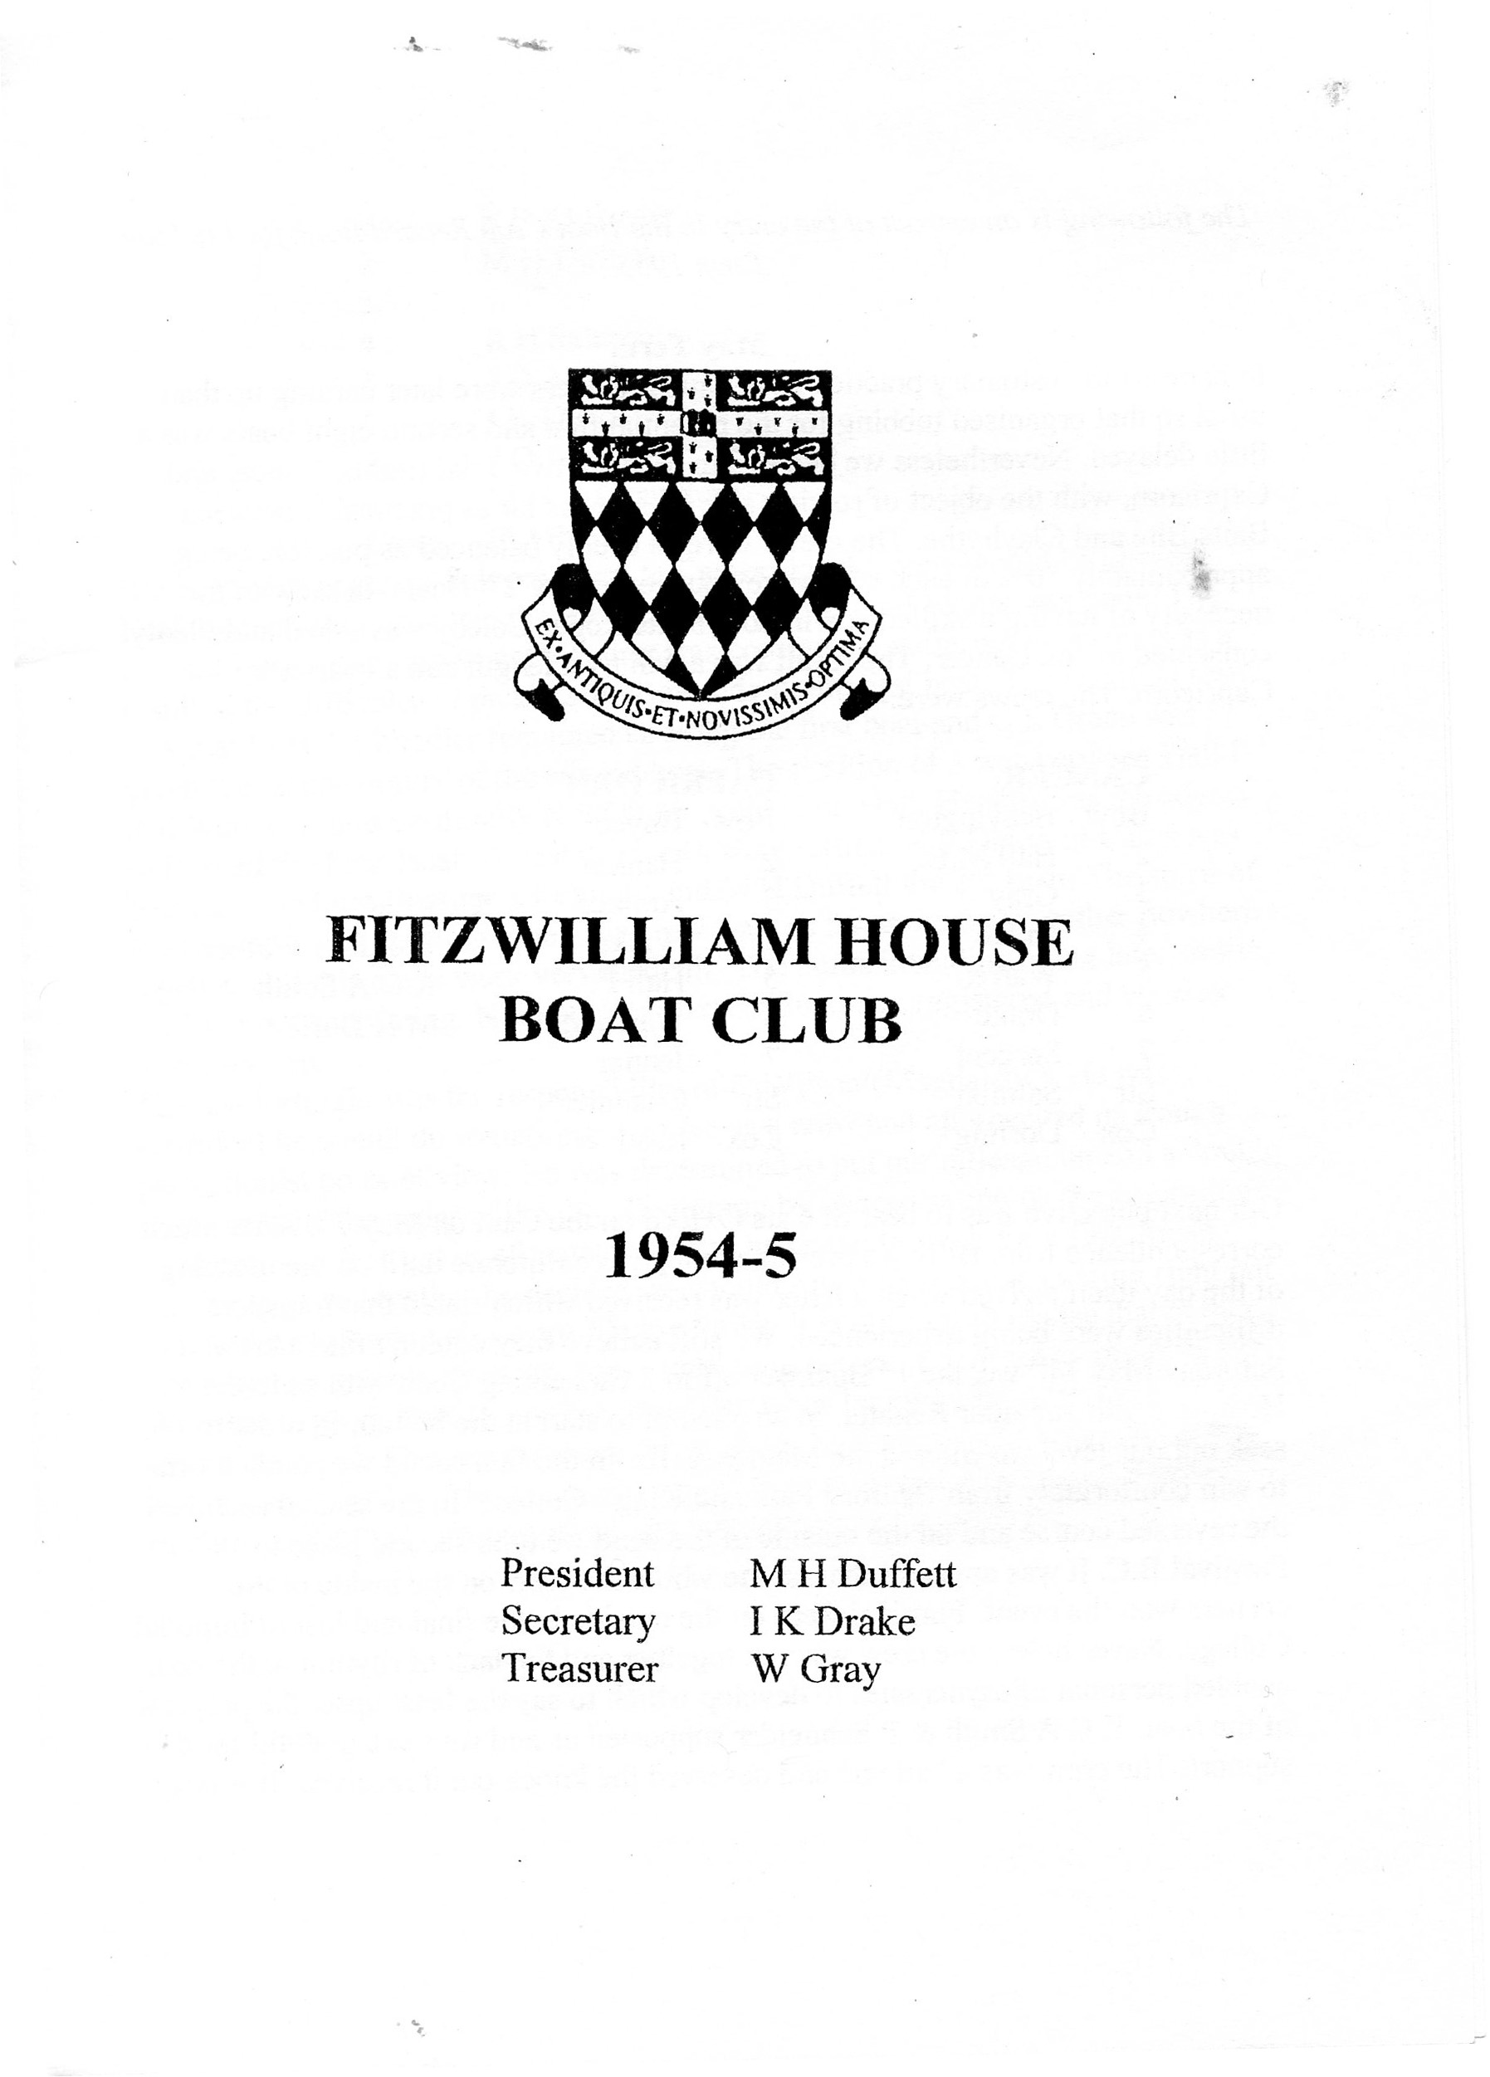

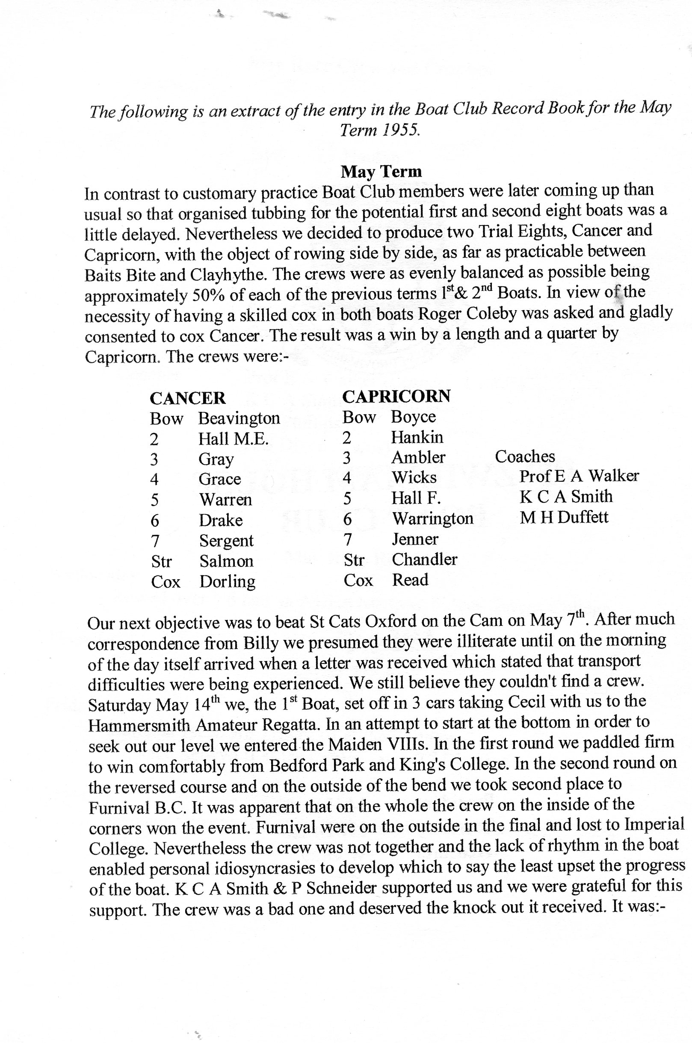
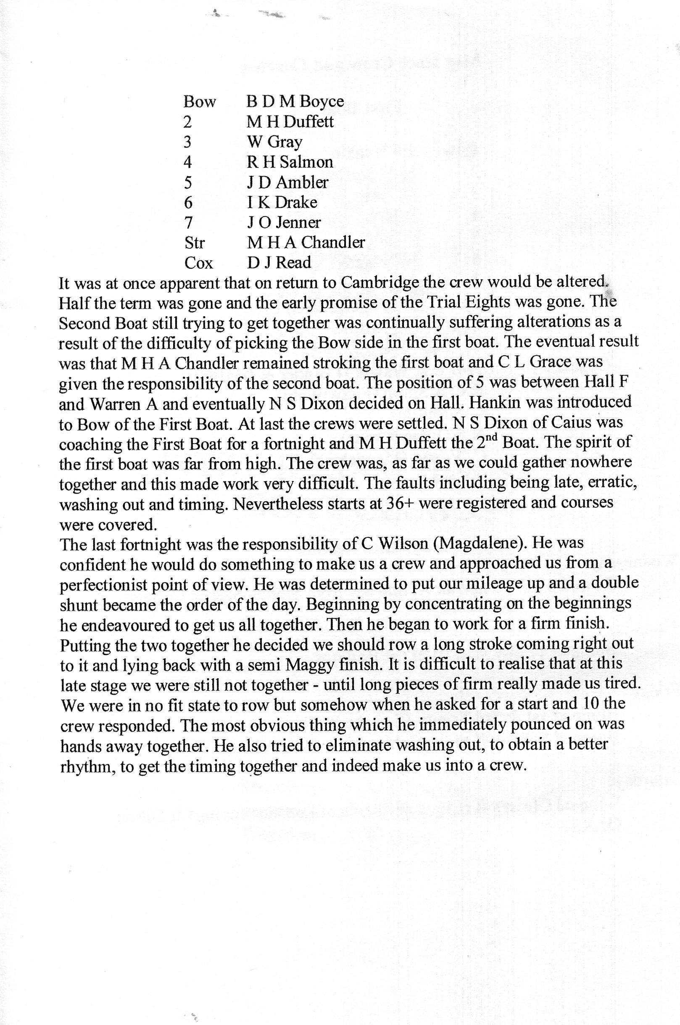

The detail about the crew changes needs clarification. There were three main problems that needed resolution. Who should stroke the crew was perhaps the most important decision and it was decided that Mike Chandler would carry that responsibility. The two candidates to row at 5 were Frank Hall and Alan Warren and former was picked by one of the coaches. The third problem was who should occupy the bow seat. Norman Issberner had rowed on bow side in the 1st VIII in the Fairbairn Term 1954 and in the Lent Term 1955 successfully and ought to have rowed at bow but his tutor had told him that if he rowed he would be sent down and obviously he had to give up rowing this term so eventually John Hankin was placed in that seat but he then had to learn to row on bow side! Norman returned to row in the 1957 Lent 4th boat on stroke side at 6 - he could and did row on both sides!
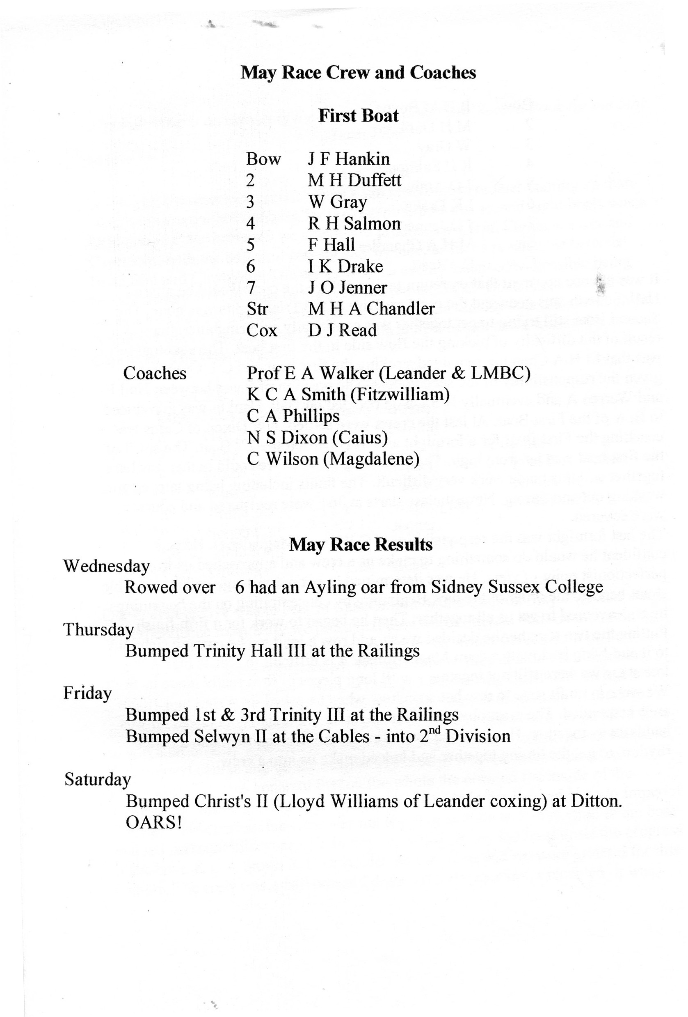

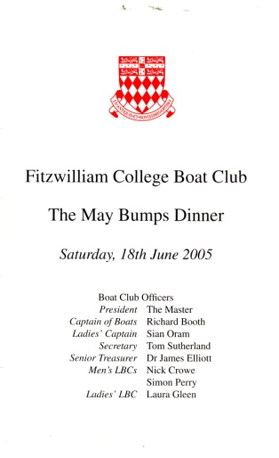
2005 The 50th Anniversary of Winning our Oars and moving into the Second Division
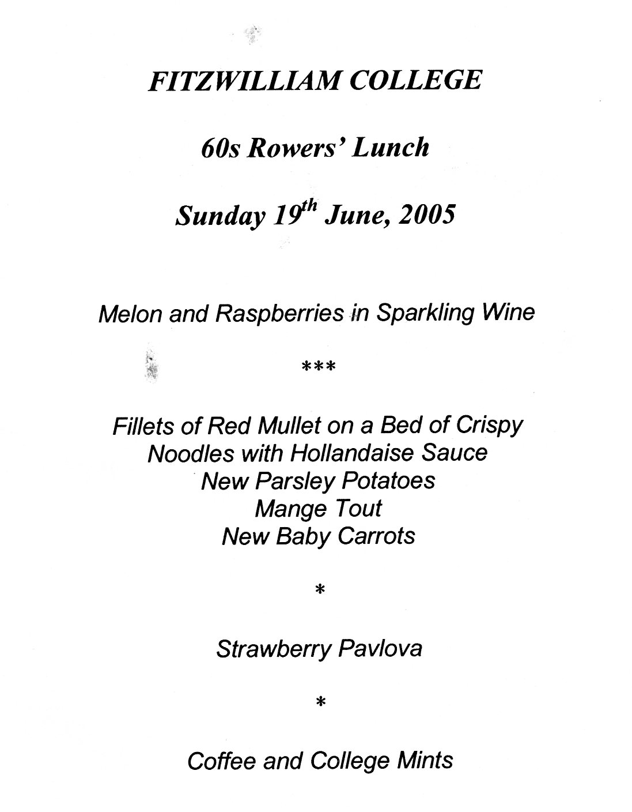
The ways of celebrating this get together of this crew gradually started to emerge following discussions with the College and the Boat Club. The original idea was the actual row at the 2005 Annual Reunion at the end of September and that remained the main event. However, further discussions suggested that the crew might well like to attend the Mays Bumps Dinner that year. This we did and very much enjoyed the experience. The Master and Mrs Johnson were keen to entertain the group to lunch and eventually it was decided this would be on the Sunday following the Mays Bumps Dinner. It was unfortunate that two members of the crew and their wives, Mike and Ann Duffett and Warren and Jean Gray were unable to attend the two events held this week-end. The Master and Mrs Johnson invited us to join them for what was described as "60s Rowers Lunch". A specially printed menu made the event seem even more special. It was a lovely informal occasion and half way through we swapped places to sit next to different people. The weather was lovely and we all enjoyed the informal but very friendly occasion.
The next celebrations were to be at the end of September, some 3 months later. The first of these was the outing on the Cam and for some it was their first meeting since the 1950s. Derek Read, our cox, had produced a copy of the original group photograph taken at the Fitzwilliam Museum with the lions always visible. We did our best to borrow boat club blazers for those who did not have them from the members of the other two eights which were going out as part of the Over 60s Reunion Row that year. That was the first and only time that we had three eights out for these Reunion rows from our own group. Then we assembled for the 2005 group photograph standing and sitting exactly where we did 50 years ago. Not only did we have the whole crew but also one of coaches - Ken Smith of Fitzwilliam who joined us for the photograph. Two of the coaches had died, Cecil Phillips the boatman and Prof E A Walker (L.M.B.C. and Leander). Of the other two coaches we managed to get in touch with N S Dixon (Caius) but he was unable to attend the celebration and the other C Wilson (Magdalene) we were unable to locate.
These are the two photographs
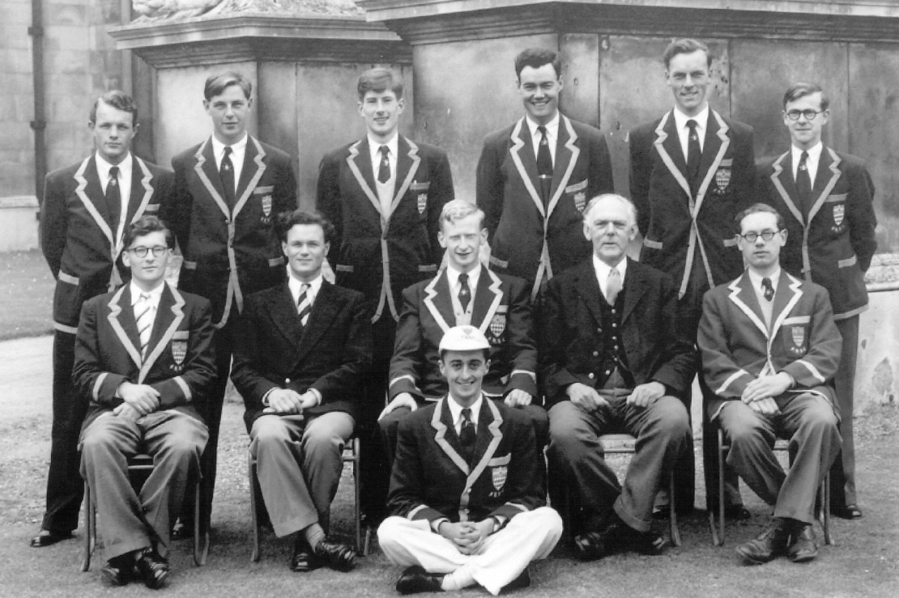
1955 1st May Crew which won its oars - photograph taken at Fitzwilliam Museum
J F Hankin (Bow), Warren Gray (3), Richard Salmon (4), Ken Drake (6), Frank Hall (5), John Jenner (7)
Mike Chandler (Stroke), coach N. S. Dixon (Caius), Mike Duffett (President)(2), Coach Prof E A Walker (L.M.B.C. & Leander), Coach Ken Smith (Fitzwilliam)
Derek Read (Cox)

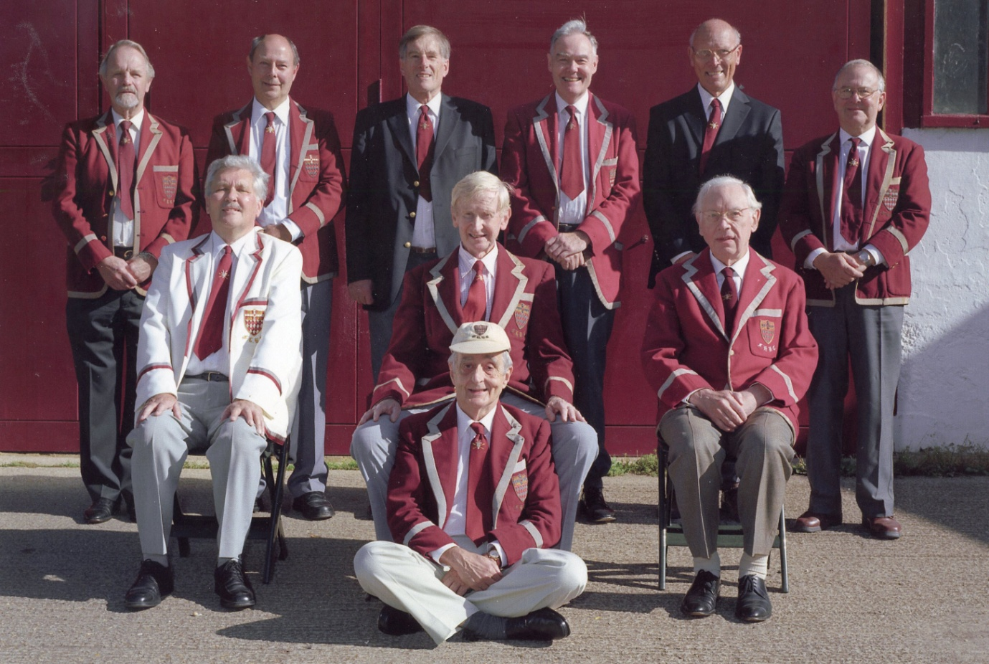
1955 1st May Crew which won its oars - photograph taken at Fitzwilliam Boathouse
John Hankin (Bow), Warren Gray (3), Richard Salmon (4), Ken Drake (6), Frank Hall (5), John Jenner (7)
Mike Chandler, (Stroke), Mike Duffett (President )(2), Coach Ken Smith (Fitzwilliam)
Derek Read (Cox)
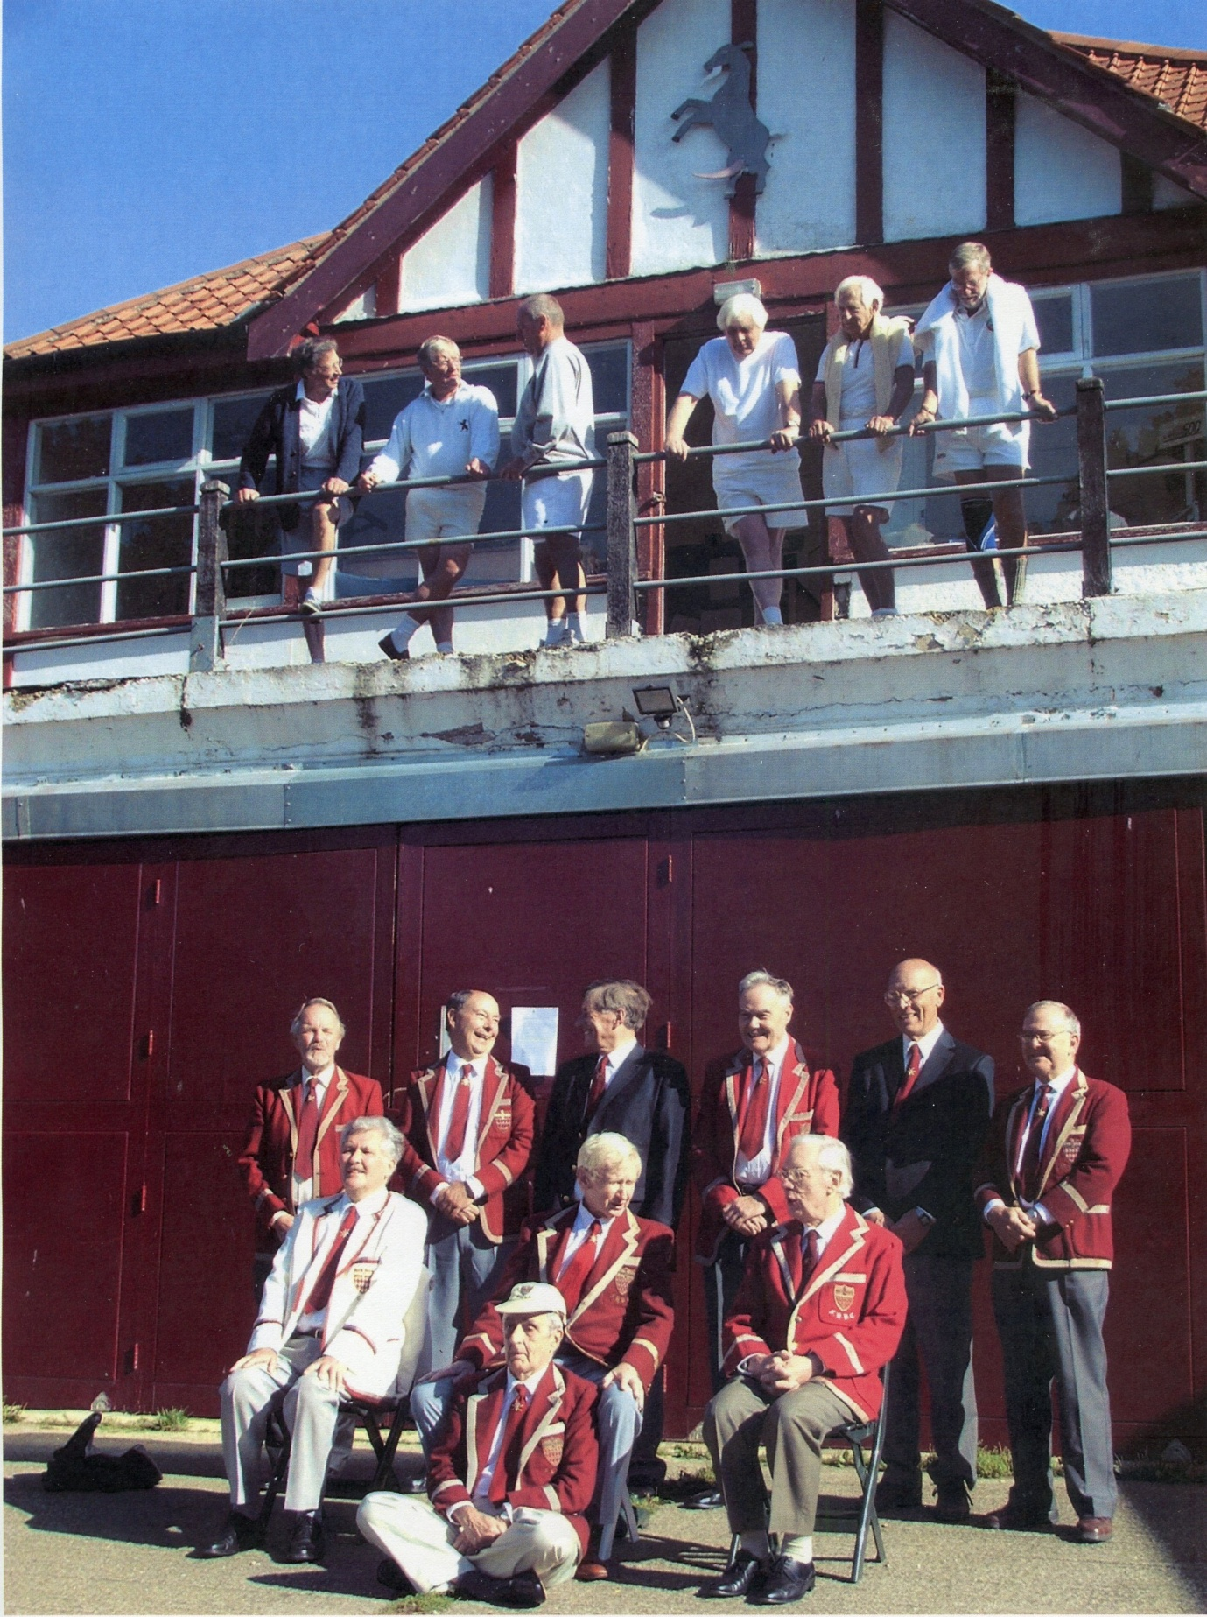
This is a less formal photograph of the 1955 crew below and spectators above
Derek Read, our cox, had produced a booklet showing the emergence of this crew from some of the crews he had coxed since his arrival in 1952. The book cover was like this:-

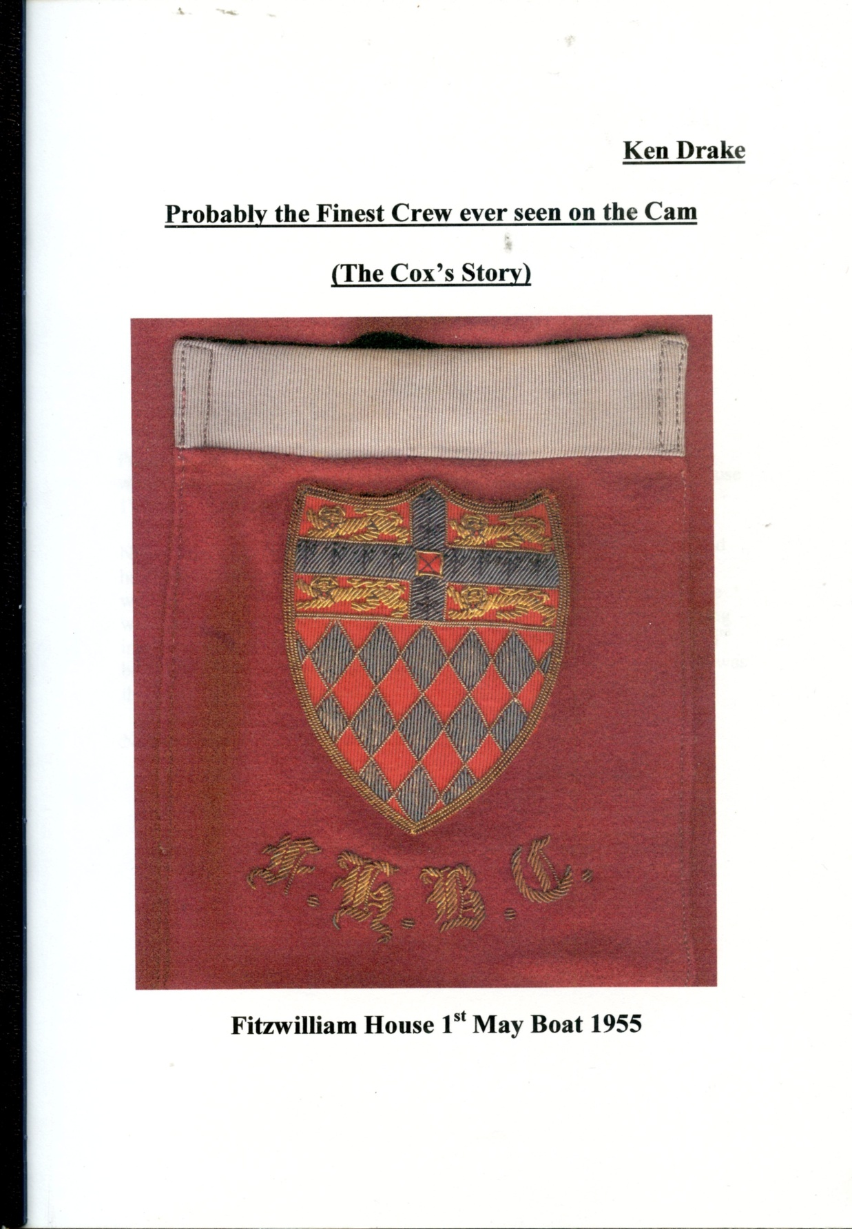

He made a copy of this booklet for all members of the crew and this was my copy hence my name on the cover. I am sure we all appreciated Derek's title for his masterpiece "Probably the finest crew ever seen on the Cam." Obviously the illustration on the cover is his own Fitzwilliam House Boat Club blazer pocket with the initials F.H.B.C. below in gold. In the 1950s a 1st Lent colour was allowed to have these initials in grey and the 1st May colour was allowed them in gold.

The next task was to find the boat allocated to us, lift it down off the rack, (why is it we often get the boats on the highest racks?), remove it slowly and carefully from the boathouse, get it alongside the river bank and carefully place it on the water. Oars were then collected, we had Cox alongside instructing us when to get in and before long we were all aboard, our feet fitted into the shoes on the stretcher plate which in turn was adjusted to enable us to get our legs flat at back stops. We then individually had our photos taken sitting in the boat as you can see below:-
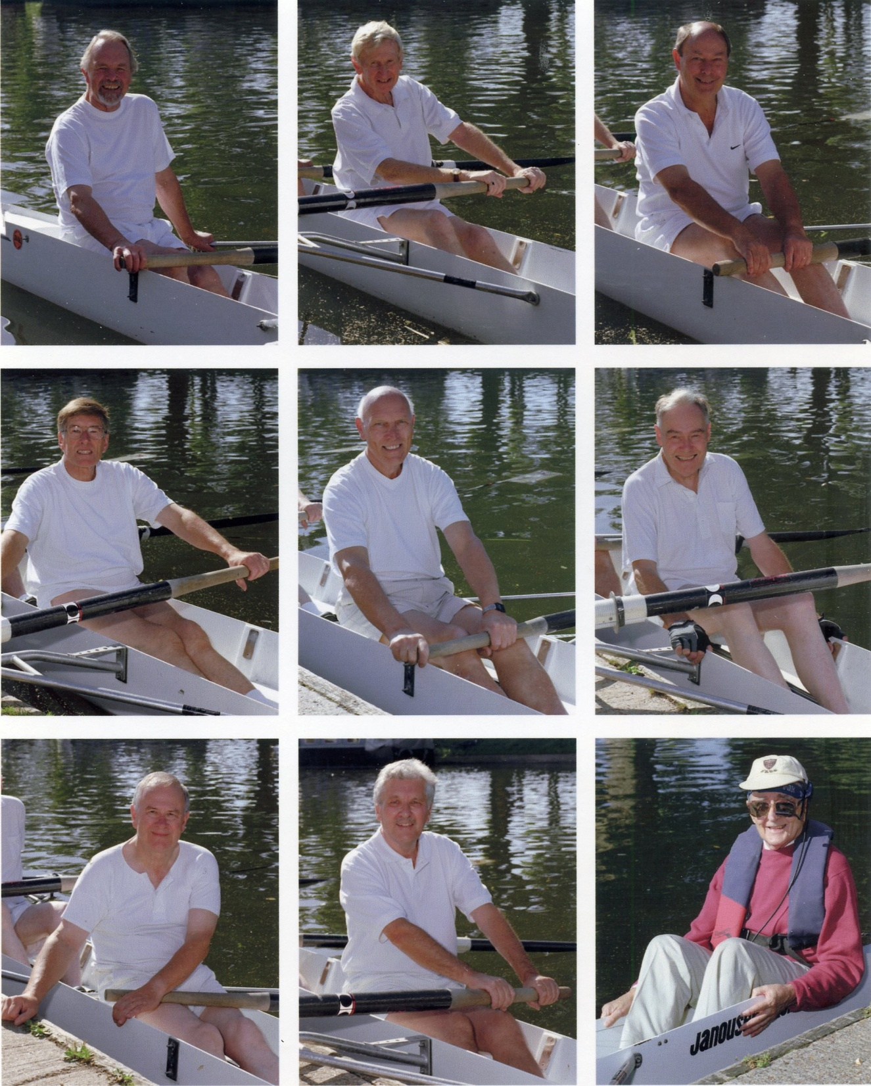
Top row Bow John Hankin 2 Mike Duffett 3 Warren Gray
Middle row 4 Richard Salmon 5 Frank Hall 6 Ken Drake
Bottom row 7 John Jenner Stroke Mike Chandler Cox Derek Read
We were then gently pushed out and cox took over "Come forward - one stroke - Row" which 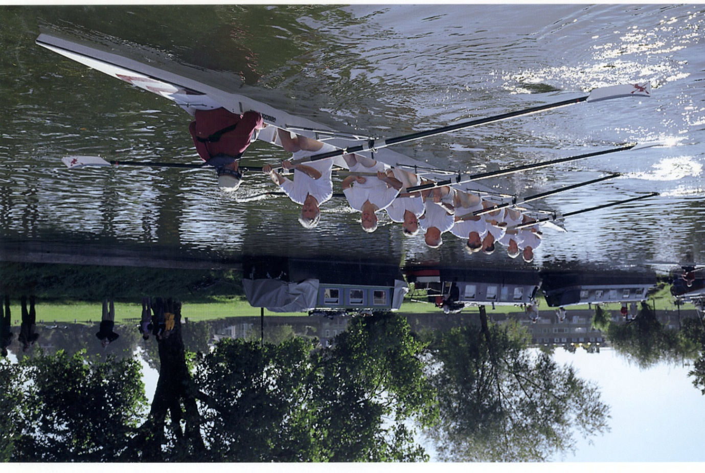enabled us to move the boat to the correct side of the river and be ready to move off.
Not only did we have the complete crew but we were also supported by all our wives for this celebratory row. There were eighteen of us - Mike and Margaret Chandler, Ken and Vivian Drake, Mike and Ann Duffett, Warren and Jean Gray, Frank and Kathleen Hall, John and Pauline Hankin, John Jenner, Derek and Mavis Read, Richard and Helen Salmon and Ken Smith.
It is very rare to see all three ways that winning oars or blades are celebrated at the same time. As this is such an unusual event in celebrating the oars won fifty years earlier I thought it was interesting to record all three - the rudder, coaching prow and oar or blade.

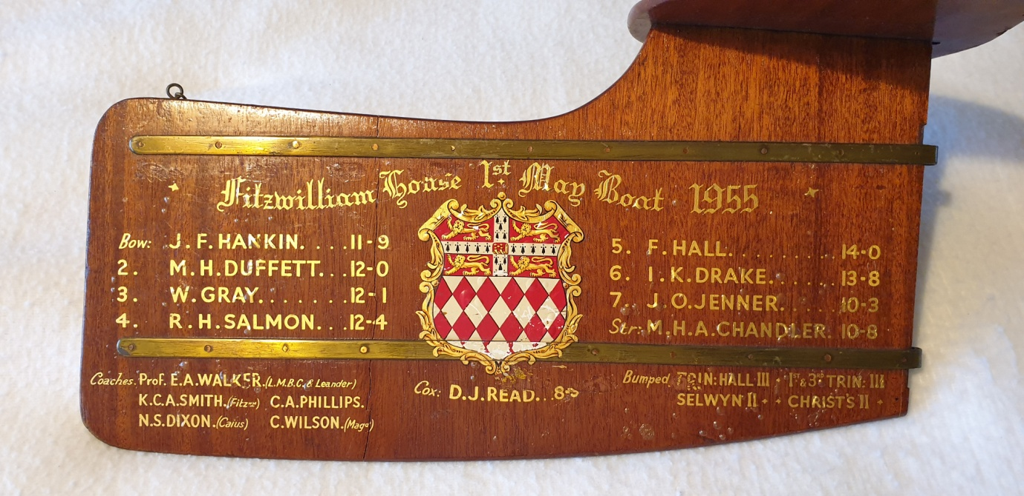
Derek Read (Cox)'s Rudder

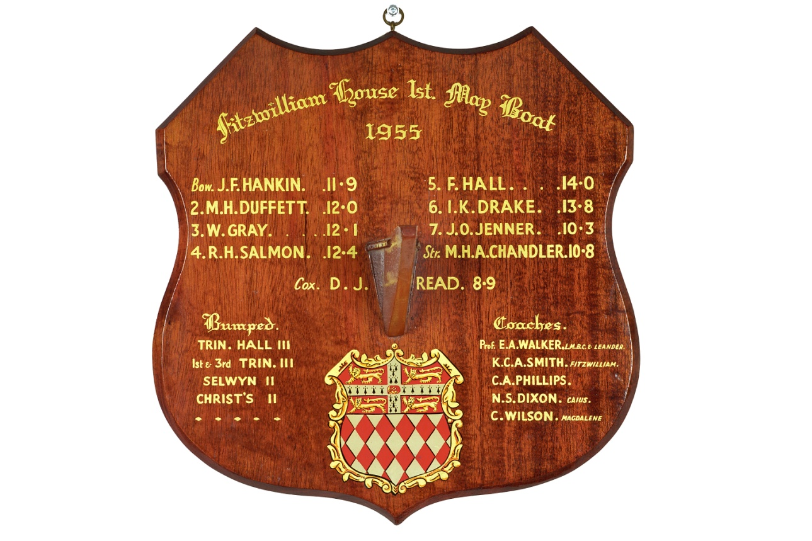
Ken Smith's Prow for coaching the crew.

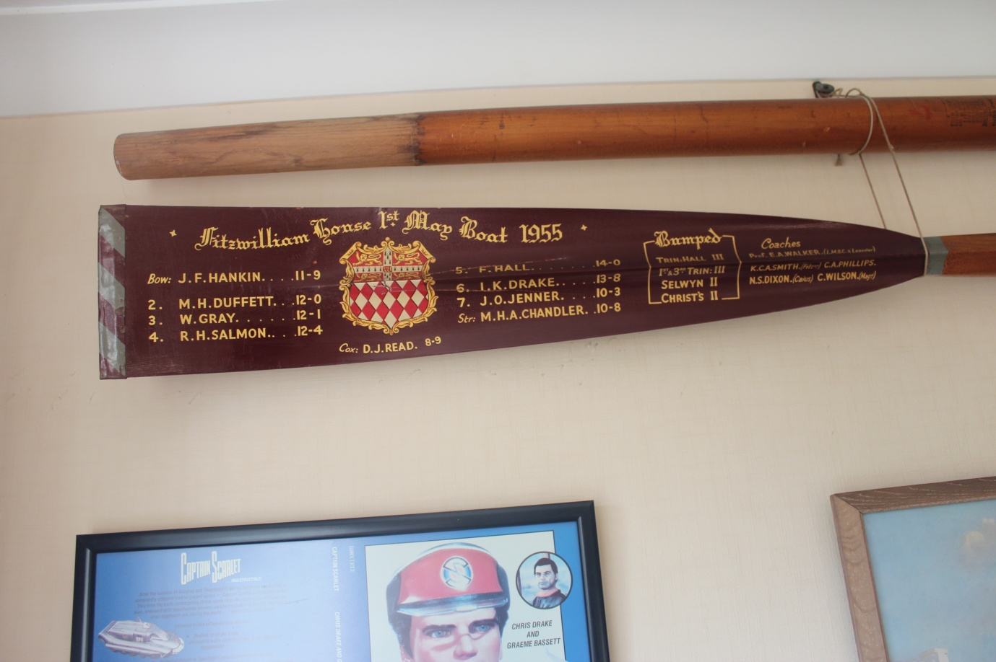
Ken Drake's Oar

Derek Read wrote an article about this for the Fitzwilliam Journal which I am repeating here.
1955 - 2005
To be honest, the older members of the crew found the way in which the young 70 year olds were scampering around the boathouse a little tiring. Nothing, however, could dampen the overall enthusiasm for what was about to be accomplished. The Fitzwilliam House 1955 First Boat crew who won their oars (or blades as they are called in 2005 speak) were going out together again in an eight. They had further accomplished Fitzwilliam’s rise from the 3rd to the 2nd division after the Boat Club had languished at the lower level for 20 years. All were aged 70 or over and their combined ages totalled 640.
The original idea for the celebration had come from John Jenner but it was taken up enthusiastically by Ken Drake who spent much time organising this event and a gathering of 7 of the 9 crew members at a special May Bumps weekend earlier in the year. As well as attending the Bumps Supper they were entertained to lunch the next day by the Master and Mrs Johnson.
Finding all the crew members had not been easy - indeed Bow had escaped detection until quite late in the day; only being unearthed by the magic of the internet (a facility not available in 1955) utilised by Cox’s younger son Philip (also not available in 1955). But there they all were:
Bow: John Hankin
2: Mike Duffett (who popped over from Australia for the event)
3. Warren Gray
4. Richard Salmon
5. Frank Hall
6. Ken Drake
7. John Jenner
Stroke: Mike Chandler
Cox. Derek Read

Firstly a group photo was taken with the crew and Ken Smith (Fitzwilliam), one of their coaches 50 years previously, in the same positions as they had occupied in 1955. Not one member of the crew looked more than 50 years older than he was in the previous photo.
They were allocated the boat named after Ray Kelly who, appropriately had been a Fitzwilliam Tutor in the 1950s. The crew then discovered that, happily, the boat was on the top rack in the boathouse. This enabled the upper limbs to be flexed and the muttering muscles to be loosened. However, in no time at all the boat was lifted down, taken out and launched onto the river. Then, before the admiring gaze of the assembled wives and friends - several of whom appeared hardly able to believe what they were witnessing - the journey down river began.
Things had changed. The Gas Works had disappeared and bridges had appeared where there had not been bridges of yore - one of them confusing Cox by pretending to be the Railway Bridge when it wasn’t! The Pike and Eel was still there but its name had been changed. It was agreed that this virtually amounted to an act of nomenclatural vandalism.
It appeared that the boat was somewhat lower in the water than the crew remembered and some members were worried that this might indicate an increase in the overall weight load aboard compared to 1955. Happily, however, Cox, being a Geographer, was able to point out that, as it had rained the day before, the river was slightly in flood and this explained why the water came further up the side of the boat.
Although it had indeed rained the previous day, and the following day was overcast, the weather on the day of the outing was glorious: (never any harm in having a Revd. in the crew!) and the Cam was looking at its Autumnal best. The swans displayed the skills they had inherited from their ancestors of 50 years ago and, whenever the boat bore down upon them, they glided serenely to one side or the other and, always, just in the nick of time, they were just sufficiently out of range to avoid Bow’s or 2’s blade by the merest whisker (or feather).
The crew rowed 2½ miles down to the upper end of First Post Reach where the boat was spun. To be more accurate, they didn’t row, they paddled down and back with a mixture of ‘firm’ and ‘light’. To be even more accurate, they paddled down and back ‘light’ all the way apart from an occasional few strokes of ‘firm’ early in the proceedings to prove that they could still do it.
They returned past the scenes of their earlier glory: First Post Corner, The Gut, Grassy Corner, Plough Reach and then stopped at Ditton Corner at the very spot where they had bumped Christ's II on the Saturday 50 years previously in 1955 to win their blades. It was quite a moment to think that, 50 years later, they were all 9 there together again in an eight.
At one stage on the homeward journey Cox, carried away by the excitement of the whole thing, suggested they tried a racing start and 10. A lively and friendly debate then took place but the motion was narrowly defeated by 8 votes to 1.
A couple of crabs were caught in spectacular fashion and the occasional air shot was performed with style and grace whilst timing was not always a matter of precision. However, something which had held the crew together in 1955 had clearly remained deeply rooted in the minds of the 9 individuals, as the quality of the balance in the boat was quite remarkable.
The two Fitzwilliam Over 60’s crews also on the river kindly acknowledged the Even Older Boys when they met. However lithe young lady scullers were also encountered and it was necessary for Cox, as of old, to remind the oarsmen that they should keep their eyes in the boat. Some things do not change as the years pass!
Muscles ached and muscles hurt and blisters formed but everyone stayed the full 5-mile course although it appeared that one or two members were so severely affected by their efforts that they would never be able to clamber ashore from the boat. Eventually, though, all were brought onto dry land and a briskly executed “Up”,” Stroke side under” and “Down” proved that everyone was still full of energy before the craft was once more placed on the top rack in the boathouse.
And so to lunch!
The 2055 outing will be truly remarkable! Derek J Read 1952
So the outing on the river was duly completed and we then retired, as was usual for the majority of our over 60 Reunion rows, to the Nines' boathouse where John Jenner had kindly provided us with a sandwich lunch and he opened the bar throughout the luncheon. This was always a most enjoyable social time where wives and partners joined their husbands to chat until they decided to return to college or go elsewhere.
The next and final event to celebrate our 50 year winning of our oars was to attend the Annual Fitzwilliam Reunion Dinner in the Dining Hall.
At the Reunion Dinner, which is one of the largest such events in Cambridge, there was no mention of our achievement on the menu card. However, we took the opportunity to sign menu cards as mementoes for us to recall this occasion, the final event to celebrate our winning our oars and rowing five miles on the Cam to revisit the sites where we made those bumps fifty years ago.

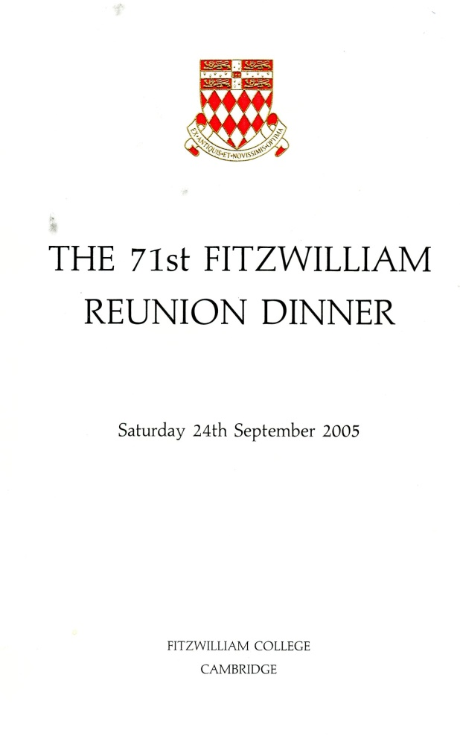
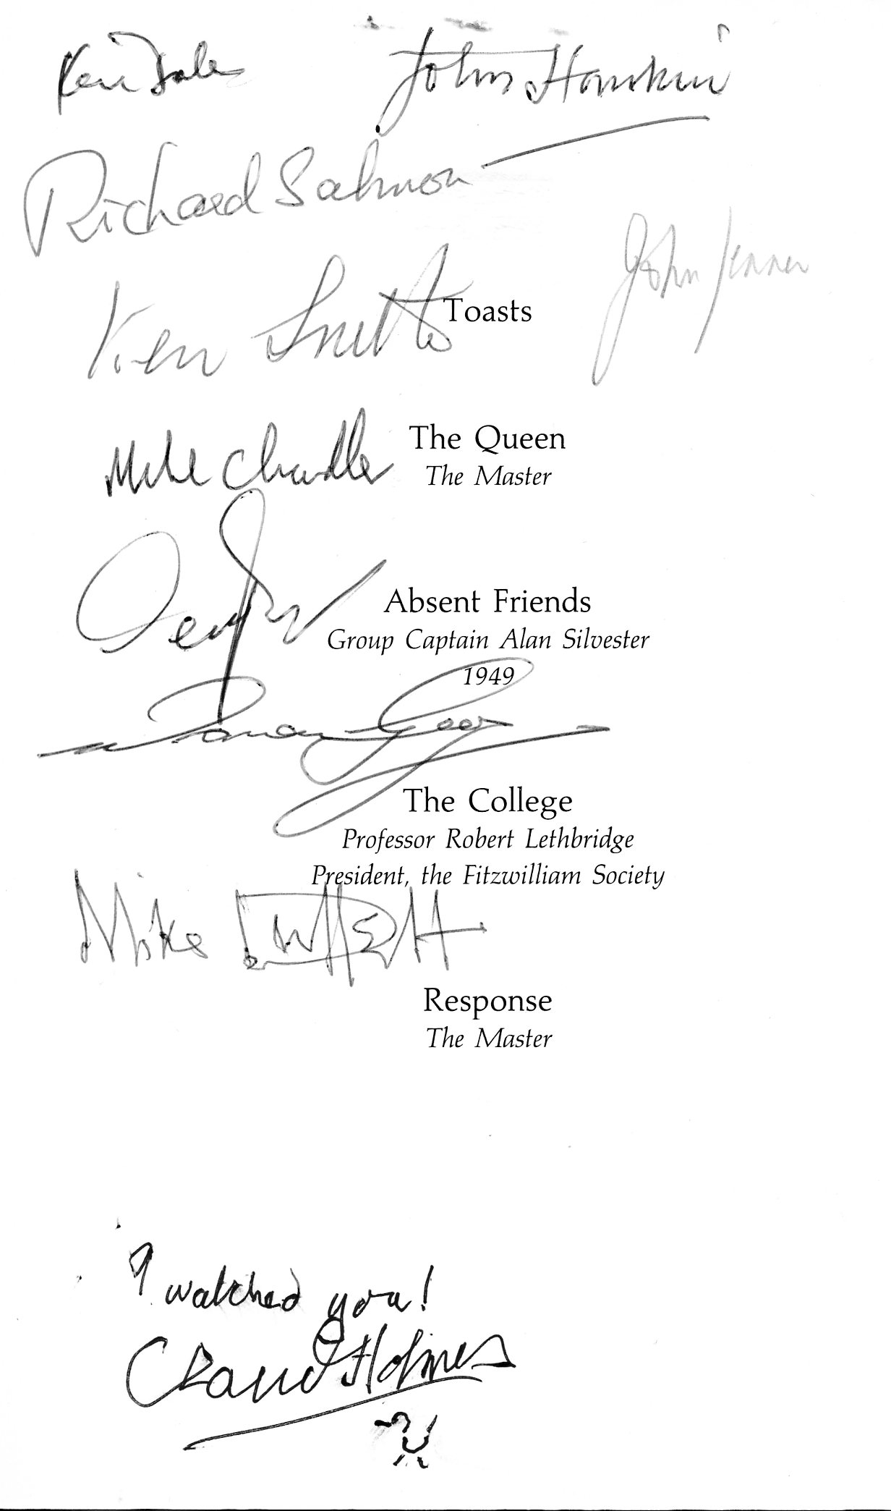
The Master, Mr Johnson, was naturally at the top table and during his speech he paused to mention our achievement and to call the whole crew forward so we could be given a hearty round of applause by the 200 plus diners. This photograph shows us at the front.
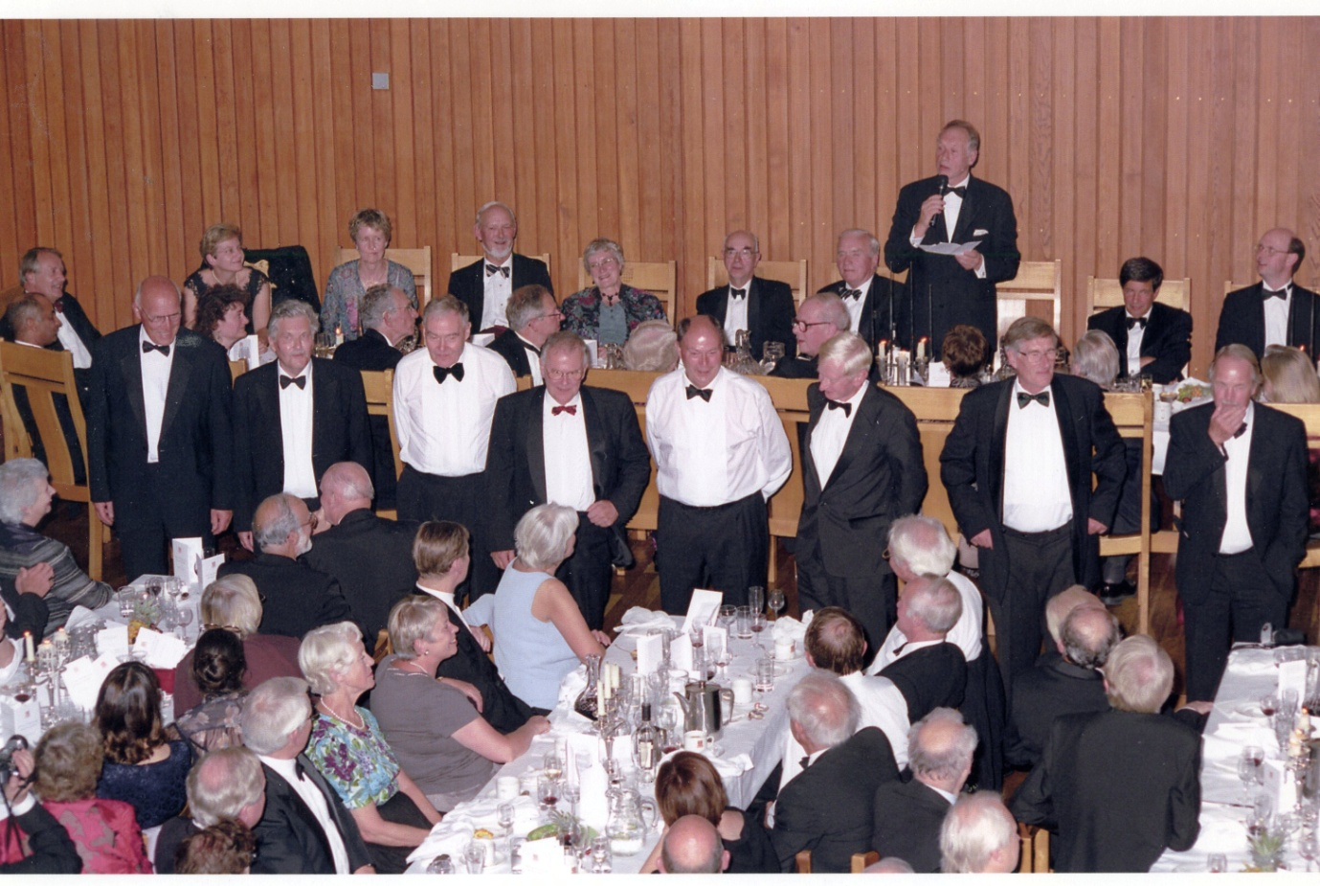
Frank Hall, Mike Chandler, Ken Drake, John Jenner, Warren Gray, Mike Duffett, Richard Salmon, John Hankin. Where was Derek Read?
And so our celebrations came to end. But we wanted to get as much publicity as we could for the sport, for the college and the university. Naturally our first port of call was the Fitzwilliam Journal. We had the foresight to ask its editor, Dr John Cleaver, to take our photographs this year. This meant that we had professional quality photographs but those taken by Susan English for many of our later Reunion Rows were also of excellent quality.
The Fitzwilliam Journal produced the article by Derek Read (above) and the two group photographs of 1955 and 2005 shown above.
The Cambridge News has been an excellent source of publicity for us in the past and this year was no exception. They gave us a whole double page spread much of which was in colour. This included the two groups which they depicted as:-
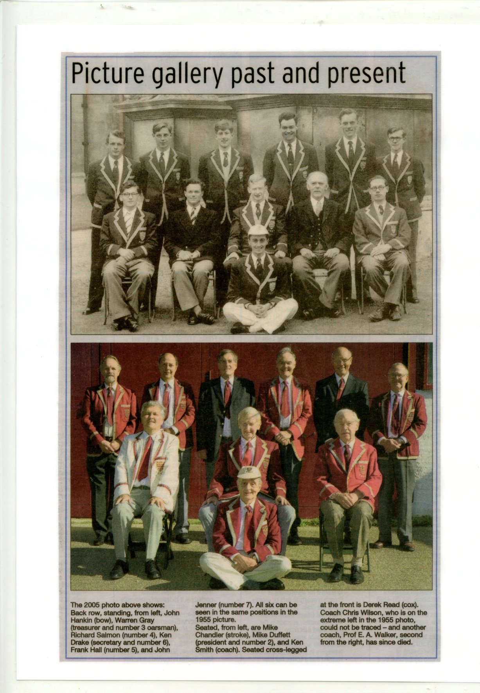
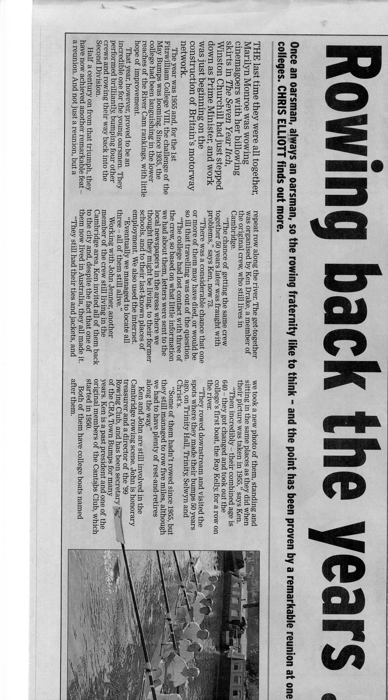
Two further parts of the Cambridge News tribute to us:-

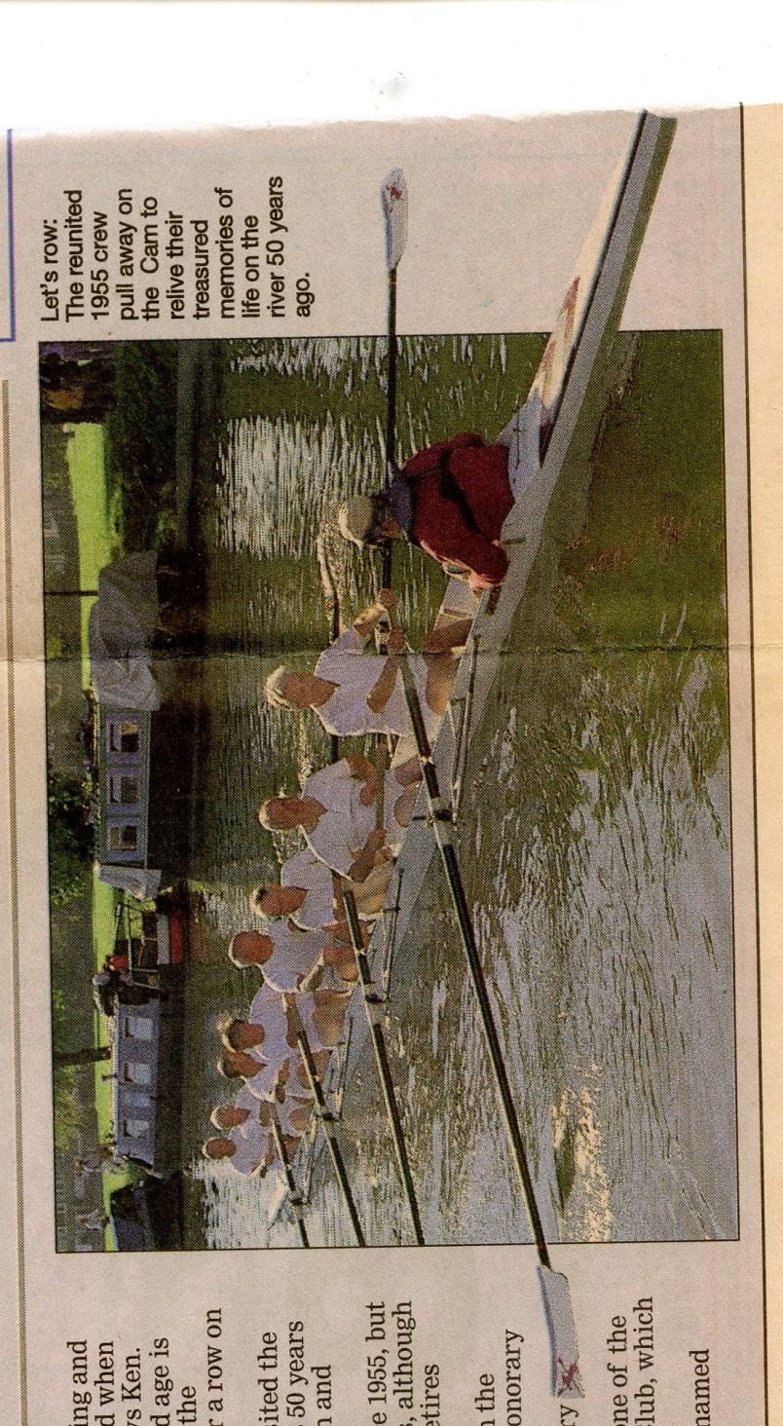

This last photograph from the Cambridge News double page colour spread is, unfortunately, a photo of the wrong crew!!!! There were three Over 60s crews on the river this Saturday and this is one of the others. The coach's prow top left was presented to our coach Ken Smith and that should indeed be here.
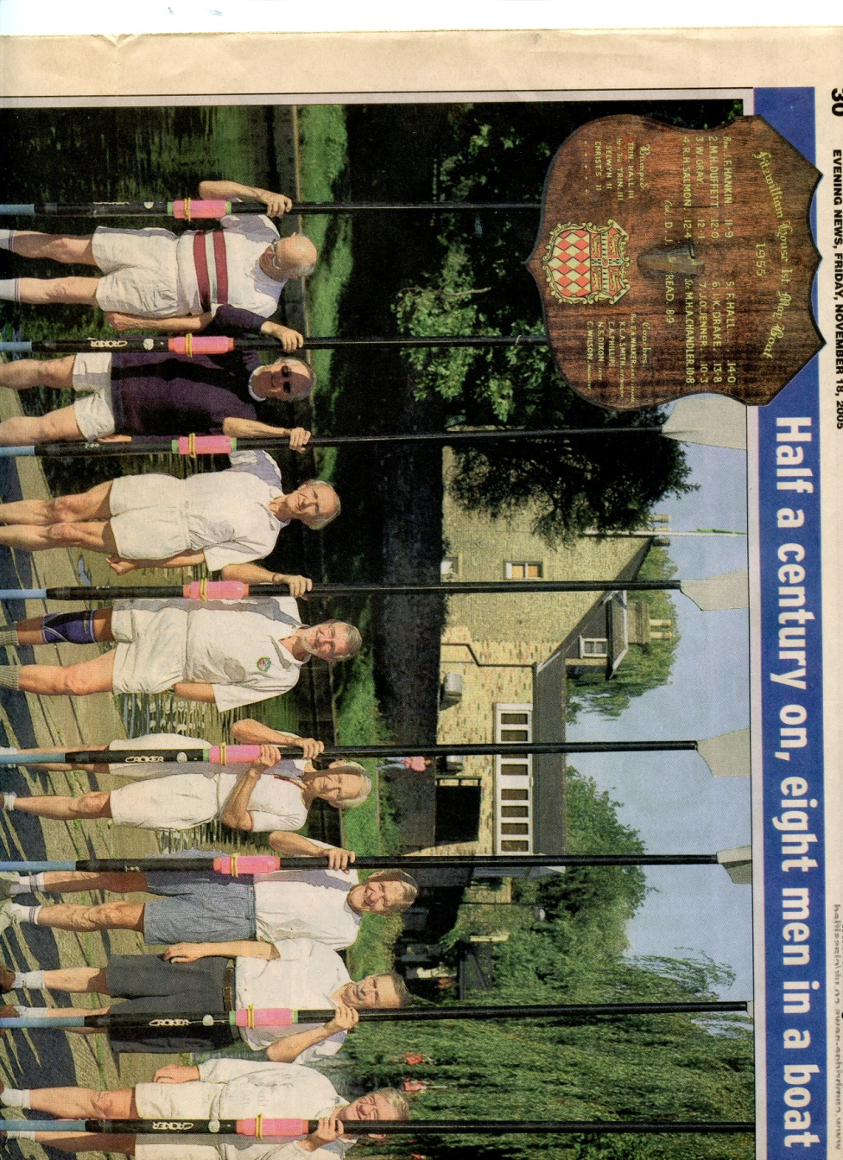

The Daily Mail printed the following
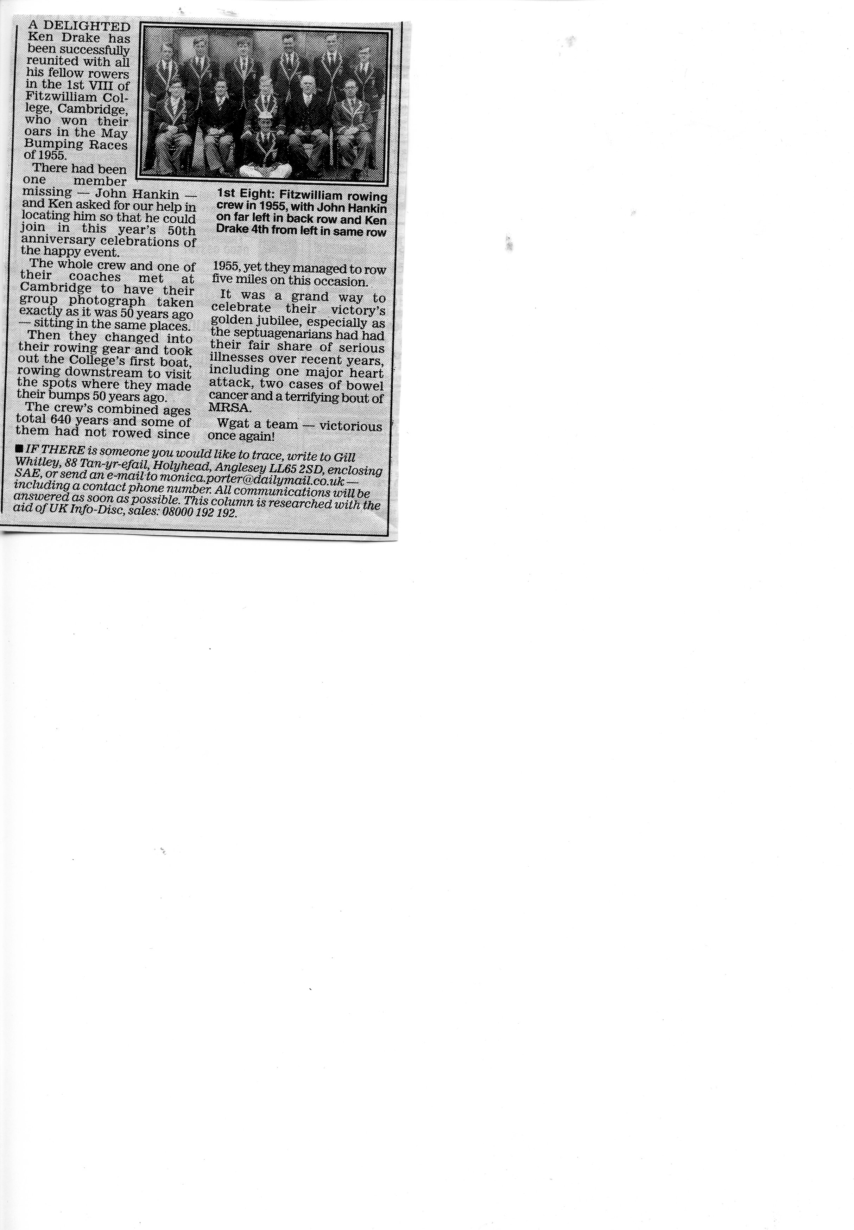

The National Rowing Magazine, called Regatta, produced the following full page colour spread
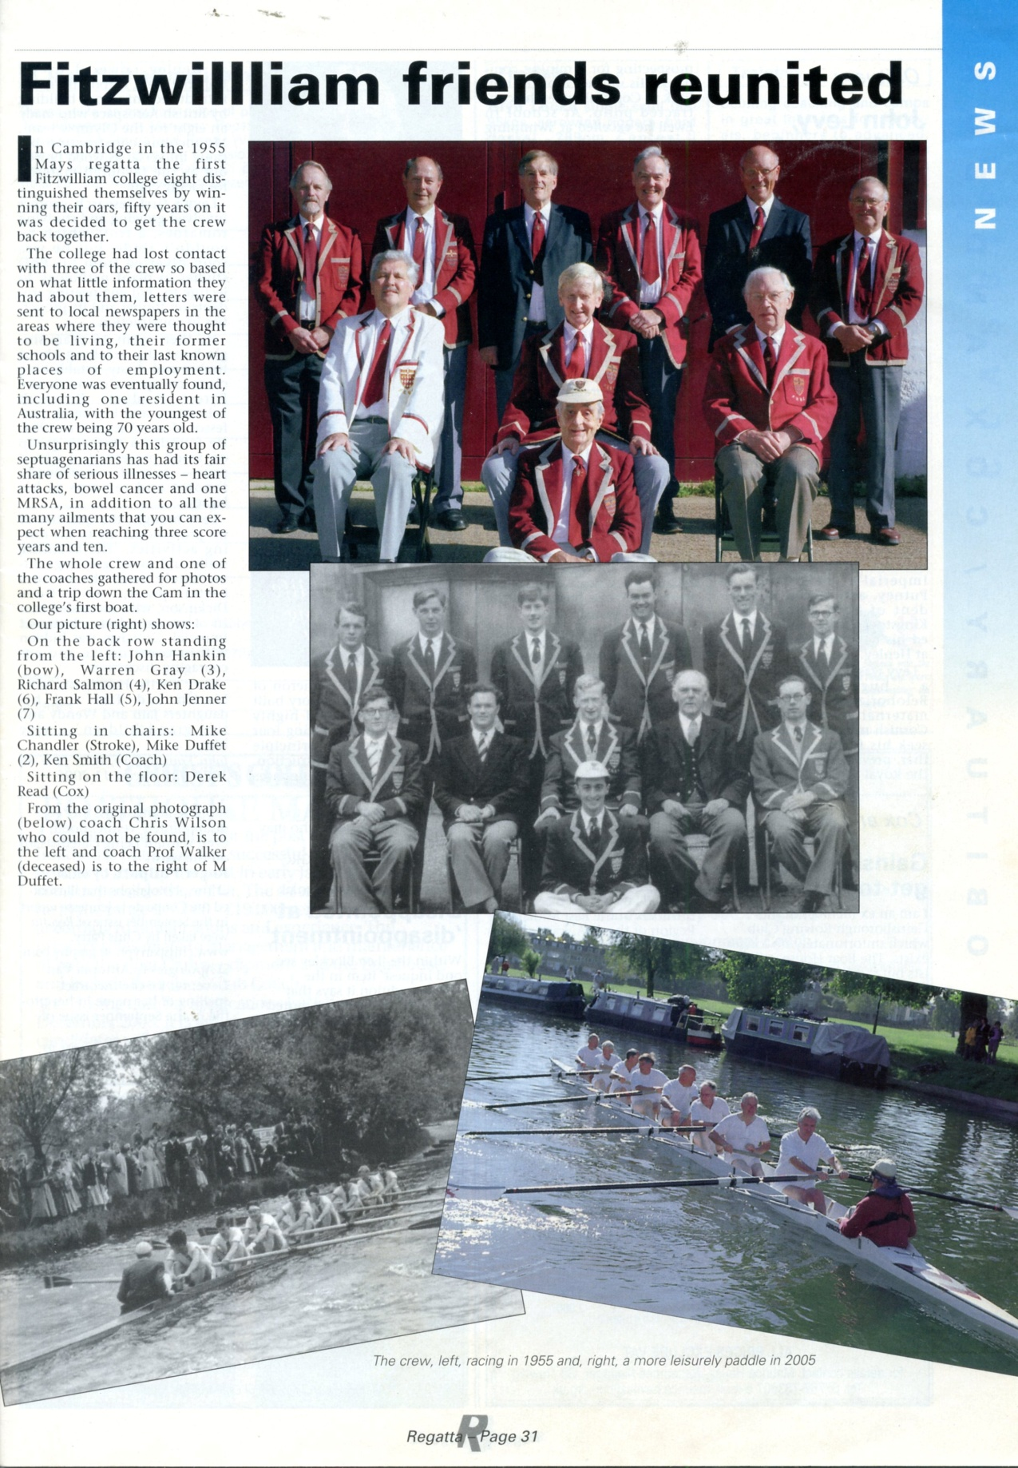
Suitable photographs and text were also sent to the Daily Telegraph, The Times and CAM but they all politely rejected them.
After the celebratory row I wrote the following letter to the crew:-

4 TEDDER WAY, CAMBRIDGE CB4 3RJ
Telephone (01223) 564606
E mail ken@drakehome.freeserve.co.uk
2 October, 2005
Dear
It really was wonderful to meet again and go out in exactly the same positions that we rowed in fifty years ago. I still cannot really believe that we have done it – although it was now over a week ago.
Did any of you remember the increase in the number of the boats in the divisions moving us up to third in the third division so that what we actually achieved was in fact possible? I certainly do not recall any discussion about it at the time and possibly having gone down in the Lents we were not really thinking of being that successful in the Mays. Come to think of it I did not recall rowing over on the first day – which usually means that winning oars is out of the question. I still prefer to use the term winning oars as that was what we called it in our day. Today’s oars are more like blades so you can understand why they have changed the expression.
In have written up an account of the four ways in which we were able to celebrate our success as I felt I would like to put something down to help me recall what had happened and having done it I thought you might also like to have a copy.
We are hoping to gain some publicity for the College by sending photographs and copy to various publications. Whether they will act on it is obviously up to them but it is certainly worth a try.
I discovered after the row was that I was not the only one to have had bowel cancer and that another member of the crew had had a very serious heart attack. In writing up the event it did seem to me that mentioning these illnesses, without saying who has had what, does add to the fact that what we did might well have been impossible had those concerned not recovered from their indispositions. Has anyone else had a serious illness or recent major operation that it would be relevant to include in this list? If so please do let me know. (No one did!)
I am proposing to write to the following publications:-
CAM – The University Magazine that I imagine you all have
Cambridge Evening News – usually interested in this sort of thing and two of us are local and play a significant part in City rowing with our respective clubs.

The Times as it features the Lents and Mays
The Daily Telegraph as it features the Lents and Mays
Regatta – the ARA Magazine
Daily Mail – as we used their Search and Found feature to try to find some of our crew
If you can think of any other publications which might be interested then please let me know and I will arrange to send them some copy and photographs.
I am sure we are all very grateful to Derek for producing his story about our crew. It was great to have a pictorial record of the development of the crew and then its successes. It certainly makes a very interesting document. I am sure we have all thanked Derek individually for his efforts but I felt it appropriate for me to say them again on behalf of us all. I did not have time to look at it before my few words at the Saturday luncheon.
I was very surprised to read the account of the term from the Boat Club Record Book. I honestly cannot recall some of the items mentioned. I recall going to Hammersmith and getting beaten but I was not aware that anyone had written such a detailed account of the trials and tribulations of the term. Indeed I wondered who had been responsible for writing it as everyone in the crew was criticised – apart from Derek our Cox and Mike our Stroke. Surely they could not be responsible. I decided to get in touch with John Adams and he told me that it came from the book which was kept by the respective Secretaries of the Boat Club. Oh dear! That was me. He also said that he was pretty sure it was done in my handwriting! It looks as if I am guilty.
It is a very frank account of the state of affairs. It makes pretty grim reading. I wonder why I wrote it? Was I asked to do so? Who gave me the information? There was obviously no way I could tell what the members of the crew were doing who sat behind me – and as I was 6 that was most of you! What purpose did all the personal criticism in this written report serve when those concerned did not see it – until 50 years later. Presumably the coaches were aware of the problems and worked hard with us to sort them out in 1955.
If we look upon our celebrations this year as joyous occasions the last thing it seems to me that we wanted was to read criticism of our oarsmanship. After all, whatever our imperfections we did achieve two very worthwhile objectives – our oars and a place in the 2nd Division.
I was not aware that it was proposed to circulate this report. Had I been consulted I am sure that I would have edited it rather than producing it exactly as I wrote it. If we want to keep it as a record of the term’s activities then I suggest that we do not need to read of our imperfections. I have therefore produced my own version of it in which I have removed the individual criticisms. It is obviously up to you which copy you keep but I felt it was worth producing this different copy. Presumably as its author I am entitled to produce this abridged version. I have also modified the back page. In addition to the report about the coaching on the document above individual members of the crew were criticised for usually being late, regularly or occasionally washing out and finding difficulty with the timing. Basically the crew were having real difficulty in doing things together which made it hard work and the results did not reflect the energy which was being applied. Our final coach, C Wilson of Magdalene obviously did an excellent job in getting us to the position where we could row faster than the crews we were chasing so we caught them and won our oars.
Looking at the first page of the report I wonder why Geoff Dorling is shown as coxing Cancer when Roger Coleby had obviously agreed to do it as the previous paragraph indicates. I thought that the river was rather narrow between Baits Bite and Clayhithe so I was surprised to see that attempts were made to race the crews side by side. I cannot remember these trial eights at all but perhaps that was because I was in the crew that lost! On the back page there is reference to me rowing with an oar borrowed from Sidney Sussex. I know that going down to the start I managed to break my oar as I had recorded this in my photo album but I had forgotten that I actually rowed with this replacement one. Presumably because we shared the boathouse with Sidney and Cecil looked after the boats of both colleges this was fairly easily arranged.
One week on and I still have the remains of a blister on my hand and am slightly stiff but who cares! I managed to scratch my shins with my finger nails as I was coming forward. I often do this and have no idea why but I must remember to cut and file my nails in future so they do not dig quite so deep!!
I do hope that no one has suffered any serious problems as a result of the row down the Cam.
Thank you very much to everyone of you for making all the celebrations so brilliant.
Ken

