**Extracts from the Fitzwilliam Magazine 1949-52**

**July 1949**

The number of recruits persuaded to join the club at the beginning of the year was most encouraging after an extremely poor influx in the preceding year. Six crews were chosen from about seventy members in varying states of physical fitness. The coaches are to be congratulated on instilling the rudiments of rowing into so many in such a short time. The pioneer work of Alan Kemp, now regarded almost as a permanent fixture merits notice. We are also fortunate in having a 'rowing don' in the person of Mr Wayper, to coach. Of the six crews, surely an all time record, five were entered for the Fairbairn Cup race. With the race almost on top of us we suffered an unfortunate setback when one of the first eight had to go into sick bay. In view of the consequent rearrangement it is hardly surprising that our fortunes should be chequered. The cohesion of the lower crews suffered grievously in having to supply reserves to the higher boats. Not one of the crews managed to maintain its position but the third boat are to be congratulated on beating the second. The serious business of training which included long-to-be-remembered trips to Ely, were relieved by lighter incidents which included a note of reproach for non-attendance at the river to a person who did not exist. The remark of a member of the fourth eight, when pulled out of bed at 7.30 a.m. to go for his run on the first day of training - "surely you're joking" also deserves recording.

The Lent Term saw two or three people drop out. Selection of crews began early and serious training started in earnest. The trips to Ely helped to boost the figures on the mileage chart, some members of the first and second eights passing the two hundred and fifty mile mark by the end of term. The sight of the third eight slowly sinking about a hundred yards from the boathouse, with the cox endeavouring to steer with completely submerged rudder strings, will live long in the memory of those present.

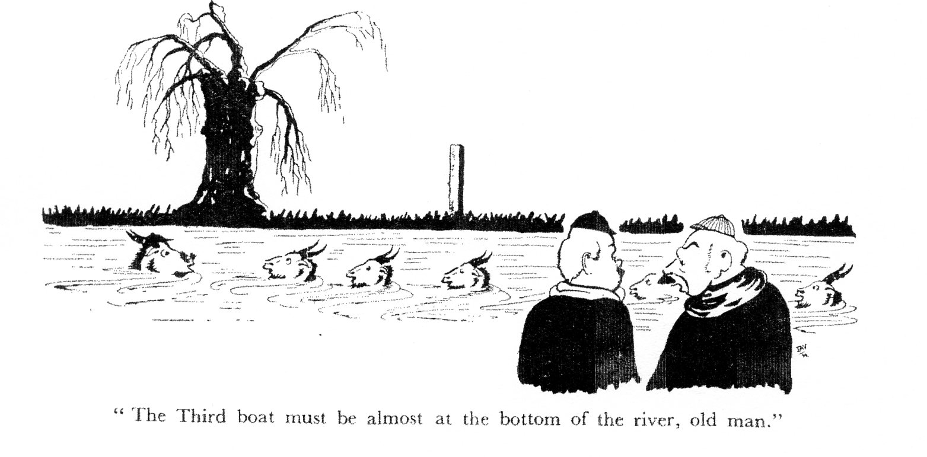

The club did not distinguish itself in the Lents. The fourth eight failed to get on the river. The crew apparently had the impression that they would move the boat faster by rushing up their slides. The first eight , one of our best since the war, went to pieces in the races - they could paddle but not race, their bumps on the first three nights being more attributable to the boat's low position than to its racing qualities. The second eight had a brilliant first night, making an overbump which made them 'Sandwich boat' and, to quote from The Times, "further distinguished themselves by bumping Emmanuel III".

The May term has brought the usual troubles for the club officials. The present rather chaotic state of the boats makes it rather difficult to write the usual platitudes. However, we have five boats on the river. The other clubs are hoping to get a "rugger boat" on the river under the guidance of one of our "deserters" - namely George Dyke. It is hoped to send a crew to Marlow or Henley, and an invitation to a continental regatta is eagerly awaited.

G MARSDEN

Heard in the boathouse "Well, how was I to know it was loaded?"

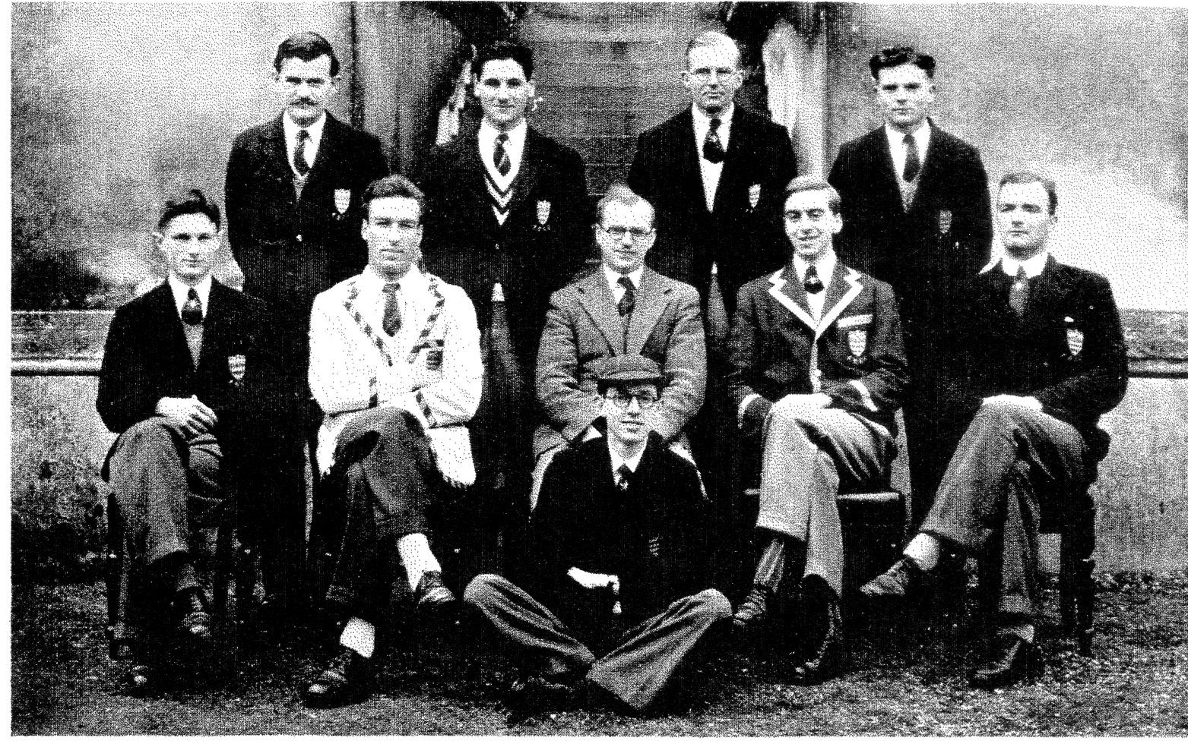

Fitzwilliam 1st Lent Crew

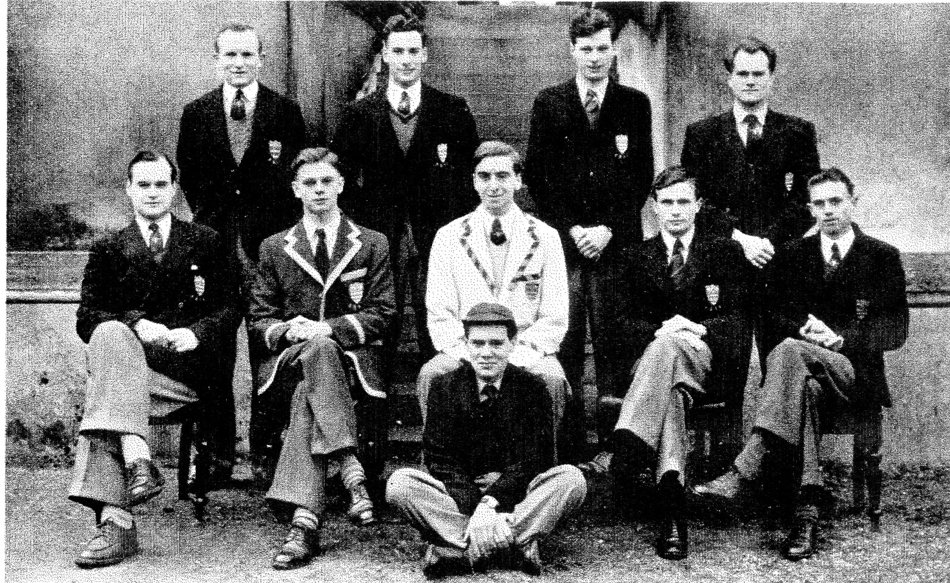

Fitzwilliam 2nd Lent Crew

**June 1951 Fitzwilliam Magazine**

Boat Club

President G Marsden

Hon. Sec. A W W Barker

The climax so far as the Boat Cub was concerned, of the academic year 1949-50 was reached when, for the first time in the history of the club, the first three eights all won their oars in the May races. The first eight was unable to enhance this success further afield, being narrowly defeated in the Junior Eights at the Marlow Amateur Regatta. At long last, the post-war gloom which descended on Fitzwilliam rowing was fully lifted, and the efforts of the pioneers who had been faced with the task of re-forming the Club were rewarded.

This year saw us in an extremely fortunate position of having seven members of the First May Boat still in residence, along with several members of the Second and Third Boats, which provided us with the nucleus of two fairly experienced crews with which to start training. For the first time for many years, we were able to enter the University Clinker Fours, and with a considerable amount of success. The First Four reached the final, where it was beaten by King's who took the previous record. The Fairbairn Cup Race saw a continuation of this success, as all three boats went up, the First Eight came fifth - in a time which broke the previous course record.

In the Lent Races the First Eight won their oars, the Second Eight went up three places and narrowly missed making a fourth bump by a matter of inches, while the Third Eight held its place gallantly re-bumping the boat which had previously caught it. The omens seemed favourable for a visit to the Tideway Head of the River Race at Putney, but here, after a strenuous week's training, disaster met us, for "6" broke his slide at Barnes Bridge and was placed in the unhappy position of being a complete passenger over nearly four miles of the course. However despite our shortage of man-power, we were still able to go up and beat 100 crews. Our shattered fortunes were greatly restored by the Second Eight who finished 60th out of 214 contestants.

The reporting of success is always a pleasure, but I would like to point out that we are still short of men to be trained in order to carry on in the years to come. Rowing is one of the few sports which in Cambridge one can enter as a complete beginner - two members of this year's Blue Boat learned their rowing at Cambridge; surely it is not too much to hope that some of the men who prefer to 'stand and stare' would like to serve in more active capacity.

I would like to record the thanks of the Club to Professor E. A. Walker, T. W. W. Pemberton, R. F. A. Sharpley and G. W. Wace of L.M.B.C., D. Kirby-Johnson, D. N. C. McWatters and J. H. Nichols of Corpus and J Debeneham of King's all of whom have coached us so ably and enthusiastically during the past year. Without their help little could have been achieved.

First May colours for 1949-50 are awarded to B.T. Tuffield, E.W. Brown, J.B.W. Lowe, K.H. Unger, A.J. Braund, A.W.W. Barker, D. Chamberlain and J. D. Reynolds.

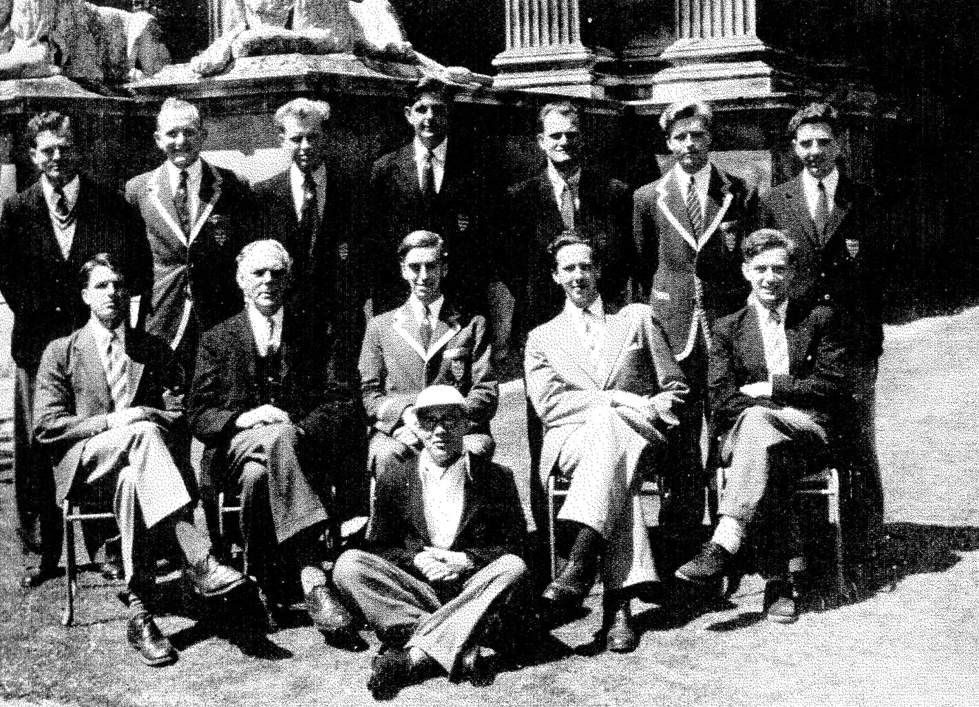

Fitzwilliam 1st May Boat 1950

A.W.W. Barker

**December 1951**

**ROWING**

THE successes of the Boat Club during the last two years, prompts one to find out something more about earlier exploits and achievements of the Club. Unfortunately the past records of most of the clubs are meagre and often missing altogether, which makes the compilation of a formal history out of the question. One can only hope for the sake of their successors that the club secretaries of today are recording the activities of their clubs in considerable detail. However this article has no intention of being a formal history, but only hopes to recall, and that briefly, a few of the “highlights” in the not uneventful career of the Boat Club.

The first mention of the Club occurs in 1884, but from the tone of the minute—that inevitable demand for another new boat—it is apparent that the Club had been in existence for quite a number of years previously. This then credits it with a life of over sixty-five years at least. It is difficult to imagine that many, if any, of the original crew still survive, and in a way, from the viewpoint of the oft-repeated and interminable stories likely to be associated with such an epoch-making event, this probably is a very good thing.

Up to the first World War the “Hall” was represented in the main by only one “eight”, and, despite the youth of the club it was not rewarded with any great success. Because of the incompleteness of the records, it is not possible to say how many times the boat won their oars during this early period,(but this is now indicated in documents in these records KD) but it is interesting to see that when they did, as in 1905, the cost of a new set of oars was only £5, whilst that of an “eight” was only £50. The comparative costs today, as may be ascertained—probably with embellishments—from either the Bursar or the Club Treasurer, lie in the region of £64 and £250.

Through lack of support the club was suspended between 1909-10, as it was also, in common with many of the other clubs, during the two World Wars. In passing we might note the formation of the Rugger Club during the 1913 season. After the war the Boat Club was re-formed and soon revealed a vigour and success which parallels that evident today. Two boats formed the mainstay of the Club during this period, and recorded in their favour 22 bumps with 8 against. After 1923 however, the fortunes of the club once more waned sadly. Neither the successes nor the failures of the boats at this time though, can be entirely attributed to our present Bursar, who was then an enthusiastic (sic !) member of one of the crews, for it appears that in addition to this, through some show of temperament on the part of either the boat or the oarsmen, or both, given the slightest opportunity and unwatched for the briefest time by the coach, the boat simply turned over and continued to float on, upside down. Though the method is both highly diverting and entertaining, yet as a stratagem for race-winning it definitely has its limitations. There was a similar sort of situation a couple of years ago. A nomadic, but nevertheless famous, cox was also firmly of the opinion that any boat he coxed was sure to progress best only by proceeding in sub-marine fashion. It is known that certain of this cox’s contemporaries contributed whole-heartedly to this view.

Up to this time it appears that the Boat Club used an interpretation of the Orthodox style, and for a number of years prior to 1927 were coached by the famous Prof. Meldrum, creator of the Lady Margaret style. However in that year it was decided to adopt the Jesus “Fairbairn” style, the change over being effected with the aid of a number of Jesus coaches. As a result the sun really shone brightly for the club, (as it has done again with the further change to the Lady Margaret style). Oars were gained with amazing rapidity. The second boat secured seven (this should read six KD) bumps in the Lents—a feat which up to then had only once before been accomplished in the history of University rowing, whilst the first boat were placed third in both the Clinker division at Putney, and the newly-created Michaelmas ‘Fairbairn’ race. By the latter performance they exceeded the efforts of their successors, who in 1950 were only placed fifth. Of course it is only fair to point out that on the first occasion there were only eleven other contestants.

Now to turn to the matter of uniform. In 1887 the Amalgamated Clubs adopted maroon and grey as the ‘Billy’ colours, and thereby laid the grounds for the battle of the blazers and the contest of the colours which has raged from that year to this. The Boat Club selected a blazer of maroon base with grey trimmings, a form which has once more emerged today, whilst the cap consisted of maroon and grey triangles, and the straw was decorated with ribbon striped in the same colours. However within one term a new and different cap for ‘May’ colours has already been evolved.

In 1896 Buttresses were appointed official tailors, and offered blazer and cap at an inclusive price of one guinea. Shorts of course were unheard of, and the normal wear, white flannel trousers could be obtained for 14/6d. With an eye to the practical though there was added to the tailor’s list, “(leather seating 1/- extra)”. When shorts were eventually introduced on the river, the first boat alone were allowed to wear them, as a mark of a great honour.

It would seem that in the early days discipline, or perhaps attempts at discipline, were far more rigorous than is the case today. Thus before 1890 a fine system for late arrival at the boat house, was severely enforced. In 1890 the whole position was defined and regulated by the amalgamated clubs and was made applicable to all the member clubs. This minute, has neither been amended nor repealed, and therefore theoretically it is still binding today. For the Boat Club it ran “that any member chosen to row in the “8” and not appearing within a quarter of an hour be fined 2/6d., and for tubbing 1/-”. Bearing in mind the changed value of money it can be seen the fines were indeed severe.

Training was also rigourously insisted upon and there are frequent mentions of grants from the amalgamated club towards defraying expenses of “training meals“. Incidentally, there is mention also of grants to buy horses for the use of the coach, as in 1896 when £7 8 0 was allotted to the Club.

Also printed in this magazine was the following poem, reprinted from the Fitzwilliam Hall Magazine of December 1922. Ed)

AN EARLY PRACTICE OF THE RUGGER BOAT

Lurching down the river like a railway train,

Rolling down the river, bows into the rain,

Splashing down the river, sways the Rugger boat,

Laughing watchers wonder how it keeps afloat.

Cox is shouting orders no one ever hears,

Round the hidden corners daringly he steers,

On the old Barge trundles till he turns her round,

Then the weary blighters know they're homeward bound.

Stroke is looking worried - face as black as night -

Boat was near capsizing - that gave him a fright,

Stroke side all are barging, bow side digging deep,

Surely that's enough to make an angel weep.

Seven's rather sleepy, seven's never there,

Seven's blade is waving high up in the air,

Till it plunges deeply. Heavens! What a roll!

Can't you hear the coach mutter curses on his soul.

Six has got some blisters, six has caught some crabs,

Five is cutting tea fights, while he digs for dabs,

Four would like his rigger higher than the sky,

Three is swearing horrid - he's about to die.

Two was feeling lazy, so he broke his strap,

Walked back on the tow path, cunning little chap,

Bow though pulling nobly, ne'er in time can be -

(Nor can cox when shouting - " One and Two and Three")

Coach is very patient, standing on the side,

He'll at least acknowledge most of us have tried,

Were he to refer to every fault we make,

He would talk to Christmas - not a single break!

Rolling up the river, lurching through the gloom,

Splashing up the river, underneath the moon,

Crawling up the river, homing very late,

Come's earth's greatest marvel, Billie's Rugger Eight.

Chauhattar

**January 1952 Fitzwilliam Magazine Supplement**

President B A Skinner

Secretary A J Brand

**1950-51**

At the May Bumps, both the first and the third VIII's made four bumps, so winning their oars, the second boat made two bumps. Later at the Marlow Regatta, our VIII beat Peterhouse (Camb), Downing (Camb.), Oriel (Oxford) and Thames R.C. II to reach the semi-final. In our finest race of the year we lost by one length to Pembroke who won this Regatta and also the Ladies Plate at Henley.

Though a little below our Marlow form, we also distinguished ourselves at Henley by achieving the second fastest time of the day, but were beaten by a fast King's (Camb) crew. So ended for Fitzwilliam rowing what must be its finest year to date.

**1951-52**

With only ten oarsmen, including several "freshers", we began training early, and made very good progress, thanks to excellent co-operation between old and new members.

In the Fairbairn Race, we were somewhat unfortunate. The crew was upset a week or two before the race by illness of two of its members, and then in the race itself Stroke's footstrap broke, making him unable to give the crew time at the finish. Even so, the VIII finished fifteenth, and had they been five send faster, they would have been tenth.

The second and third VIIIs, mainly freshers, trained hard but dropped several places. Also, we managed to float a fourth VIII for the Fairbairn, and they maintained their position throughout the race.

Though we hold the "Michel Cup" awarded to us as the most improved club last year, much remains to be achieved in the coming terms. Certainly this last term has been one of promise for the future.

**Fitzwilliam Magazine June 1952**

ROWING

President B A Skinner

Secretary A J Braund

The Lent term has been one of great disappointment. The number of bumps recorded must always be the main element in the yardstick of success.

A depleted 1st VIII appeared to be making the necessary improvements and were confidently expected by towpath pundits to make their bumps. After missing their bump on the first night by only two feet the crew never got into a racing stride during the remainder of the Lents. This was largely because of the inexperience of the crew.

The 2nd VIII, consisting mainly of Freshmen, made great strides during the course of the term and did well even though they were bumped twice. They were rowing among crews with far greater experience than themselves.

The 3rd VIII were all newcomers to the gentle art, and were limited in the number of outings to two or three a week. However, they put in much useful work which should result in future benefit.

Obviously we shall have to make greater progress in the coming terms, which calls for an even greater effort by all members. It is also essential that at this point in the Club's history we make every endeavour to increase membership.

C. L. Dawson