**Bob Perkins is probably Fitzwilliam's most successful bumps oarsman who moved up more places than anyone else.**

**John Adams is possibly Fitzwilliam's most successful oarsman who won more oars than anyone else.**

Bob came up in 1961 and learnt to row in his first term and rowed in the Fairbairn Race. The next term he rowed in the Fitzwilliam third crew. All this crew were new to rowing so this Lents was the first experience they had of racing in bumping races. They obviously had little idea of what to expect. It was hoped they would make a bump on the first day but they did rather more than that. This turned out to be the record breaking 3rd Lent crew of 1962 which went up 10 places on the first day and a further three on the next three days making 13 places in all.

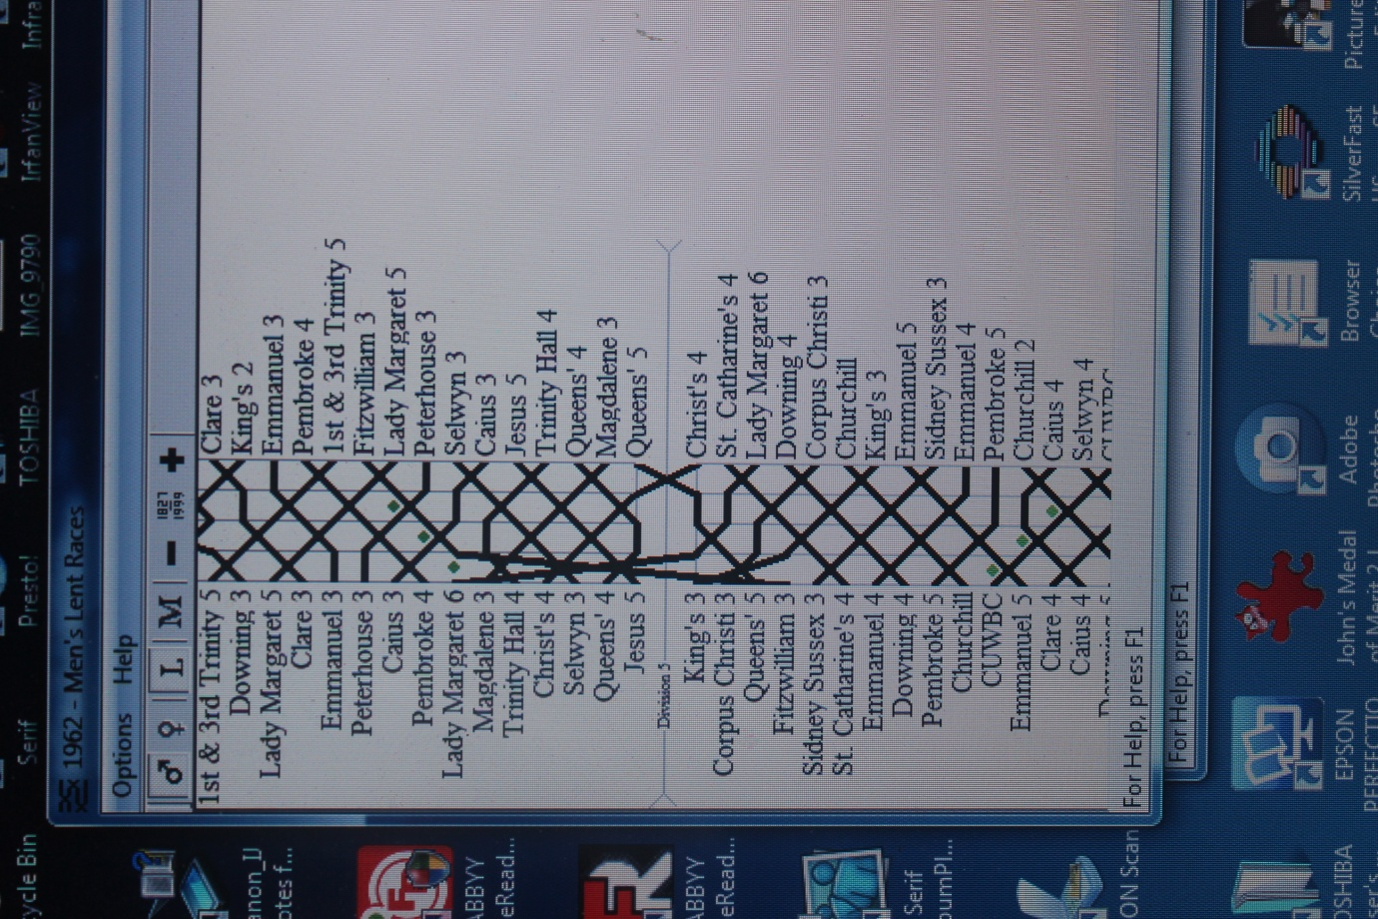On the first day the crew started 4th in the 5th division and chased Queens' 5 but they bumped Corpus Christi 3 so Fitzwilliam now were chasing King's 3, who were sandwich boat. They successfully overbumped King's 3 taking their place as sandwich boat and 45 minutes later they rowed again that day at the bottom of the 4th division. Starting almost in Baits Bite Lock they chased Jesus 5 but they bumped Queens' 4 so they then chased Selwyn 3 but they bumped Christ's 4, so they then chased Trinity Hall 4 but they bumped Magdalene 3 so they then chased L.M.B.C. 6 and bumped them some 30 yards before the finishing line. The bumps between Fitzwilliam and L.M.B.C. 6 did not necessarily take place in that order but they did all happen to leave Fitzwilliam 3 with the prospect of chasing a crew that at first appeared a very long way away. However as the Billy crew were encouraged by a very enthusiastic bank party, led by their Vice Captain of Boats, David Knowles, Fitz 3 did manage to make the very first triple overbump that had ever been made in the Lents or Mays. This meant that the crew had made up a distance of 16.5 boat lengths (1 boat length is 60 feet). The crew as a result of these Herculean endeavours went up 10 places in one day - a university record which still stands today. On the next three days they bumped Caius 3, Peterhouse 3 *The* *dots along the part opposite Lady Margaret 6*

and Lady Margaret 5 making a total of 13 places gained. *NE wards* *indicate where these bumps were made.*

*It says opposite Lady Margaret 6 Morley's Holt*

It is interesting that in the 2018 Mays Magdalene 4 *[note that this was the first ever triple overbump].*

made a quadruple overbump but that still only  *They bumped Caius 3 at The Ditch (which was in*

took them up 9 places, 1 below the Fitzwilliam *First Post Reach) and Peterhouse 3 at Grassy* and

Record of 10 places in one day. This was thought  *no mention of where they got Lady Margaret 5.*

at the time to be the first ever quadruple *Do you remember?*

overbump in Lents or Mays. However, the first was actually made by Peterhouse Women's 1st VIII in 1986 but this is not recorded in "The Bumps". However, Peterhouse were subsequently bumped twice and rowed over on the fourth day as I mention in the document entitled "Maximum Number.... *.*

Incidentally this chart is taken from the book entitled "The Bumps" by John Durack, George Gilbert and John Marks. It illustrates the tremendous progress that Fitzwilliam 3rd Lent 1962 crew made on the first day. I am grateful for permission to use this chart in these records.

A full account of that remarkable crew which broke three University records appears as a separate document in these Fitzwilliam records. Those records which still stand in 2022 are:-

(a) The crew to go up the most places in one day - 10 places

(b) The crew to go up the most places in one bumps - 13 places

(c) The first crew to make a triple overbump.

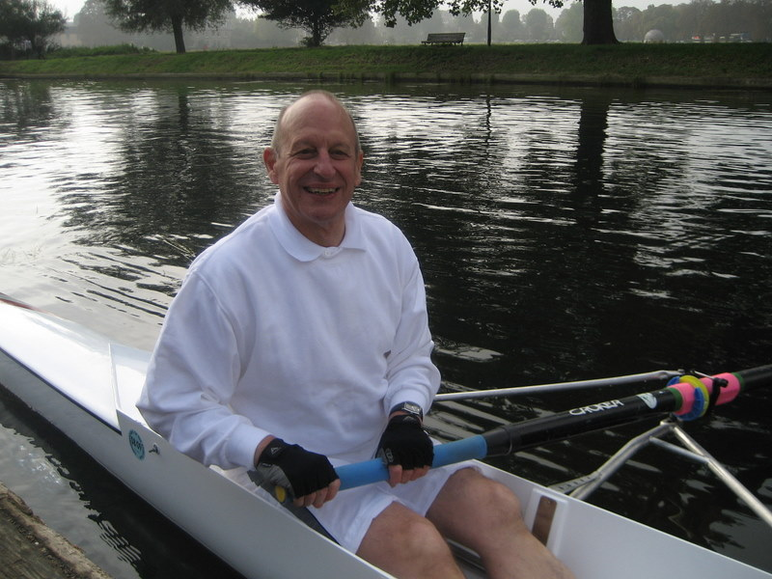In the 1962 Mays Bob rowed in the 4th boat and on the first night they overbumped Selwyn 7 (over Corpus Christi 4 and C.U.W.B.C.) to became sandwich boat and 45 minutes later they bumped Downing 6 thereby going up four places on the first day. On the next three days they bumped Churchill 4, Selwyn 6 and Lady Margaret 12 thereby going up 7 places that Mays.

The 1963 Lents were cancelled because of snow.

The 1963 Fitzwilliam 4th May boat bumped each day, demoting successively Lady Margaret 11, Christ's 7, Sidney Sussex 4 and Downing 5 going up 4 places that Mays.

The 1964 Fitzwilliam 1st Lent crew rowing in the First Division bumped on all four days Jesus 2, Lady Margaret 2, Christ's and Clare to go up 4 places.

*Bob rowing in Over 60sReunion Row crew in 2006*

The 1964 Fitzwilliam 2nd May crew rowed over on the first day, and then on the next three days bumped Clare 2, Lady Margaret 4 and Jesus 4 going up 3 places

So he went up an incredible 31 places in just 5 sets of bumping races. He won 4 oars and he challenges any other Fitzwilliam man or woman to beat his claim to be the most successful Fitzwilliam bumps oarsman ever. Indeed, it would, I suspect, be highly unlikely to find anyone in the university who can equal this unique record in only five sets of bumps.

This is a summary of Bob's record:-

1962 3rd Lent boat 13

1962 4th May boat 7

1963 Lents cancelled - snow 0

1963 4th May boat 4

1964 1st Lent boat 4

1964 2nd May boat only 3

Total 31

**John Adams probably won more oars in Fitzwilliam crews than anyone else**

John Adams was extremely successful in the Lents and Mays for Fitzwilliam.

He won five oars, one more than Bob, but the total number of places he moved up was 27 compared with Bob's 31.

John matriculated in 1958 and rowed in the 1959 Lents in the 3rd crew which bumped Sidney Sussex 3, Lady Margaret 7, Caius 4, Emmanuel 4 and Jesus 5 going up five places and winning his first oar.

In the 1959 Mays John was in the third crew which bumped Sidney Sussex 3, Selwyn 5, Caius 5 and Caius 4 going up 4 places and winning his second oar.

He rowed in the 1960 Lent 1st crew which bumped St Catharine's 2, Downing 1 and Trinity Hall 2 going up 3 places.

He was in the 1st crew for the 1960 Mays which bumped Lady Margaret 3 and Pembroke 2 going up 2 places.

In the 1961 Lents he was in the 1st crew which bumped Sidney Sussex 1,Corpus Christi 1, 1st & 3rd Trinity 2, Magdalene 1 and King's 1 rising 5 places and winning his third oar.

He continued rowing in the 1st crew for the 1961 Mays which bumped Queens' 2, Corpus Christi 1, Magdalene 2 and Trinity Hall 2 going up 4 places and winning his fourth oar.

His last race was in 1962 Mays, again in the 1st crew, which bumped Sidney Sussex 1, Jesus 3, Emmanuel 2 and Caius 1 going up 4 places and winning his 5th oar.

This is a summary of John's record:-

1959 3rd Lent boat 5

1959 3rd May boat 4

1960 1st Lent boat 3

1960 1st May boat 2

1961 1st Lent boat 5

1961 1st May boat 4

1962 1st May boat 4

Total 27

So John rowed in 7 sets of bumping races whereas Bob only rowed in 5 sets.

John of course went on to become Secretary to the Billygoats Society, a post which he held with distinction for 50 years.

I wonder if John holds the record of winning the greatest number of Fitzwilliam oars? I certainly am not aware of anyone who won more oars than John. If you did please let me know.

Ken Drake

2022