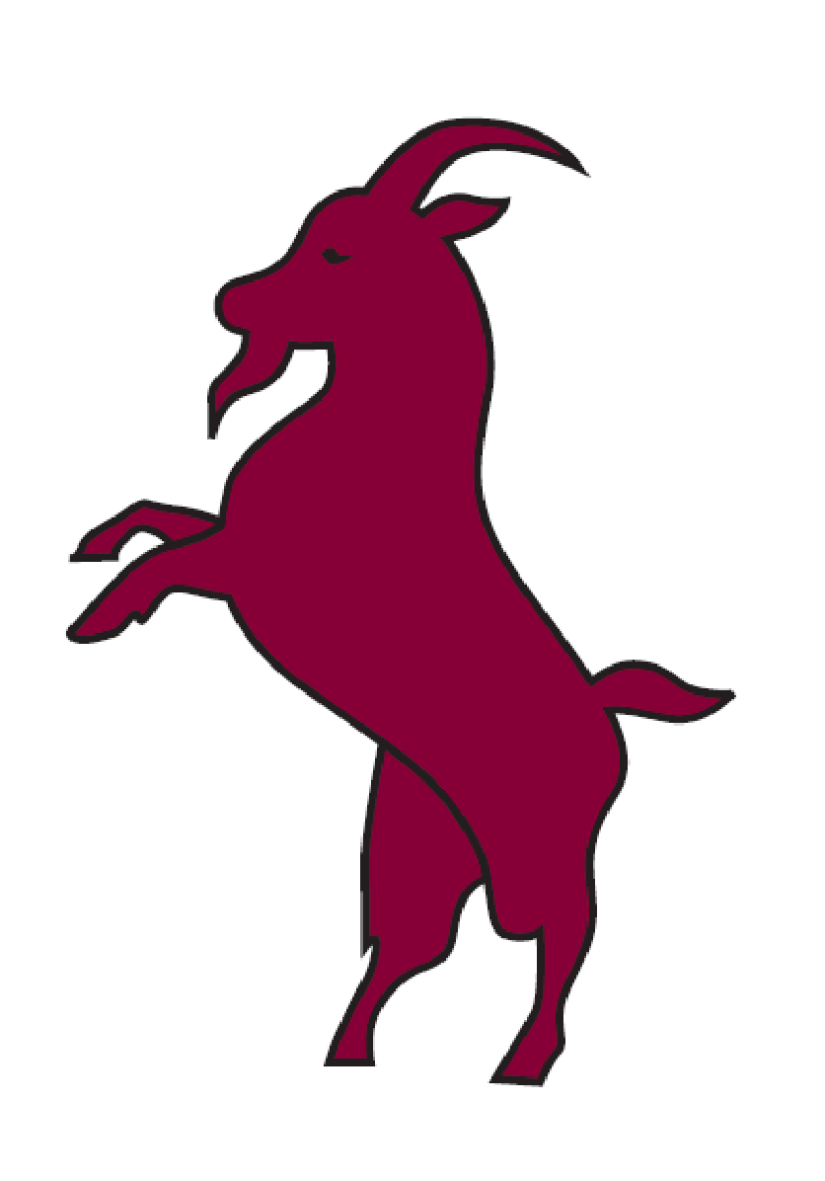**BILLYGOATS SOCIETY**

**40th Annual Henley Dinner**

Member’s Balcony Leander Club

Friday 6th July 2018

|  |  |  |
| --- | --- | --- |
| Professor Michael Potter  *(Treasurer)* | Carole Wright  *(1984, President)* | Jaume Vilar  *(1994)* |
| John Jenner  *(1954)* | David Wright  *(1982)* | Caroline Vilar  *(Guest)* |
| Adrian Tollett  *(1972)* | Dan George  *(1979, Secretary)* | Paul Speedy  *(1994)* |
| Ian Hall  *(1964)* | Joseph Everest  *(FCBC)* | Blathnaid Speedy  *(Guest)* |
| Jane Hall  *(Guest)* | Alisha Levermore  *(FCBC)* | Andrew Glynn  *(1994)* |
| Ted Bates  *(1960)* | Louise Brett  *(FCBC)* | Jaqueline Glynn  *(Guest)* |
| Britt Bates  *(Guest)* | Robbie Sewell  *(FCBC)* | John McKelvey  *(1994)* |
| John Adams  *(1958, Secretary Emeritus & Vice-President)* | Anna Wood  *(FCBC)* |  |
| Joan Adams  *(Honorary Billygoat)* | Robert Doe  *(1982)* | Peter Reynolds  *(2008)* |
| Nick Tittle  *(1976)* | Iain Reid  *(1978)* | Lju Lazarevic  *(Guest)* |
| Chris Radford  *(1975)* | Ian Clarke  *(1984)* |  |
|  | Kate Clarke  *(Guest)* |  |
|  |  |  |
|  |  |  |

**BILLYGOATS SOCIETY**

**40th Annual Henley Dinner**

**Friday 6 July 2018**

Oak smoked duck breast with apple & celeriac remoulade, quince jelly, duck powder, baby rocket salad

Vegetarian Option

*******

Roast rump of lamb with Quinoa & braised shoulder croquette, golden beetroot puree, sautéed spring greens & seared baby vine tomatoes

Vegetarian Option

*******

Leander bi-centennial cheesecake: English rhubarb cheesecake, Leander Pink sorbet & gold leaf